Format Flash Drive for Tencor SOP

Purpose and Scope
This document instructs how to format a flash drive compatible with the Tencor P-10 and P-20 Profilometers and Tencor Flexus 2320 Film Stress Analyzer. These Tencor tools use an operating system designed for use with a specific removable media: 3.5 inch floppy drives. Because 3.5 inch floppy drives are no longer accessible, use of a flash drive specifically formatted for use with that operating system is required. Any flash drive inserted into the USB port of the Tencor tools will only be recognized by the computer if it is first formatted by that computer. This SOP explains how.

Table of Contents
Format Flash Drive for Tencor SOP 1
Purpose and Scope 1
Table of Contents 2
Reference Documents 2
Acronyms, Abbreviations and Definitions 2
Equipment and Supplies 2
Safety 2
Job Breakdown – Format Flash Drive 3
Revision History 5

Reference Documents
Reference Documents | SOP Number or link
User Guide | https://www.nanofab.utah.edu/documents/2016/02/smbb-user-guide.pdf/

Acronyms, Abbreviations and Definitions
Term | Description
SOP | Standard Operating Procedure

Equipment and Supplies
Description
Tencor Computer | Located in the Metrology bay
Thumb drive | Purchase from Staff

Safety
Follow all Nanofab Metrology Bay safety procedures.

Job Breakdown – Format Flash Drive
A | Prepare to Format  - Locate the Tencor Computer and its USB port.  - Verify the computer is on and the screen displays.  - If in Windows, exit Windows by either closing the file from the upper left hand corner of the window or simultaneously selecting the three buttons: CTRL-ALT-DELETE. A DOS prompt will appear:  C:\> | 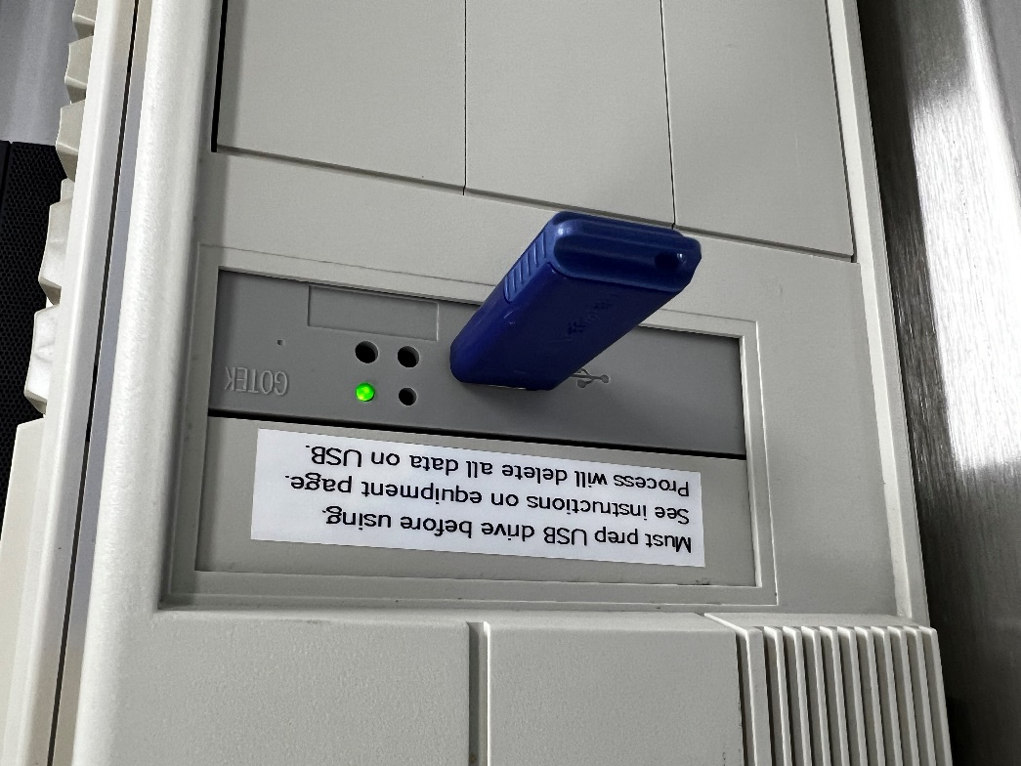
B | Format  - At the DOS prompt, type:  format a:  then press the ENTER button. The following will be displayed:  Insert new diskette for drive A:  and press ENTER when ready  - Insert the flash drive  Note that the order of these steps affects formatting success. If the flash drive is inserted before the computer is started, it will detect a drive that it cannot read and display an error. The way past this error is to remove the flash drive and restart the computer with an empty USB port.  - Press ENTER. The screen will display formatting progress, then report a total disk space in bytes. It will ask whether you want to name the drive and whether formatting another flash drive is needed. Enter a name if desired.  - If formatting another drive, remove the first drive, insert the next drive, then type the letter Y.  - Repeat until all drives needed are formatted and named if applicable.  - Press CTRL-ALT-DEL to return to Windows. | 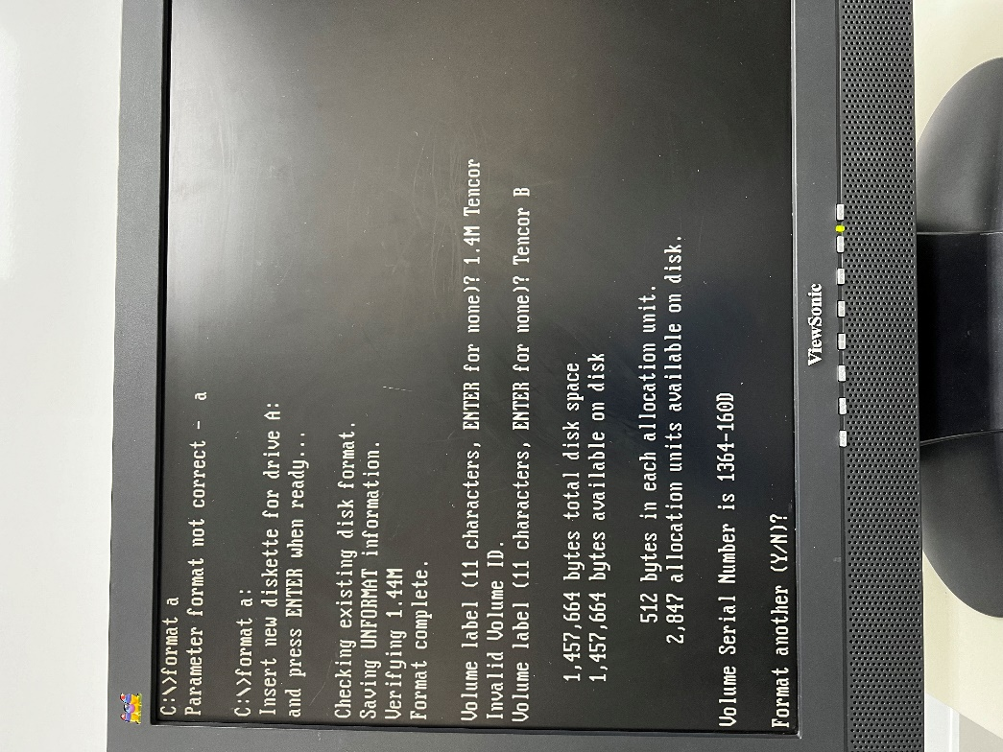

Revision History
Rev | Date | Originator | Description of Changes
1 | 12 Dec 2023 | Kathy Anderson | Initial Release

