Cambridge NanoTech Fiji F200 ALD SOP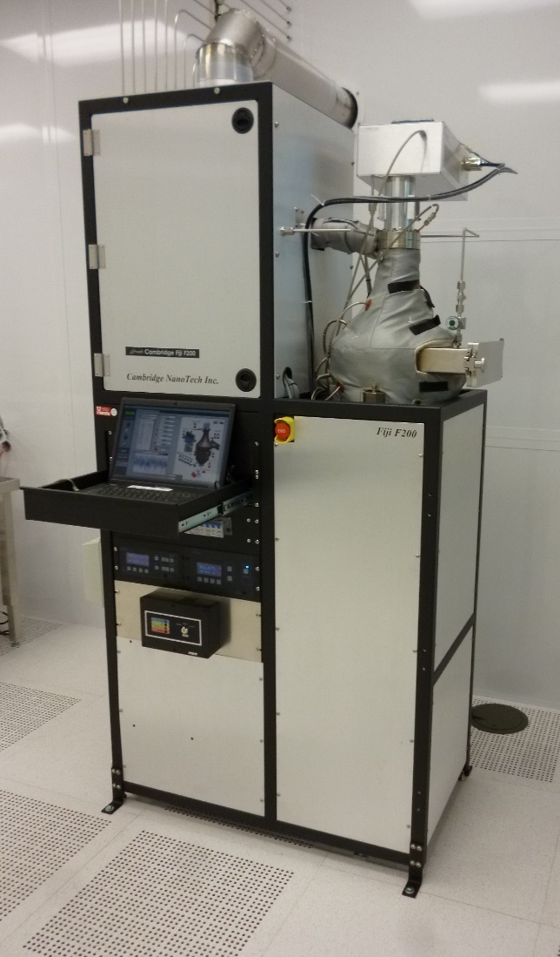

1. Scope
   1. This document provides standard operating procedures and instructions to deposit thin films with the Cambridge NanoTech Fiji F200 Atomic Layer Deposition (ALD) system.
      1. This system uses reactive chemistry to generate highly conformal films one atomic layer at a time.
      2. The system supports multiple precursors and can be used to generate a variety of films.
2. Table of Contents

1 Scope 1

2 Table of Contents 1

3 Reference Documents 2

3.1 Referenced within this Document 2

3.2 External Documents 2

4 Equipment and/or Materials 3

5 Safety 3

6 System Description 4

6.1 System Overview 4

6.2 Software Interface 4

6.2.3 Process Tab Description 5

7 Setup Procedures 6

7.1 Verify Chamber Vacuum 6

7.2 Verify Heaters 6

7.3 Purge Chamber 6

7.4 Select Startup Recipe 7

7.5 Run Startup Recipe 8

8 Film Deposition Procedures 8

8.1 Enable in Coral 8

8.2 Verify Temperatures 8

8.3 Vent Chamber 8

8.4 Remove Substrate Platen 8

8.5 Load Sample(s) 8

8.6 Load Monitor 9

8.7 Load Substrate Platen 9

8.8 Pump Down 9

8.9 Load Recipe 9

8.10 Adjust Recipe 10

8.11 Run the Process 10

8.12 Vent Chamber 11

8.13 Remove Substrate Platen 11

8.14 Remove Wafer/Sample 11

8.15 Load Substrate Platen 11

8.16 Place ALD in Standby 11

8.17 Measure Monitor 11

8.18 Disable in Coral 11

9 Process Notes 12

9.1 Definitions and Process Terminology 12

9.2 Programming Commands 13

10 Revision History 13

Figure 1, Cambridge Fiji F200 ALD System Configuration 4

Figure 2, ALD Control Screen 5

Figure 3, Purge Valve 6

Figure 4, Recipe Section Detail 7

Figure 5, Modify Loops 10

Figure 6, Deposition Pulses 10

Table 1, ALD Recipe and Process Information 7

Table 2, Recipe Instructions 13

1. Reference Documents

Referenced within this Document

* + 1. None

External Documents

* + 1. None

1. Equipment and/or Materials
   1. Cambridge Fiji F200 ALD system
   2. Monitors (bare silicon)
   3. Precursors, as needed
   4. Quartz Plate
   5. Research Grade Argon
   6. Research Grade Nitrogen
   7. Research Grade Oxygen
   8. Substrate Platen
   9. Substrate Platen Wand
   10. Wafer/Sample
2. Safety
   1. Follow all Nanofab safety procedures.
   2. During operation, parts of the ALD become VERY warm – up to approximately 300°C.
      1. Never place flammable materials, such as paper, on or near the reactor chamber.
   3. Do NOT touch the substrate carrier with your hands as it WILL be HOT.
   4. After the chuck has been removed from the chamber, allow sufficient time (at least 10 minutes) for the chuck and sample to cool before handling the sample.
   5. Some precursors are pyrophoric and will combust and/or explode on contact with room air.
      1. Only Nanofab Staff is authorized to handle any precursor material, including water.
   6. Precursors are changed only by Nanofab Staff.
3. System Description

System Overview

* + 1. See Figure 1, Cambridge Fiji F200 ALD System Configuration for a view of the system and major components.

Figure 1, Cambridge Fiji F200 ALD System Configuration

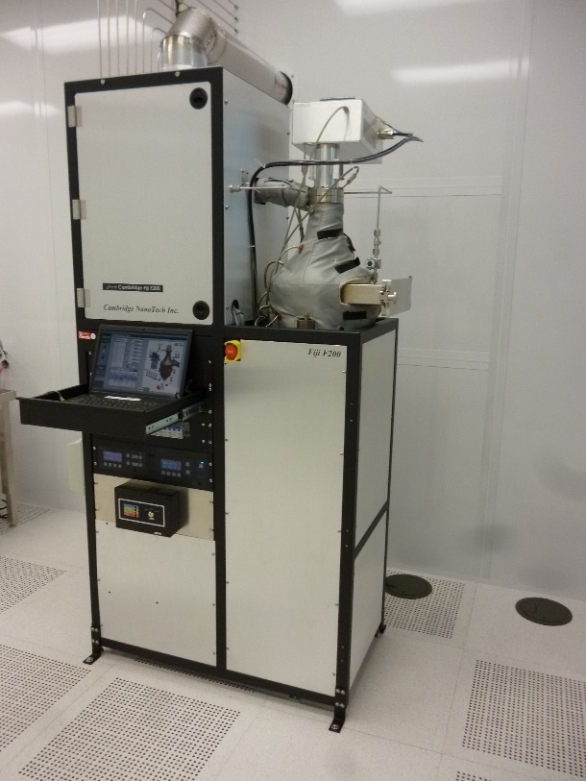

Plasma Source

Reactor Chamber

Load Chamber Door

EMO

Precursor Cabinet

Computer Drawer

Software Interface

* + 1. All actions for the system are managed and controlled through a software application processing on a Windows-based laptop computer. (See Figure 2, ALD Control Screen.)
    2. The application supports 4 different software tabs: Process, Notes & Items, Advanced, and Debug.
    3. Operation of the system is done through the Process tab. Lab Members should not modify information on any other tab.

Process Tab Description

Figure 2, ALD Control Screen

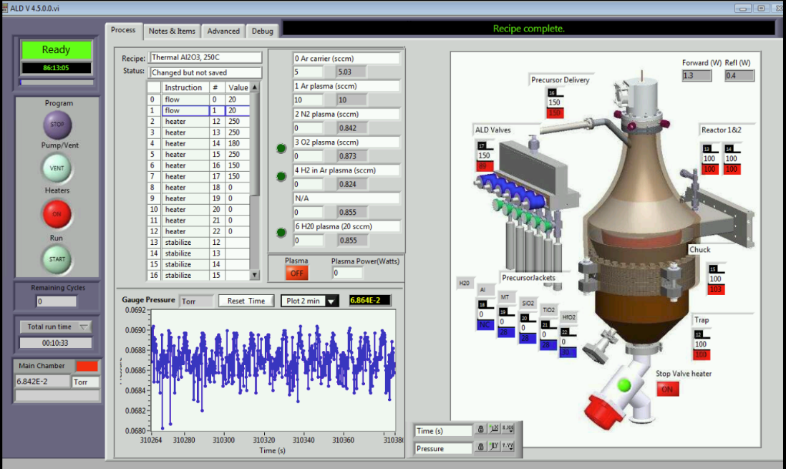

System Messages

Software Tabs

Recipe Section

Heater & Valve Section

Process Status

Pressure Graph

System Controls

Gas Section

System Status



* + - 1. **Gas Section.** This section displays information (valve #, valve status, Gas Name, current flow rate, and setpoint) for each gas. It also includes information for the plasma source.
         1. In standby mode, MFC setpoints and valve status can be changed manually.
      2. **Heater & Valve Section.** This section displays information for all the heaters (setpoint and current temperature) and the stop valve status.
         1. In standby mode, heater setpoints and the stop valve status can be changed manually.
      3. **Pressure Graph.** The graph shows a running history of the reactor/system pressure.
      4. **Process Status.** This section is for display only and shows the number of cycles (goto loops) remaining in the current recipe, the Total run time of the currently loaded recipe, and the current pressure.
      5. **Recipe Section.** This section is used to load, save, and modify a recipe. See 9.2Programming Commands for details of recipe commands.
      6. **System Controls.** This section contains several buttons that are used to activate/deactivate the system hardware and recipes. The button text shows what action will occur if the button is clicked.
         1. **Program button.** If necessary, use this button to Stop program execution.
         2. **Pump/Vent**. Opens and closes the stop valve (gate valve) to either pump the system down or vent it.
         3. **Heaters.** Turns all the heaters on or off. Turning the heaters on will enable each heater to ramp to the defined setpoint. Turning the heaters off will give all heaters a setpoint of 0.
         4. **Run.** Use this button to Start or Abort the currently loaded recipe.
      7. **System Messages.** This field will show messages and information about the current recipe.
      8. **System Status.** This section indicates the current status of the system and the time since the last recipe started or ended.

1. Setup Procedures
2. All samples/substrates must have a thickness less than 6mm.
3. Films thicker than 50 nm (500 Å) require prior approval from Nanofab Staff.

Verify Chamber Vacuum

* + 1. Ensure the chamber is pumped down (under vacuum).
       1. **If the Pump/Vent button in the System Controls section shows “PUMP”**, do the following.
          1. Close the Chamber Load Door.
          2. Click “PUMP”.
       2. **If the Pump/Vent button shows “Vent” and the Main Chamber pressure in the Process Status section is greater than 1E-1 Torr**, do not proceed.
          1. Notify Staff.

Verify Heaters

* + 1. **If the Heaters button is red**, click the button.
       1. The Heaters button must be green.

Purge Chamber

Figure 3, Purge Valve

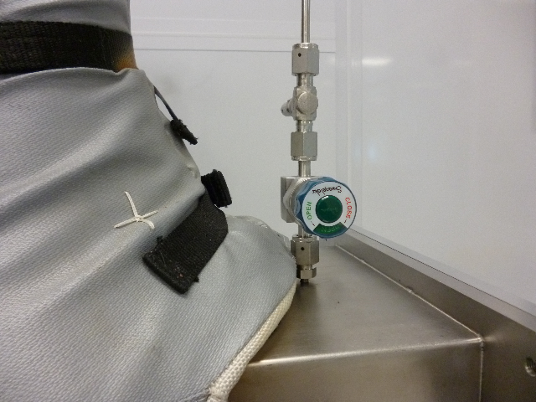

Load Chamber Purge Valve

* + 1. Turn the Load Chamber Purge Valve counter-clockwise to the “Open” position. (See Figure 3, Purge Valve.)
    2. This valve is either open or closed. It does not control the flow rate of the purge gas.

Select Startup Recipe

Figure 4, Recipe Section Detail

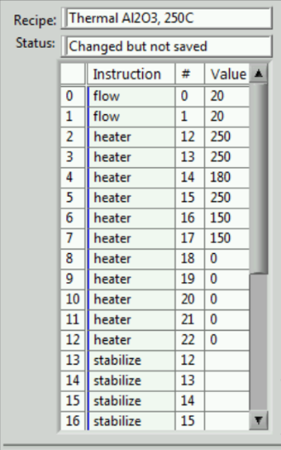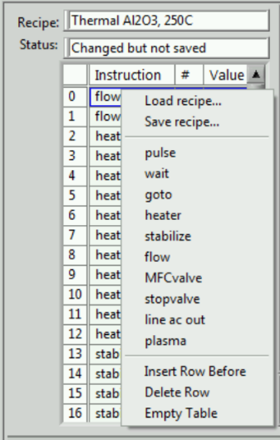

Recipe Table

Right Click

* + 1. Right click in the recipe steps table. (See Figure 4, Recipe Section Detail.)
    2. Click on “Load recipe …” in the drop down menu.
    3. Choose the ALDStartup recipe that matches the desired temperatures. (See Table 1, ALD Recipe and Process Information.)

|  |  |  |  |  |  |  |  |
| --- | --- | --- | --- | --- | --- | --- | --- |
| Table 1, ALD Recipe and Process Information | | | | | | | |
| **Type** | **Recipe Name** | **Film Deposited** | **Chuck Temp (°C)** | **goto line #** | **Precursor** | **Precursor Temp (°C)** | **Dep Rate (Å/cycle)** |
| Standby | ALDStandby, 100C |  | 100 |  |  |  |  |
| Startup | ALDStartup, 150C  ALDStartup, 200C  ALDStartup, 250C  ALDStartup, 270C |  | 150  200  250  270 |  |  |  |  |
| Plasma | Plasma Al2O3, 250C  Plasma HfO2, 200C  Plasma SiO2, 150C  Plasma SiO2, 200C | Al2O3  HfO2  SiO2  SiO2 | 250  200  150  200 | 30  31  30  30 | TMA  TDMAHf  3DMAS  3DMAS | Room  100  Room  Room | 1.023  1.017  0.534  0.440 |
| Thermal | Thermal Al2O3, 250C  Thermal HfO2, 200C | Al2O3  HfO2 | 250  200 | 25  26 | TMA  TDMAHf | Room  100 | 1.087  0.976 |
| Precursor Abbreviations Abbr. Precursor Material  3DMAS Tris(dimethylamino)silane  TDMAHf Tetrakis(dimethylamino)halfnium  TMA Trimethylaluminum | | | | | | | |
| Recipes are found in the read-only directory c:\Cambridge Nanotech\Recipes\Masters | | | | | | | |

Run Startup Recipe

* + 1. Press the Start button in the System Controls section. (See Figure 2, ALD Control Screen.)
    2. At the “Are you sure you want to start a Run?” prompt, click ”Yes”.
    3. Wait for the system temperatures to reach setpoint.
    4. Since the system can take several hours to reach desired temperatures (especially when cooling), a lab member could intervene and use the system after another has initiated their process conditions. To prevent this, a member should reserve and enable the tool while the temperatures are stabilizing. Tool use charges may apply.

1. Film Deposition Procedures

Enable in Coral

* + 1. Log in to Coral and Enable the tool.

Verify Temperatures

* + 1. From the Heater & Valve Section, ensure temperatures are stable at the desired setpoints.
       1. **If they are not**, continue to wait.
       2. **If the setpoints are not correct**, repeat the procedures in section 7 Setup Procedures.

Vent Chamber

* + 1. **If the Pump/Vent button in the System Controls section reads “VENT”**, click the button.
    2. The button text will now change to “PUMP”.
    3. Wait until the chamber pressure is greater than 5.50E+2 Torr.

Remove Substrate Platen

* + 1. Open the door of the Load Chamber.
    2. Insert the loading wand into the Load Chamber.
    3. Slide the curved tips of the loading wand under the clips on the substrate platen.
    4. Using the wand, slightly lift the substrate platen from the chuck.
    5. Slide the substrate platen out of the process chamber.
       1. Be careful not to rub against the walls of the load chamber or the chuck.
    6. Place the substrate platen on a quartz plate.
    7. Do NOT place the platen on any other surface.

|  |  |  |
| --- | --- | --- |
| ✪ ✪ ✪ ✪ ✪ | **CAUTION** | ✪ ✪ ✪ ✪ ✪ |
|  | **The substrate platen may be very hot.**  **Do NOT touch the platen or place it on any surface other than quartz.** |  |
| ✪ ✪ ✪ ✪ ✪ | **CAUTION** | ✪ ✪ ✪ ✪ ✪ |

Load Sample(s)

* + 1. Place the wafer or sample in the center of the substrate platen.

Load Monitor

* + 1. Place a monitor on the substrate platen, near the wafer or substrate.
    2. The monitor must be bare silicon. It may be a 2” wafer or a piece of a larger wafer.

Load Substrate Platen

* + 1. Open the door of the Load Chamber.
    2. Slide the curved tips of the loading wand under the clips on the substrate platen.
    3. Using the wand, lift the substrate platen.
    4. Slide the substrate platen into the process chamber.
       1. Be careful not to rub against the walls of the load chamber or the chuck.
    5. When fully inserted, lower the substrate platen so that it rests on the chuck.
    6. Lower the loading wand to release the clips.
    7. Carefully slide the loading wand out the of the Load Chamber.
    8. Place the loading wand it its storage location.

Pump Down

* + 1. Close and hold the process chamber door.
    2. Click the Pump/Vent button to pump down the system.
    3. The button text will now change to “VENT”.
    4. Wait until pressure is less than 1E-1 Torr (100mTorr).

Load Recipe

* + 1. Right click in the recipe steps table. (See Figure 4, Recipe Section Detail.)
    2. Click on “Load recipe …” in the drop down menu.
    3. Select the recipe for the desired deposition. (See Figure 2, ALD Control Screen.)
    4. Click OK.

Adjust Recipe

* 1. Master recipes reside in a write-protected directory. They can be modified, but cannot be saved to the master directory. However, recipes can be saved to user-defined subdirectories.
     1. Modify the value of the goto instruction listed in Table 1, ALD Recipe and Process Information to the necessary number of loops for the target thickness. (See Figure 5, Modify Loops.)

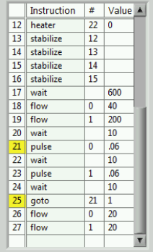

Figure 5, Modify Loops

Modify # of Loops

* + 1. By default, all recipes will not repeat the loop. Failure to change this value will result in a single cycle for deposition.
    2. **If desired,** modify the heater setpoints at the end of the recipe.
    3. All deposition recipes are written to return to the standby temperatures at the end of the deposition. There may be occasions when other temperatures are wanted (i.e., back-to-back runs).

Run the Process

* + 1. Press the Start button in the System Controls section. (See Figure 2, ALD Control Screen.)
    2. At the “Are you sure you want to start a Run?” prompt, click ”Yes”.
    3. During the 600 second wait instruction, note the system pressure.
    4. This is the base pressure to be recorded later in Coral.
    5. Monitor the first several pulse commands.
       1. Ensure there is a rise in pressure from each pulse command. (See Figure 6, Deposition Pulses.)

Figure 6, Deposition Pulses



Pulses

* + 1. **If running a plasma recipe**, ensure the plasma ignites.
    2. Wait for the end of the recipe.
    3. There will be a “Recipe complete.” message in the System Messages section.

Vent Chamber

* + 1. Follow the procedure in paragraph 8.3 Vent Chamber.

Remove Substrate Platen

* + 1. Follow the procedure in paragraph 8.4 Remove Substrate Platen.

Remove Wafer/Sample

* + 1. Wait a minimum of 5 minutes for the platen and sample to cool.
    2. Remove the wafer/sample from the platen.
    3. Remove the monitor from the platen.

Load Substrate Platen

* + 1. Follow the procedure in paragraph 8.7 Load Substrate Platen.

Place ALD in Standby

* + 1. Close and hold the process chamber door.
    2. Click the Pump/Vent button to pump down the system.
    3. The button text will now change to “VENT”.
    4. Wait until pressure is less than 1E-1 Torr (100mTorr).
    5. Right click in the recipe steps table. (See Figure 4, Recipe Section Detail.)
    6. Click on “Load recipe …” in the drop down menu.
    7. Select the ALDStandby, 100C recipe.
    8. Click OK.
    9. Press START to run the program.
    10. Click OK in the recipe start confirmation window.
    11. Turn the Load Chamber Purge Valve clockwise to the “Closed” position. (See Figure 3, Purge Valve.)

Measure Monitor

* + 1. Using the Nanospec, n&k, or Woollam Ellipsometer, measure the thickness on the monitor wafer.

Disable in Coral

* + 1. Log in to Coral and Disable the tool.
    2. Enter all requested information.

1. Process Notes

Definitions and Process Terminology

* + 1. Plasma. The Inductively-Coupled Plasma (ICP) coil produces a very high density power output that can be used to enhance film deposition.
    2. Heaters. The system includes several heating elements to maintain a stable temperature of various components.
    3. Gas Delivery. Mass Flow Controllers (MFC’s) are used to control the rate process gases flow into the reactor chamber.
    4. Precursor. A chemical compound that includes the element intended for the deposition cycle. Precursors are generally highly reactive and must be treated with extreme care.
    5. Plasma Deposition. A deposition technique that uses an inert gas with a plasma energy source in addition to the precursor. The chuck may be kept at room temperature, but is frequently controlled to higher temperatures.
    6. Thermal Deposition. A deposition technique that does not use a plasma energy source. This technique normally uses pulses of water in addition to the precursor and temperature of the chuck to control the deposition rate.
    7. Exposure Mode. Pulsing precursors with the stopvalve closed temporarily between pulses. This technique is normally used for precursors with a low vapor pressure.

Programming Commands

* + 1. Table 2, Recipe Instructions describes the programming commands available for a recipe with their parameters and primary function.

|  |  |  |  |
| --- | --- | --- | --- |
| Table 2, Recipe Instructions | | | |
| **Instruction** | **#** | **Value** | **Description** |
| flow | 0 – 5 | 0 – 200 | Sets the setpoint of MFC “**#**” to “**value**” in sccm.  The associated MFCValve must be open to ensure flow. |
| goto | 0 – recipe max | ≥ 1 | Sends the recipe to line number “**#**” for “value” loops.  Please note a Value of 0 or less will result in an infinite loop.  Goto loops can be nested. |
| heater | 12 – 22 | 0 – max | Sets the setpoint of heater “**#**” to “**value**”.  # Heater Max  12 Trap 250  13 Reactor 1 300  14 Reactor 2 180  15 Chuck 300  16 Precursor Delivery 150  17 ALD Valves 150  18-22 Precursors 150, but varies by precursor |
| line ac out | n/a | 0, 1 | Turns “#” ac plug on (1) or off (0). These plugs can be used for accessory equipment. Currently, none are used in this system. |
| MFCValve | 1 – 5 | 0, 1 | Opens (1) or closes (0) the downstream pneumatic valve for the specific gas (enables actual gas flow through the “flow” instruction). |
| plasma |  | 0 – 300 | Sets the setpoint of the ICP coil to “**value**” watts.  When a recipe uses the plasma, there MUST be a “plasma 0” instruction to turn the plasma off. |
| pulse | 0 – 5 | 0.01 – 10 | Opens (pulses) the selected precursor ALD valve, “**#**”, for “**value**” seconds. |
| stabilize | 12 – 22 |  | Waits until heater “**#**” is ±2°C of setpoint. |
| stopvalve |  | 0, 1 | Opens (1) or closes (0) the stop valve (gate valve). Close the stopvalve to use Exposure mode for materials with very low vapor pressure.  A “stopvalve 1” instruction MUST be included to end the Exposure mode step and prevent excess CVD deposition in the chamber. |
| wait |  | ≥ 0 | Waits/pauses for “**value**” seconds before moving to the next instruction in the recipe. |

1. Revision History

|  |  |  |  |
| --- | --- | --- | --- |
| Rev | Date | Originator | Description of Changes |
|  |  |  |  |
|  |  |  |  |
| 3 | 05 Jun 2019 | T. Olsen | Update document format. |
| 2 | 02 Apr 2018 | T. Olsen | Major rewrite. |
| 1 | 04 Aug 2010 | Sam Bell | Original Release. |