EV 420 Aligner SOP
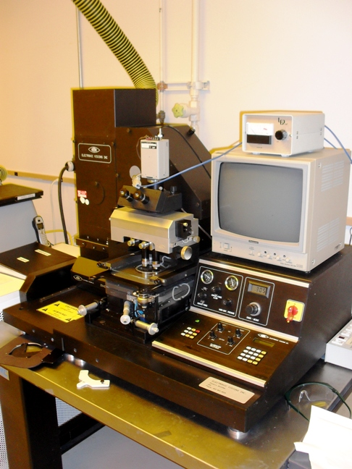
- Scope
  - This document provides procedures for operating and maintaining the EV 420 front and backside aligner.
- Table of Contents
1. Scope 1
2. Table of Contents 1
3. Reference Documents 2
3.1 Referenced within this Document 2
3.2 External Documents 2
4. Equipment and/or Materials 2
5. Safety 2
6. Setup Procedures 3
6.1 Turn on UV Lamp 3
6.2 Replace Mask Holder 3
6.3 Turn on Aligner 4
7. Front Side Alignment Procedures 4
7.1 Load Mask 4
7.2 Align Mask 4
7.3 Load and Align Sample 5
7.4 Enter Exposure Time 5
7.5 Contact Mask and Sample 5
7.6 Expose and Remove Sample 6
7.7 Remove Mask and Shutdown 6
8. Back Side Alignment 6
8.1 Align Mask and Sample 6
9. Process Notes 7
9.1 Exposing Thick SU-8 7
9.2 Adjust Pressures 7
10. Revision History 7

Figure 1, UV Lamp Power Supply 3
Figure 2, Control Panel 4
Figure 3, Microscope Light Power Supply 5

- Reference Documents
Referenced within this Document
    - None
External Documents
    - None
- Equipment and/or Materials
  - EV 420 Aligner
  - Mask
  - Wafer/Sample
- Safety
  - Follow all Nanofab safety procedures.
- Setup Procedures
Turn on UV Lamp
    - Make sure EV 420 power is off.
    - Turn on the white power switch on the UV lamp power supply located to the left of the aligner. See Figure 1.
    - Press ‘start’ on the UV lamp power supply. See Figure 1.
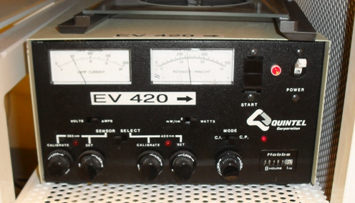
Power Switch
Start Button
Figure 1, UV Lamp Power Supply
Replace Mask Holder
    - Mask holders are available for both 4” and 5” masks. If the correct mask holder is not on the system do the following:
    - Remove the microscope objectives
      - Unscrew each objective
      - Put one hand underneath the objective as you unscrew them to catch them when they fall
      - Place the objectives in a safe place where they won’t fall and get damaged.
    - Remove the mask holder
      - Unscrew thumbscrews on each side of the mask holder and slide the sliders away
      - Lift up gently and slide mask holder towards front of the aligner
      - Put mask holder in the top drawer of the white spinner bench.
    - Install the new mask holder
      - Gently slide the mask holder in, with the rim facing the back of the aligner.
      - Slide in the sliders
      - Screw in the thumbscrews
    - Reinstall the microscope objectives.
Turn on Aligner
    - Press the green Power On button. See Figure 2.
    - Wait for the system to initialize.
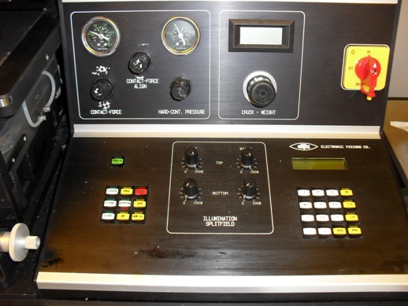
Figure 2, Control Panel
Power On Button
- Front Side Alignment Procedures
Load Mask
    - Move out the tray when prompted.
    - Load the mask frame with the three plastic pins facing up.
    - Place the mask face down between the three pins.
    - Move the tray in.
    - Wait for the mask to level.
Align Mask
    - Turn on the microscope light power supply. See Figure 3.
    - Adjust the voltage until it reads 7.0 V. See Figure 3.
    - View the mask through the optics.
    - Rotate the mask and/or the objectives until two similar features appear on both halves and are lined up horizontally.
    - Make sure that the mask is entirely underneath the white vacuum grooves.
    - Press Enter when the mask is aligned.
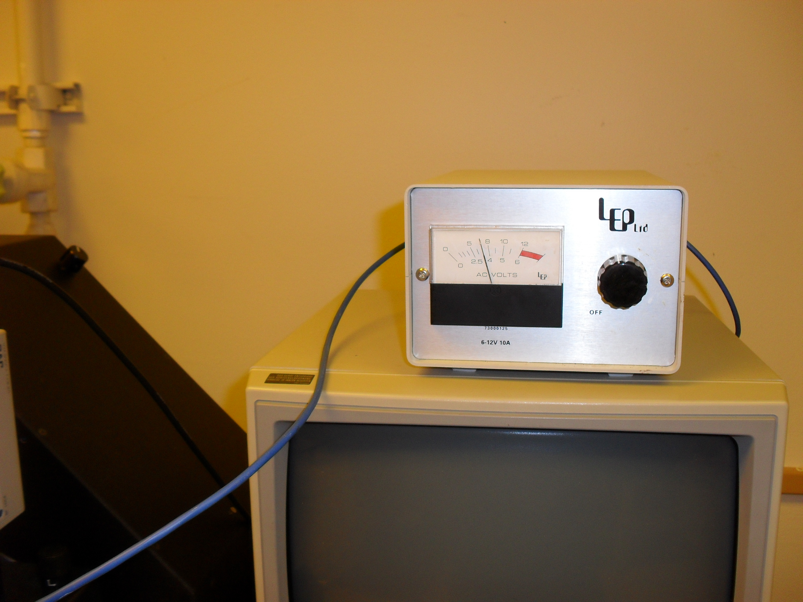
Power/Voltage Knob
Figure 3, Microscope Light Power Supply
Load and Align Sample
    - Unload the mask frame and press ‘Enter’.
    - Load your sample and press the ‘V-Chuck’ button.
    - Press ‘Enter” when it says ‘remove ruler’ on the LCD.
    - Move the tray in when prompted.
    - Wait for the system to level. The LCD will read ‘align wafer’ when it is done leveling.
    - Align the wafer to the mask using the micrometers to rotate the substrate or move it back and forth.
Enter Exposure Time
    - Press ‘Menu’.
    - Press the right arrow once (numeric keypad 6) to select ‘Proc’ on the display.
    - Press ‘Enter’.
    - Press ‘Enter’.
    - Press ‘Enter’.
    - Press ‘Enter’.
    - Press ‘Enter’.
    - Enter the desired exposure time.
    - Press ‘Enter’.
    - Press ‘Enter’.
    - Press ‘Menu’.
Contact Mask and Sample
    - When the substrate and mask are aligned, press the ‘separation’ button.
    - Press the ‘H-Cont’ button and wait until it says ‘Adjust Chamber Vaccum’.
    - Make sure the hard-cont pressure gauge reads a max of 1 bar, then press ‘Enter’.
Expose and Remove Sample
    - Press the ‘EXP’ button when it is selected.
    - Wait for the prompt, then move tray out and remove sample.
    - Load another sample if desired (see 7.1).
Remove Mask and Shutdown
    - Press the red “RESET” key.
    - Press ‘Enter’ when the LCD reads ‘unload mask’.
    - Move tray in when prompted.
    - Move tray out when prompted.
    - Remove your mask.
- Back Side Alignment
Align Mask and Sample
    - Move tray out when prompted.
    - Place the mask face down but DO NOT use the mask frame with the three pins.
    - Move tray in when prompted.
    - Wait for the mask to level (LCD will read ‘align mask’).
    - Turn up the backside (bottom) illumination on the control panel.
    - Press the TB button.
    - On the TV monitor turn brightness down all the way and turn contrast up all the way.
    - Turn off the top illumination and the room lights.
    - Press LR to toggle between moving the microscope objectives.
    - Press the up and down arrows to focus the left and right objectives.
    - Align the crosses on the mask to the crosses on the TV screen by rotating and moving the mask left and right with the micrometers.
    - Press ‘enter’ and the mask vacuum will turn on.
    - Load the wafer (see 7.1).
    - Do not touch the bottom focus or move the bottom lenses. Move only the sample when it tells you to align the sample.
    - Align the crosses on the backside of the sample to the crosses on the TV screen.
    - Press the ‘Enter’ button when the sample is aligned.
    - Set the exposure time (see 7.4).
    - Expose and remove the sample (see 7.6).
    - Shut down the system (see 7.7).
- Process Notes
Exposing Thick SU-8
    - Use a filter over top of mask
    - Break up exposure into small time increments (~30 sec. intervals) so SU-8 does not over heat and cure before development.
      - Menu>Proc>Expo>Exp>Preset>Edit>1
      - Enter total exposure time in seconds
      - Int- enter # of breaks
      - Enter break time (lamp off time)
      - Proximity off
      - Enter separation gap (typically 80 um)
      - Select>1>Menu
Adjust Pressures
    - Contact Force-Align: 1.1
      - This is what the left gage usually reads, except during WEC.
    - Chuck Weight: should be between 0.26-0.29 (bellows under WEC unit)
    - To calibrate WEC Chuck Weight:
      - Menu>Proc>Exp>WEC>Cal
      - Load substrate, V-Chuck, Move tray in
      - Adjust chuck weight to read 0.241
      - Controls separation distance between mask and wafer during soft contact and alignment.
    - Contact Force: 0.5 bar (WEC force)
      - Adjust the contact force during WEC. This pressure is only displayed during WEC.
      - The higher the number the lower the contact force.
    - Hard Contact Pressure: adjust any time (Max 1 bar)
- Revision History
Rev | Date | Originator | Description of Changes
1 | 12 Jan 2010 | Sam Bell

