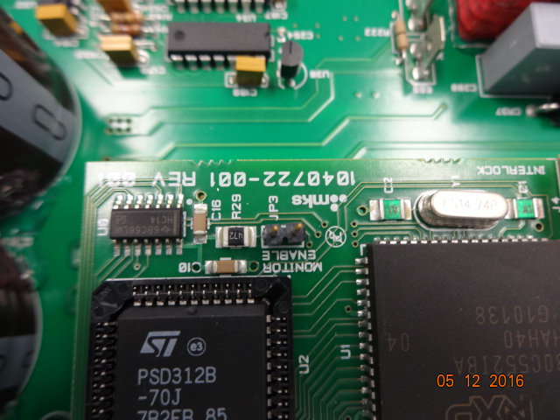

Monitor Enable jumper open, factory configuration
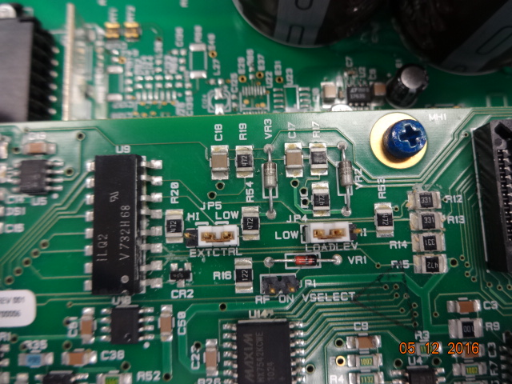

EXTCTRL jumper, was Hi for +24VDC RF enable, now LOW for 5VDC Oxford 100 direct control 05/12/2016

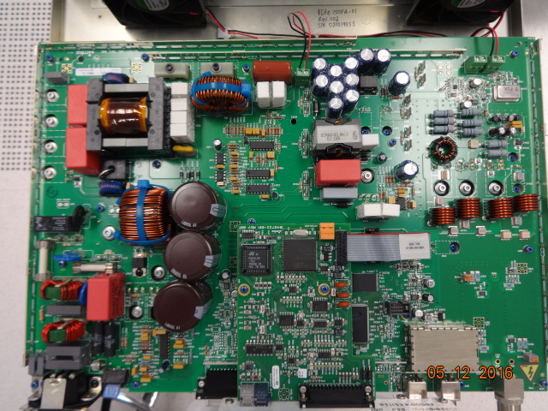
Main board
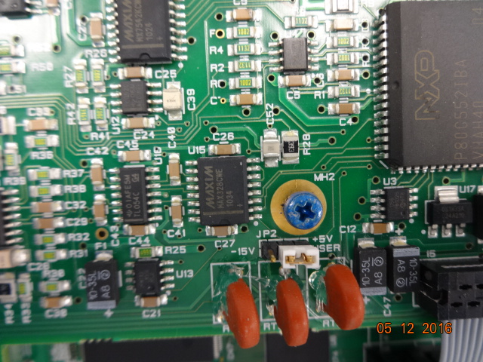

JP2 factory configuration, function ?

