LaserStar Laser Welder SOP
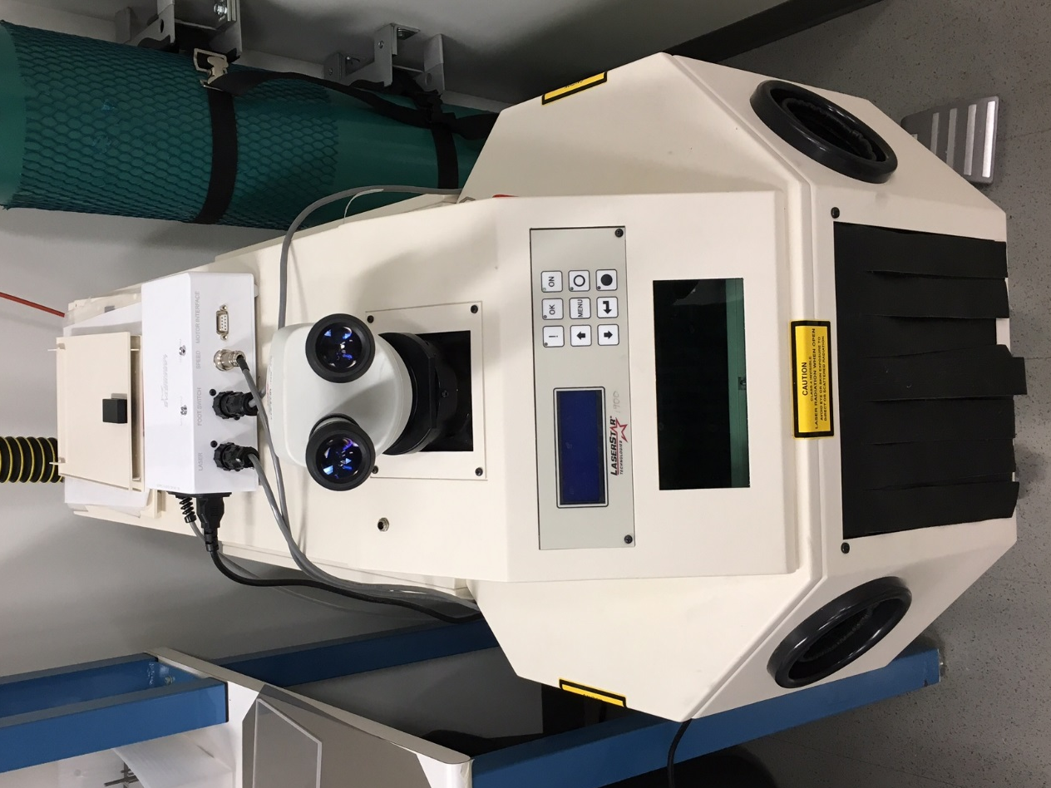
- Scope
  - This document provides the procedure for operating the LaserStar Laser Welder.
- Table of Contents
1. Scope 1
2. Table of Contents 1
3. Reference Documents 2
3.1 Referenced within this Document 2
3.2 External Documents 2
4. Equipment and/or Materials 2
5. Safety 2
6. Setup Procedures 2
6.1 Turning on the Machine 2
6.2 Adjust the Binocular Stereo Microscope 3
6.3 Setting Operating Parameters 4
6.4 Turning on the Gas and Foot Pedal Controller 4
7. Welding 5
7.1 Preparing to Weld 5
7.2 Welding 5
7.3 Switching the Equipment Off 5
8. Process Notes 6
8.1 Typical Film Characteristics Error! Bookmark not defined.
8.2 Process Summary Error! Bookmark not defined.
9. Revision History 7

Figure 1, Main and Key Switches 3
Figure 2, Control Panel and Keypad 3
Figure 3, Argon Gas Bottle 4
Figure 4, Foot Pedal Controller 5

- Reference Documents
Referenced within this Document
    - None
External Documents
    - None
- Equipment and/or Materials
  - Laser welder
  - Argon
  - Sample
- Safety
  - Follow all Nanofab safety procedures.
  - Radiation produced by laser light is capable of melting, burning or vaporizing almost any material. Refer to Section II Safety of the Operation and Service Manual for the proper safety guidelines prior to using this equipment.
- Setup Procedures
Turning on the Machine
    - Reserve and enable the equipment in CORAL. (Packaging – Laser Welding)
      - Obtain the interlock connector from staff in the office.
    - Check that the Main Switch and Key Switch are in the OFF positions. See Figure 1.
    - Turn Main Switch ON.
      - For optimal performance, wait approximately 5 minutes before turning on Key Switch.
    - Turn Key Switch ON.
      - The green system ON indicator should light up on the keypad and the tool will carry out a series of tests. If a failure occurs, an error message will display on the control panel.
    - Once the self-test has completed, the green OK indicator should turn on.
Main Switch
Key Switch
Figure 1, Main and Key Switches
    - Press the Shutter Open button. See Figure 2.
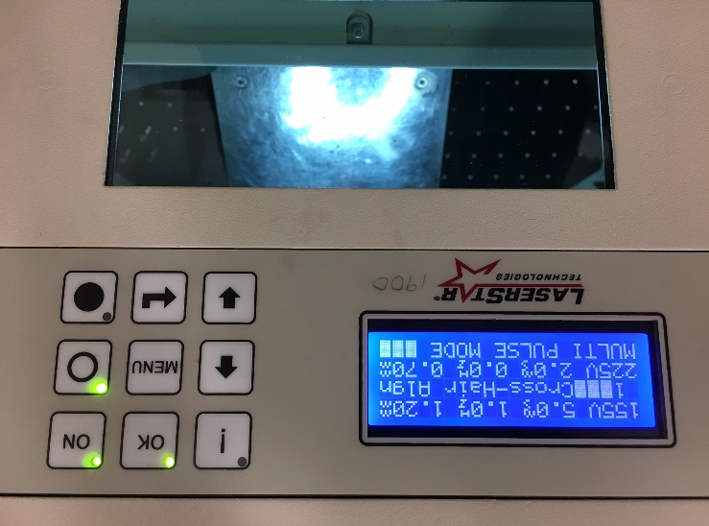
Shutter Open
Figure 2, Control Panel and Keypad
Adjust the Binocular Stereo Microscope
    - After the equipment is turned on and the tests are completed without fault, place a sample on the stage in the welding area.
    - Ensure eyepieces are pushed onto the eyepiece as far as they can go.
    - Adjust the stage height so that the sample is in focus when seen only through the left eyepiece.
    - Look through the right eyepiece and turn the adjustment ring so that the cross hair appears focused on the sample.
Setting Operating Parameters
    - On the keypad, use the enter key to select the operating parameters and the arrow keys to change the parameter values.
      - Press the enter key and the selected parameter value flashes.
      - Press the enter key several times to step through the different parameters.
        - The parameters consist of Voltage, Pulse Time, Pulse Frequency and Pulse Width.
    - You will have to experiment with different settings as different materials will require different settings to properly weld together.
      - The settings may be saved, but note that when the equipment is shut off completely, the stored settings are deleted and the tool defaults back to the original settings.
Turning on the Gas and Foot Pedal Controller
    - Open the Argon gas bottle by turning the valve about 1 full turn. The pressure gauges should both increase shortly after opening the valve. See Figure 3.
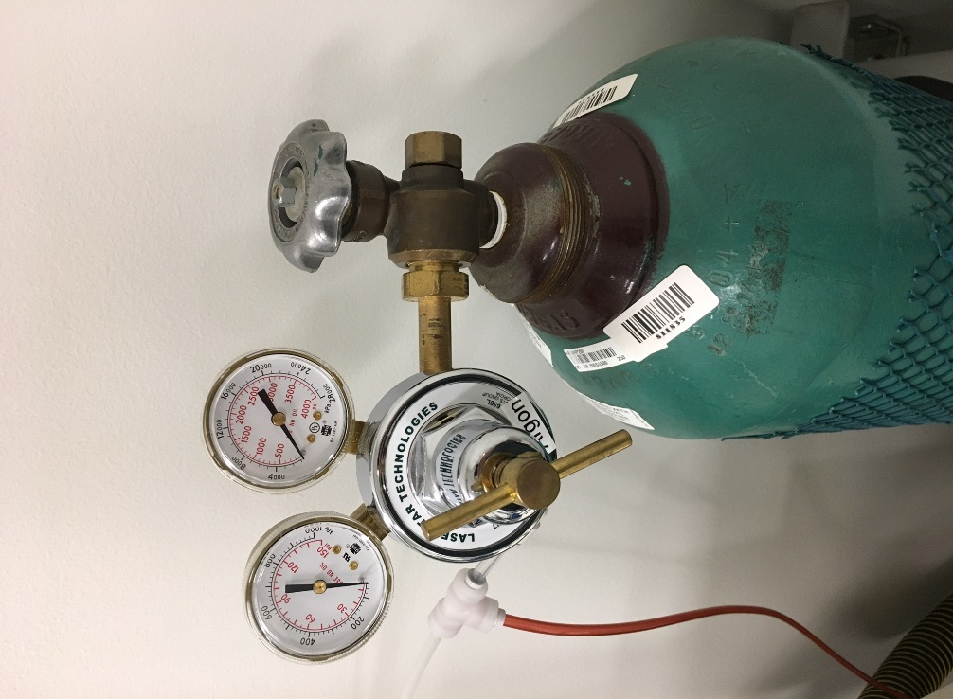
Open/Close Valve
Figure 3, Argon Gas Bottle
    - Flip the switch on the foot pedal controller to on. See Figure 4.
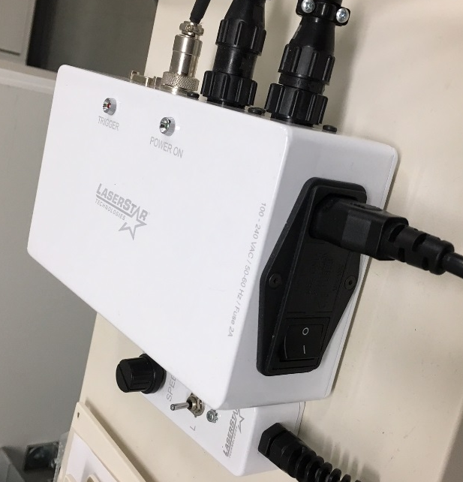
Figure 4, Foot Pedal Controller
- Welding
Preparing to Weld
    - Place the work piece that you intend to weld on the stage in the welding chamber.
    - Put both hands through the openings in the welding chamber so that you can hold and align the materials you intend to weld.
    - CAUTION: Do not position your hands under the cross hair. The laser welds in the position of the cross hair and your hands will be burned if the laser is activated.
    - Adjust the stage up or down again to make sure the cross hair is focused on the materials you intend to weld.
Welding
    - Looking through the eyepieces, join the materials you intend to weld together so the exact spot you want to weld is positioned directly under the cross hair.
    - Press the pedal down lightly until you hear one click. This will enable the gas flow.
    - Let gas fill the chamber for one or two seconds and then press the pedal down all the way. This will enable the laser and start the welding.
    - When welding occurs, the view shutter in the eyepiece will shortly black out to protect your eyes from the laser.
    - In Multi-Pulse Mode, the laser will continually fire with the frequency set in the parameters for the duration of time that the foot pedal is being pressed.
      - For example, if the frequency is set to 1Hz, the laser will fire once every second.
Switching the Equipment Off
    - Turn the Key Switch to the OFF position.
    - Turn the Main Switch to the OFF position.
    - Close the Argon gas valve. Note that the pressure gauges won’t decrease immediately after closing the valve.
    - Turn off the foot pedal controller unit.
    - Remove the interlock connector and return to staff.
    - Disable the tool in CORAL.
- Process Notes
Material Selection
    - The figure below summarizes the weldability of some common materials used.
      - The figure was taken from a technical article, Laser Welding Fundamentals, published by Amada. A link to the article can be found here: http://www.amadamiyachi.com/educationalresources/articles
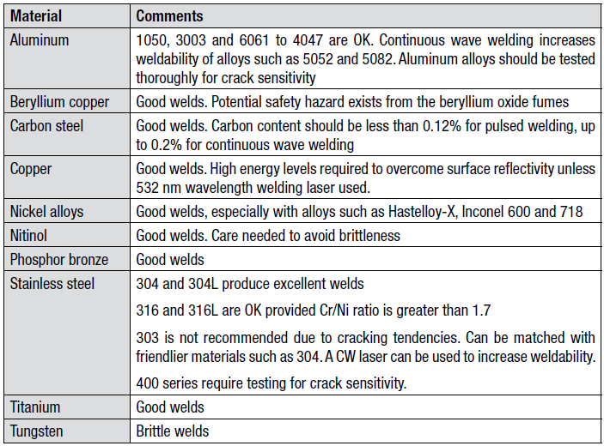
Figure 5, Weldability of Common Materials
Welding Dissimilar Metals
    - The figure below provides general guidelines for welding dissimilar metals.
      - The figure was taken from the same technical article as the figure above, Laser Welding Fundamentals, published by Amada. A link to the article can be found here: http://www.amadamiyachi.com/educationalresources/articles
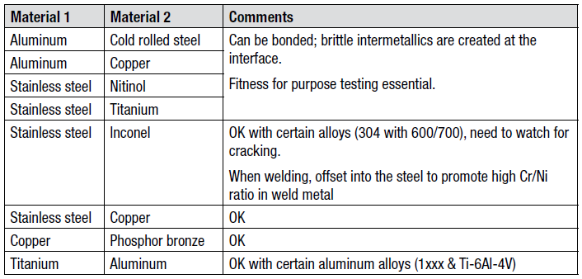
Figure 6, Welding Dissimilar Metals
- Revision History
Rev | Date | Originator | Description of Changes
1 | 05 Dec 2017 | Chris Adams | Initial writing.

