Oxford ICP 2-step DRIE SOP
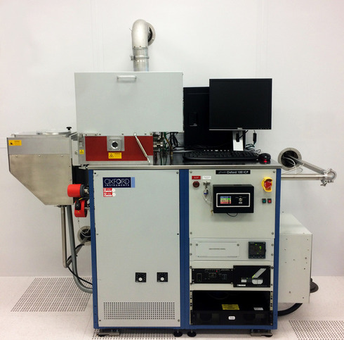
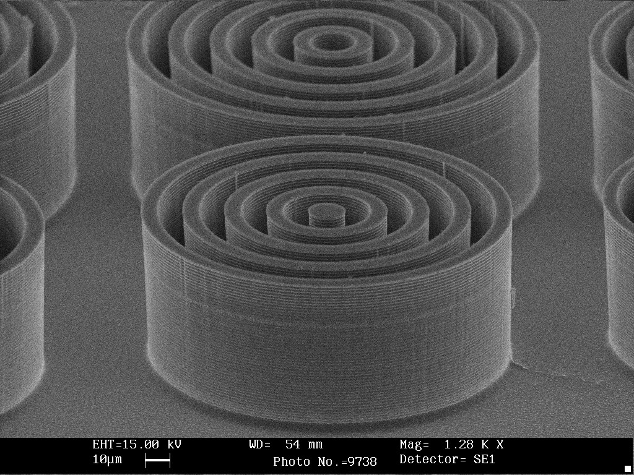
- Scope
  - This document provides operating procedures for the Oxford 100 ICP 2-step DRIE.
- Table of Contents
1. Scope 2
2. Table of Contents 2
3. Reference Documents 2
3.1 Referenced within this Document 2
3.2 External Documents 2
4. Equipment and/or Materials 3
5. Safety 3
6. Setup Procedures 3
6.1 Reserve and Enable tool in Coral 3
6.3 Vent Load Lock 5
6
6.4 Load Wafer 6
7. Run Recipe 6
7.1 Load and Edit Recipe 6
7.2 Start Etch Process 8
8. Shutdown Procedures 9
8.1 Vent Load Lock 9
8.2 Shutdown System 9
9. Revision History 11

Figure 1, Liquid Nitrogen Tank 3
Figure 2, Chiller 3
Figure 3, Pump Control Page 4
Figure 4, Load Lock 4
Figure 5, Temperature Controller 5
Figure 6, Recipe Editor Page 7
Figure 7, Process Control Page 9
Figure 8, Etch Rate for 10 um Trenches 11
Figure 9, Etch Rate for 2 um Trenches 12
Figure 10, Etch Rate for 4 um Pillars 12
Figure 11, 2-step Etching SEM Analysis 13

Table 1, Deep Etch Recipe 6
Table 2, Smooth Etch Recipe 7

- Reference Documents
Referenced within this Document
External Documents
    - None
- Equipment and/or Materials
  - Wafer/Sample
  - Oxford 100
  - Liquid Nitrogen
- Safety
  - Follow all Nanofab safety procedures.
- Setup Procedures
Reserve and Enable tool in Coral
    - Etch-Oxford 100 DRIE (software Login is nanofabuser, pw nanofabuser)
    - Record all processing and characterization information in Coral
  - Set chuck temperature
    - Click on Process icon. See Figure 1, Pump Control Page.
    - Click on “Chamber 1” on the drop-down menu
    - Set the table temperature to -15 (lower left corner of screen) See Figure 1.
    - Press the pink start button, then immediately click stop (right next to it). See Figure 1.
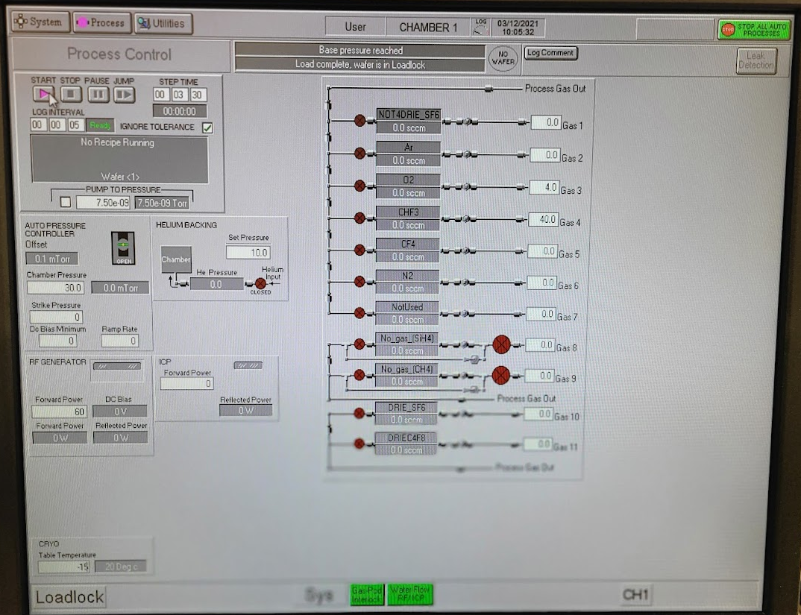
Figure 1. Set Chuck Temperature
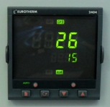
    - Check the set point on the temperature controller to make sure the set point number reads -15 (see Figure 2). The controller won’t function unless you initially set it way below your desired set point, and then change it to the actual set point later.
Set point
Actual Temperature
Figure 2, Temperature Controller

    - Find the unattached tube behind the main chamber. Feel the output to make sure nitrogen is flowing out of it (see Fig 3). This means the chuck is being cooled to the setpoint.
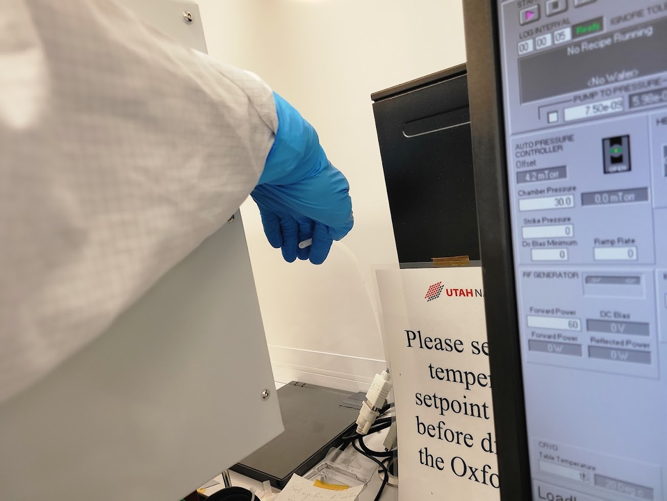
Figure 3. N2 cooling flow tube

    - Now set the table temperature to your desired setpoint (typically 15C for most DRIE Bosch recipes) (lower left corner of screen) See Figure 1.
    - Press the pink start button, then immediately click stop (right next to it). See Figure 1.
    - Find the unattached tube behind the main chamber. Feel the output to make sure nitrogen is still flowing out of it.
Vent Load Lock
    - Click on System icon. See Figure 4 Pump Control Page.
    - Click on “pumping” on the drop-down menu
    - Press stop button corresponding to the load lock mechanical pump (on the left side of the screen, do not touch the main chamber buttons on the right side of the screen). See Figure 4.
    - Press stop, then ok, then vent, then ok buttons. See Figure 1.
    - Wait for load lock to vent. The pressure will read above 600 Torr and you will hear hissing initially from the load lock lid.

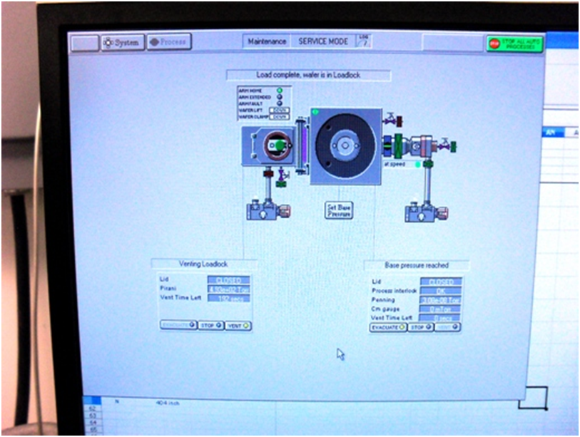
System Button
Process Buttton
Load Lock Controls
Evacuate
Stop
Vent
Main Chamber Controls Do Not Touch
Figure 4, Pump Control Page
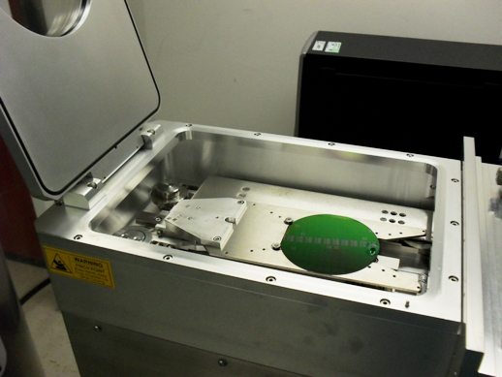
    - Press stop button. See Figure 4.
Figure 5, Load Lock
Load Wafer
    - Open load lock lid (See Fig 5)
    - Place wafer in load lock against the two pins on the transfer arm with the wafer facing the two pins. The wafer should touch the two pins. See Figure 5, Load Lock.
    - Close load lock lid.

- Run Recipe
NOTE: This recipe can be used to etch deep trenches or vias in 100 mm wafers. It is strongly advised that you do a test run on a practice wafer before working with your device wafer.
Load and Edit Recipe
    - Click on Process icon. See Figure 6, Pump Control Page.
    - Click on “Recipes” on the drop-down menu
    - Click on “New” and press ok to clear the current recipe
    - Click on “Load” and select the desired recipe (typically BB Bosch 12:5 15C 80:80 recipe for silicon DRIE), and click ok
    - The recipe steps will be displayed on the left side of the screen.
    - For Si DRIE set the number of etch cycles
      - Right click on “Repeat”
      - Click on “Repeat Step”
      - Enter the desired number of cycles to repeat the etch and deposition step for the Bosch process (typically ~0.67 um/cycle) but this varies greatly depending on the area of exposed silicon (can vary from ~0.4um/cycle to ~1.1 um/cycle).
      - Click OK
    - For other etch processes set the etch time
      - For other etch processes you can change the etch time by right clicking on the etch step and then changing the process time.
      - Do not change the gas flows or powers unless it is your own recipe and you know what you are doing. Click Save when you are done editing to save the recipe.
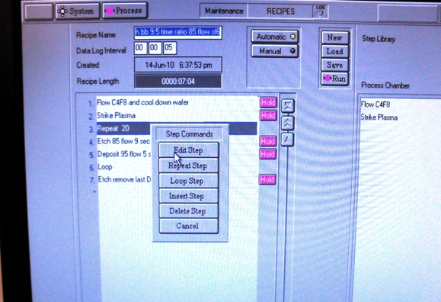
Repeat Step Button
Figure 6, Recipe Editor Page

Figure 6, Recipe Editor Page
Run Button

Run Button
Figure 6, Load, Edit, and Run Recipe Page

    - The Bosch etch recipe is as follows:
Table 1, Deep Etch Recipe
Step | C₄F₈ | SF₆ | Set  Pressure | ICP Power | RF Power | Temp.  (C) | Time
Flow C₄F₈ | 80sccm | 0 | 0mT | 0 | 0 | 15 | 5s
Strike Plasma | 80sccm | 0 | 0mT | 500W | 30W | 15 | 7s
Etch | 0 | 80sccm | 0mT | 500W | 25W | 15 | 12s
Deposit | 80sccm | 0 | 0mT | 500W | 10W | 15 | 5s
Repeat Etch & Deposit Steps
      - In all steps the He backing is 10.0.
Start Etch Process
    - Make sure the chuck is at the correct temperature. If it is too warm the Bosch process won’t work correctly.
    - Click the ‘Run’ button. See Figure 6.
NOTE: The pumpdown and subsequent wafer transfer will begin automatically and the etch process will start when the wafer is loaded. The wafer will automatically transfer to the load lock when the process is complete.
    - Listen closely to the machine during the first steps.
      - If the machine makes a repetitive clicking sound, or the ICP power is greater than 10 or fluctuating wildly, you need to stop and restart the process.
        - Press Stop.
        - Return the wafer to load lock-YES
        - Click the Run button after you see that the wafer is inside the load lock to restart the process.
    - Monitor the parameters during the first few steps of the process.
      - Go to the Process Control page.
      - Monitor the Reflected Power. It should be less than 10. See Figure 7, Process Control Page.
      - Make sure the temperature cooling is working and stable +/- 1 degree C.
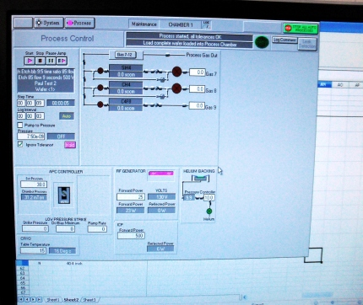
Reflected Power

Figure 7, Process Control PageReflected Power
Figure 7, Process Control Page

- Shutdown Procedures
Vent Load Lock
    - Click OK when the software says “Process completed”.
    - Look inside load lock window to make sure wafer has transferred successfully from main chamber to load lock.
    - Vent load lock.
      - Press stop button corresponding to the load lock mechanical pump. See Figure 4.
      - Click ok when it says “Wafer has finished processing”.
      - Press vent button. See Figure 4.
      - Wait ~1 min. for the load lock to vent.
    - Pull up to open load lock lid. Do not force it open, once it is vented it should open easily.
    - Press stop button to stop venting.
    - Remove wafer.
Shutdown System
    - Set the chuck temperature to 30C. This is important! Otherwise the N2 dewar will run out overnight and you will be billed for a new tank.
      - Click on Process icon. See Figure 1, Pump Control Page.
      - Click on “Chamber 1” on the drop-down menu
      - Set the table temperature to 30 (lower left corner of screen) See Figure 1.
      - Press the pink start button, then immediately click stop (right next to it). See Figure 1.
      - Double check to make sure the bottom temperature setpoint on the controller reads 30.
Figure 8. Temperature controller set to 30C

    - Run the Standby recipe to pump down the empty load lock.
      - Close load lock lid.
      - Load the “Standby” recipe
      - Run the Standby recipe
      - Important: Press ‘cancel’ when software asks for wafer name. Do not click ok or enter a name or the system will get confused and think there is a wafer inside.
      - Enter run data, measurements, and disable tool in Coral.
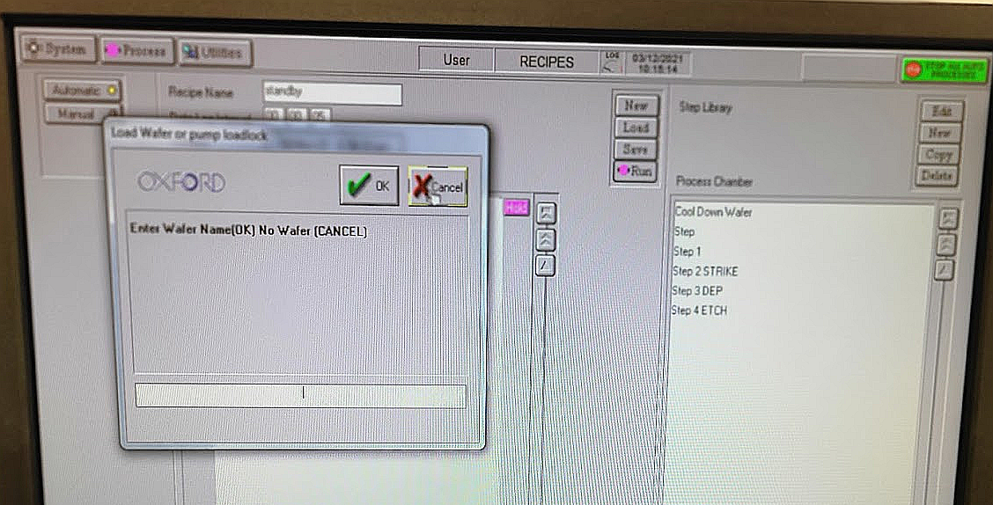
Figure 9. Run standby recipe to shutdown system

- Revision History
Rev | Date | Originator | Description of Changes
1 | 01 Jun 2010 | Sam Bell
2 | 13 Dec 2021 | Brian Baker

