Oxford 80+ PECVD SOP
- Scope
  - This document provides the operating procedure for plasma enhanced chemical vapor deposition with the Oxford 80+.
- Table of Contents
1. Scope 1
2. Table of Contents 1
3. Reference Documents 1
3.1 Referenced within this Document 1
3.2 External Documents 2
4. Equipment and/or Materials 2
5. Safety 2
6. Setup Procedures 2
6.1 Record Information on Log Sheet 2
6.2 Turn on the Burn Box 2
6.3 Check Status of the Machine 2
6.4 Start Chamber Warm Up 3
7. Deposition Procedures 4
7.1 Vent Chamber 4
7.2 Load Sample 4
7.3 Edit Recipe 4
7.4 Select Recipe 5
7.5 Start Deposition Process 5
7.6 Unload Sample 6
7.7 Pump Down Chamber 6
8. Process Notes 7
8.1 Typical Film Characteristics 7
8.2 Process Summary 7
9. Revision History 7

Figure 1, Oxford 80+ PECVD (Chamber A) 2
Figure 2, Oxford 80+ Chamber B (RIE) 3
Figure 3, Oxford Toolbar 4
Figure 4, Recipe Editor 5
Figure 5, Start Button 6

Table 1, Recipe Parameters and Results 7

- Reference Documents
Referenced within this Document
    - Ecosys Burn Box SOP
External Documents
    - None
- Equipment and/or Materials
  - Oxford 80+
  - Wafer/Sample
  - Tweezers
- Safety
  - Follow all Nanofab safety procedures.
  - The stage can be very hot. Do not touch.
- Setup Procedures
Record Information on Log Sheet
    - Record all requested setup and processing information on the log sheet.
Turn on the Burn Box
    - Follow the procedures in the Ecosys Burn Box SOP to turn on the burn box.
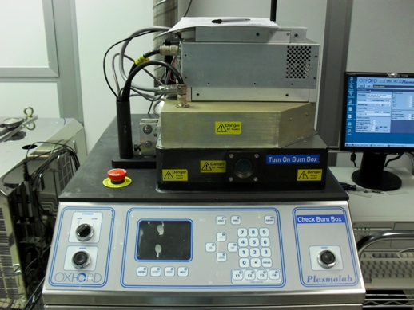
Figure 1, Oxford 80+ PECVD (Chamber A)
Open/Close Switch
Hoist Buttons
Check Status of the Machine
    - If the machine is not turned on, contact lab staff.
    - Ensure Oxford program is running on the PC.
      - If not, double-click the Oxford icon on the desktop.
    - If the switch is in Chamber A mode, skip to 6.4.
    - If the switch is in Chamber B mode. Do 6.3.4.1 - 6.3.4.3.
      - Abort pump down program if it is running.
      - Stop the turbo pump.
        - Open the Chamber B front panel.
        - Press the turbo pump stop button. See Figure 2, Oxford 80+ Chamber B (RIE).
      - Turn the chamber select switch to chamber A. See Figure 2.
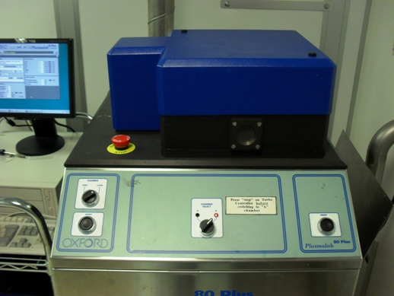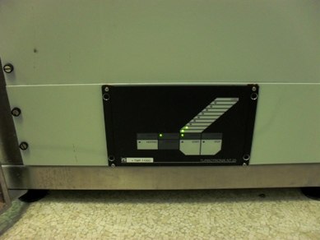
Chamber Select Switch
Turbo Pump Stop Button
Figure 2, Oxford 80+ Chamber B (RIE)
Start Chamber Warm Up
    - Go to the recipe list.
      - Click the Select button. See Figure 3.
    - Select pump300c.rec recipe.
    - Click OK.
    - Press Start. See Figure 5.
    - Wait for the chamber to reach operating temperature. See Figure 5, Status Screen.
NOTE: The status bar will read ‘Adjusting temperature’.
    - When the chamber has reached operating temperature, abort the pump down process.
    - Continue to section 7, Deposition Procedures.
- 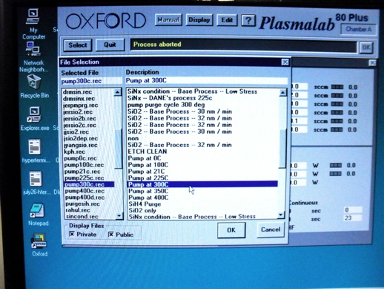Deposition Procedures
Select Button
Display Button
Edit Button
Recipe List
Figure 3, Oxford Toolbar
Vent Chamber
    - Select vent recipe.
      - Click Select. See Figure 3, Oxford Toolbar.
      - Select the vent recipe from the list.
      - Click OK.
    - Press start.
    - When the vent process is complete turn the selector knob to Open. See Figure 1.
    - Press and hold both Hoist buttons simultaneously. See Figure 1.
    - Swing the lid out of the way.
Load Sample
    - Use wafer tweezers to place sample on the stage.
    - Turn the selector knob to Close.
    - Press and hold both Hoist buttons to lower the lid.
    - You may have to use your forehead to align the lid as it closes.
    - Align lid with base.
Edit Recipe
    - Click the Edit button. See Figure 5.
    - Select Process from the drop down menu.
    - Go to File>Open.
    - Select a process recipe from the list.
    - Click on the process step to edit the parameters, as needed. See Figure 4.
    - Click OK.
    - Save the recipe.
      - Go to File>Save.
      - If you are using someone else’s recipe or making a new recipe, go to File>Save As to rename the recipe.
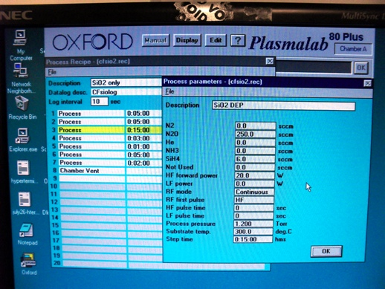
Figure 4, Recipe Editor
Select Recipe
    - Click Display button.
    - Choose Status from the drop down menu.
    - Click Select.
    - Choose your recipe from the list.
    - Click OK.
Start Deposition Process
    - Press Start Button.
NOTE: At the end of most programs the machine will vent and be ready for unloading.
    - Monitor process parameters during deposition. See Figure 5, Status Screen.
    - Wait until status bar says Process complete.
Unload Sample
    - When the vent process is complete turn the selector knob to Open.
    - Press and hold both Hoist buttons.
    - Swing the lid out of the way.
    - Use wafer tweezers to pick up the sample.
    - Turn the selector knob to Close.
    - Press and hold both Hoist buttons to lower the lid.
    - You may have to use your forehead to align the lid as it closes.
    - Align lid with base.
Pump Down Chamber
    - Select pump down recipe.
      - Click Select.
      - Select pump21c.rec.
      - Click OK.
    - Press start.
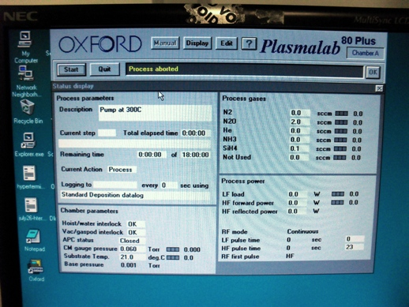
Start Button
Figure 5, Status Screen

- Process Notes
Typical Film Characteristics
Table 1, Recipe Parameters and Results
Recipe | Time | Pressure | Power | Thickness | Flatness
Process Summary
- Revision History
Rev | Date | Originator | Description of Changes
1 | 10 June 2010 | Sam Bell

