Oxford 80+ RIE SOP
- Scope
  - This document provides the operating procedure for the Oxford 80+ reactive ion etch.
- Table of Contents
1. Scope 1
2. Table of Contents 1
3. Reference Documents 1
3.1 Referenced within this Document 1
3.2 External Documents 1
4. Equipment and/or Materials 2
5. Safety 2
6. Setup Procedures 2
6.1 Record Information on Log Sheet 2
6.2 Check Status of the Machine 2
7. RIE Procedures 3
7.1 Vent Chamber 3
7.2 Load Sample 4
7.3 Edit Recipe 4
7.4 Select Recipe 5
7.5 Start Etch Process 5
7.6 Unload Sample 6
7.7 Pump Down Chamber 6
8. Process Notes 6
8.1 Typical Etch Characteristics 6
8.2 Process Summary 6
9. Revision History 6

Figure 1, Oxford 80+ RIE (Chamber B) 2
Figure 2, Turbo Pump Control Panel 3
Figure 3, Oxford Toolbar 3
Figure 4, Recipe Editor 4
Figure 5, Start Button 5

Table 1, Recipe Parameters and Results 6

- Reference Documents
Referenced within this Document
    - None
External Documents
    - None
- Equipment and/or Materials
  - Oxford 80+
  - Wafer/Sample
  - Tweezers
- Safety
  - Follow all Nanofab safety procedures.
- Setup Procedures
Record Information on Log Sheet
    - Record all requested setup and processing information on the log sheet.
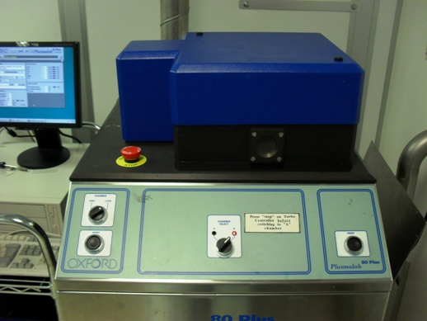
Figure 1, Oxford 80+ RIE (Chamber B)
Chamber Select Switch
Hoist Buttons
Open/Close Switch
Check Status of the Machine
    - If the machine is not turned on, contact lab staff.
    - Ensure Oxford program is running on the PC. See Figure 3. If only the top bar is showing press display then status.
      - If not, double-click the Oxford icon on the desktop.
    - Check to make sure no other process is running. If another process is running contact lab staff.
    - If the switch is in Chamber B mode, skip to section 7 RIE Procedures.
    - If the switch is in Chamber A mode: Do 6.2.4.1 - 6.2.4.3.
      - Ensure that no program is running. Abort program if necessary.
      - Turn the chamber select switch to chamber B. See Figure 1.
      - Check that the light above turbo start button is lit. If it isn’t start the Turbo pump.
        - Open the Chamber B front panel.
Start Button
Figure 2, Turbo Pump Control Panel
        - Press the Turbo pump start button. See Figure 2.
        - Wait 5 minutes for turbo to spin up to full speed
- RIE Procedures
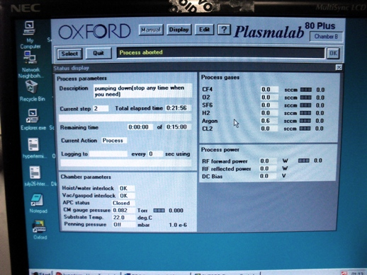
Abort/Select/Start
Display
Edit
Figure 3, Oxford Toolbar
Vent Chamber
    - If machine is in pump down mode, click Abort to stop pump down.
    - Select vent recipe.
      - Click the Select button. See Figure 3.
      - Select the vent.rec recipe from the list.
      - Click OK.
    - Click Start. See Figure 5, Start Button.
NOTE: The start button will not work unless the turbo is spinning at full speed.
    - Wait until Vac/gaspod interlock says fault.
    - DO NOT try to open the chamber lid unless it says fault.
NOTE: The vent procedure takes 5 minutes.
Load Sample
    - When the vent process is complete turn the Chamber knob to Open. See Figure 1.
    - Press and hold both Hoist buttons simultaneously. See Figure 1.
    - Use wafer tweezers to place sample on the stage.
    - Turn the selector knob to Close.
    - Press and hold both Hoist buttons to lower the lid.
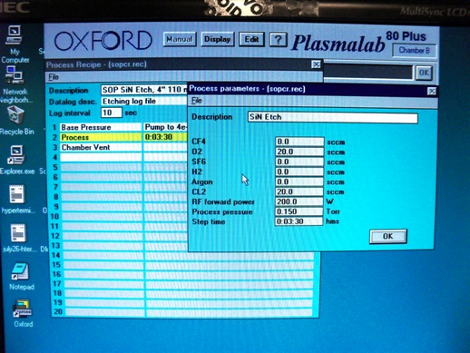
Figure 4, Recipe Editor
Edit Recipe
    - Click Edit. See Figure 3.
    - Choose Process from the drop down menu.
    - Go to File>Open.
    - Select a process recipe from the list.
    - Click on the process step to edit the parameters, as needed. See Figure 4, Recipe Editor.
    - Click OK
    - Save the recipe.
      - Go to File>Save.
      - If you are using someone else’s recipe or making a new recipe, go to File>New, suggested parameters are on sheep in front of binder
Select Recipe
    - Click Display button. See Figure 3, Oxford Toolbar.
    - Choose Status from the drop down menu.
    - Click Select.
    - Choose your recipe from the list.
    - Click OK.
Start Etch Process
    - Press Start Button.
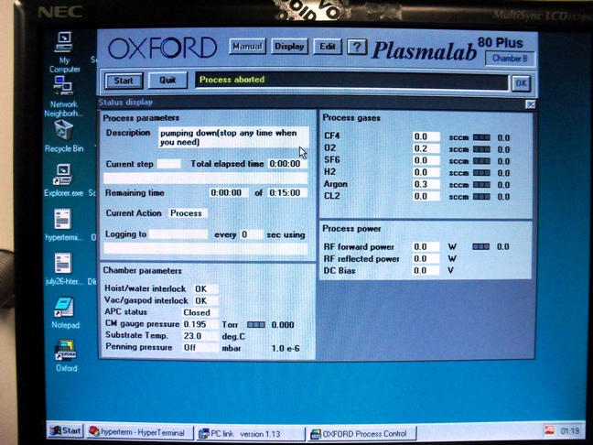
Start Button
Figure 5, Start Button
NOTE: At the end of most programs the machine will vent and be ready for unloading.
    - Observe CM gauge pressure, process gas flows, and RF power to assure etch program runs correctly.
    - Wait until Vac/gaspod interlock says fault and status bar says process complete.
      - If process compete but no “fault” reading, abort and run “vent” recipe.
Unload Sample
    - Turn the selector knob to Open when the vent process is complete.
    - Press and hold both Hoist buttons simultaneously.
    - Use wafer tweezers to pick up the sample.
    - Turn the selector knob to Close.
    - Press and hold both Hoist buttons to lower the lid.
Pump Down Chamber
    - Select pump down recipe.
      - Press Select.
      - Select pump down recipe.
      - Click OK.
    - Press Start.
- Process Notes
Typical Etch Characteristics
Table 1, Recipe Parameters and Results
Recipe | Film Etched | Gas #1 Name | Gas #1 Flow | Gas #2 Name | Gas #2 Flow | Pressure | Power | Etch Rate
Process Summary
- Revision History
Rev | Date | Originator | Description of Changes
1 | 10 June 2010 | Sam Bell
2 | 24 Sep 2010 | Trevor Knowlton

