AW610 Rapid Thermal Process system SOP
- Scope
  - This document contains information on how to operate the AccuThermo AW610.
- Table of Contents
1. Scope 1
2. Table of Contents 1
3. Reference Documents 1
4. Equipment Overview 2
5. Safety 2
6. Creating And Editing A Recipe 2
6.1 How to Create or Edit a Recipe 2
7. Process A Wafer 3
7.1 How To Process a Wafer 3
8. Daily Power-up & Power-down Procedures 3
9. Warnings 4
10. Revision History 4

- Reference Documents
Referenced within this Document
    - AccuThermo AW610 Rapid Thermal Process System Operation Manual.
    - AccuThermo AW610 Rapid Thermal Process System Technical Manual.
External Documents
    - None
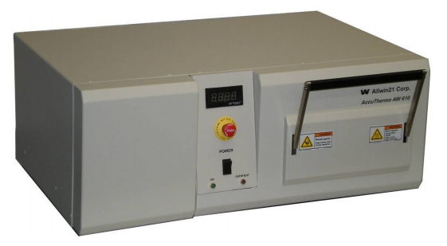

- Equipment Overview
The AccuThermo RTP system is a rapid thermal processing system, which uses high intensity visible radiation to heat single wafers for short process periods of time at precisely controlled temperatures. The process periods are typically 1-600 seconds in duration, you must receive staff approval for a longer duration.
- Safety
  - Follow all Nanofab safety procedures
  - Guidelines for Time-Temperature
    - The system is not capable of doing long anneals over extended periods of time, especially at higher temperatures. The following chart should serve as a broad guideline in determining allowable anneal time for the required temperature (roughly log dependence.) When in doubt, contact the staff before you run a new recipe.

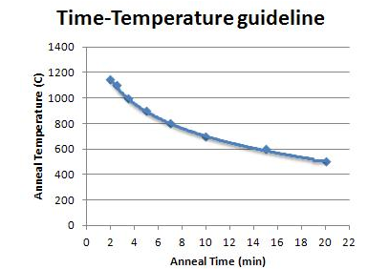

- Process A Wafer
How To Process a Wafer
    - Contact a staff member prior to making a recipe. Staff must create/approve ALL recipes
    - To log in, type a 5 in “User ID.” The username NanoFabUser should display automatically Type the password USR
    - Starting from the main menu, click “Process for Production”
    - On the left side of “DIR ID,” select USER
    - For “lot ID” select your username. If you do not have a username, type what you want your username to be and it will create it automatically
      - This is where all of your files will be saved
    - Select the recipe you plan to run
      - If more than one wafer is being processed, select the amount by clicking “wafer ID”
      - If your wafer is transparent or if you have wafer shards, proceed to section 7.1
    - Ensure the correct temperature measurement sensor is in place
      - Contact staff if the thermocouple needs to be installed or removed
      - Thermocouple is used for processes below 700°C
      - Pyrometer is used for processes between 550°C and 1150°C and the thermocouple must be removed above 700°C
    - Load your wafer by pulling the lever down to the unlock position and then pulling it forward
      - No wafer with photoresist, polymers or any other toxic or high vapor pressure material are allowed in the chamber
    - Once it is opened, you may carefully set your wafer on the quarts tray fingers
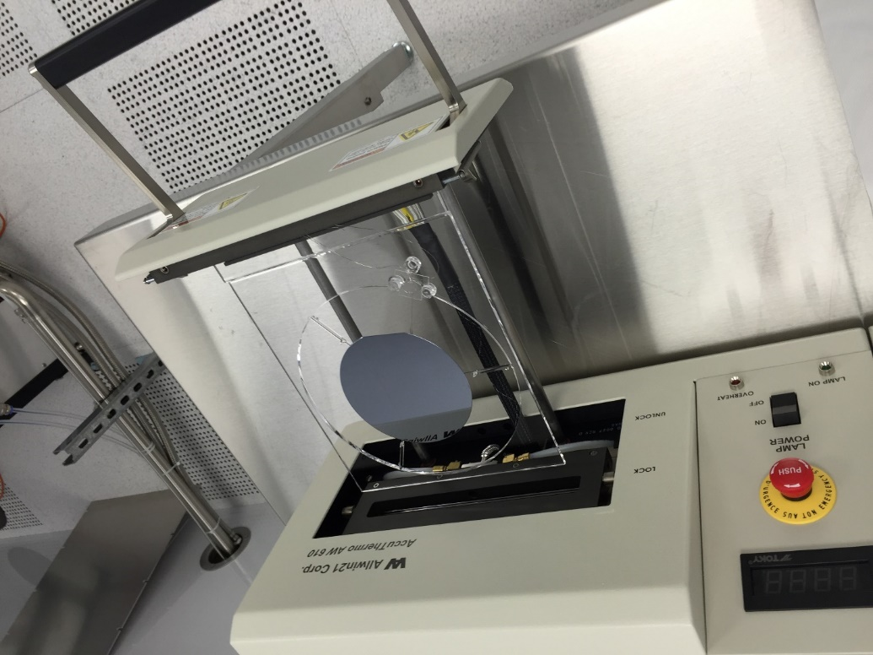

    - If using the thermocouple, insure it is in contact with the bottom of the wafer

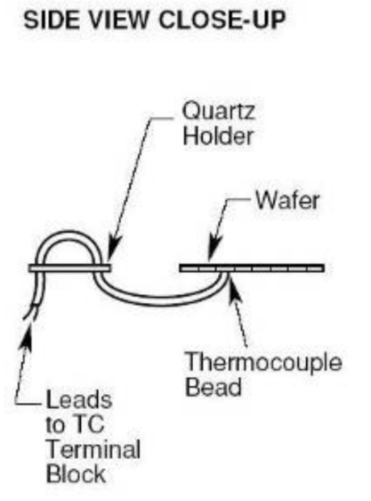
    - Close the chamber. Confirm the lever is in the locked position
    - Turn lamp power on
    - Run the recipe by clicking on the “Start process” button
    - The computer will start the recipe automatically and display a graph on the monitor showing a live feed of data
    - The screen will show “PROCESS OVER” once the final step has ended. You can click “SAVE EXIT” or “STOP NOT SAVE”
      - Watch the LED display on the front of the RTP and wait until shows .050, which represents 50°C
        - This only works when using the thermocouple
      - Or wait 2 minutes minimum after the start of the cooldown and with metal tweezers, remove the wafer and place it onto foil for the final cooldown
        - Wait minimum of 4 minutes when using the susceptor
    - Open the chamber door and take out your sample
    - Close the chamber door and turn off the lamp power

- Susceptor
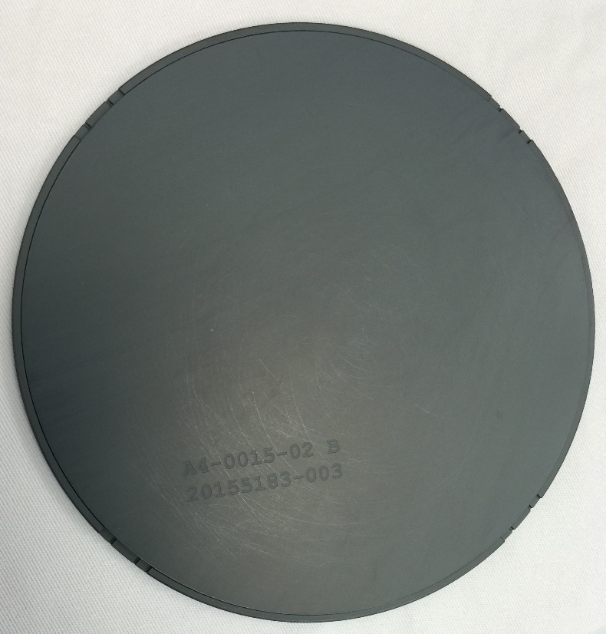
How to use the Susceptor
    - If you are using a glass wafer, some other form of transparent wafer, or a part/shard of a wafer you must load it into the susceptor
      - If you set parts of a wafer on top of a regular wafer, it will move around during the process
    - Carefully open up the susceptor and set your wafer inside
    - Carefully close the susceptor with your wafer inside
    - When loading the susceptor into the chamber, ensure the numbers are facing upwards
    - Resume to step 6.1.6

- Creating And Editing A Recipe
How to Create or Edit a Recipe
    - Contact a staff member prior to making a recipe. Staff must create/approve ALL recipes.
    - Starting from the main menu, click “Recipe” and select a pre-existing recipe
    - Click on the “Recipe Edit” button to display the recipe editor
    - Edit it (If a new recipe is being created, just change the recipe name field before saving it.)
    - If using the pyrometer as the temperature sensor device, then create an intensity step before the first ramp step. Set all the tuning parameters to 1.00 (gain, sensitivity and delay)
    - To avoid cracking the susceptor, the maximum ramp rate is 20°C/second
    - Click on “Recipe Head” to confirm RTP is set on the current calibrations
Current calibration names: Updated name, next cal
PYRONAME 160930_3.WFR or SPT ______________________
CHAMCALI LAMPCAL.WFR or SPT ______________________
    - Save the recipe with .RCP or .SPT, SPT for susceptor recipes.
    - exit the recipe editor
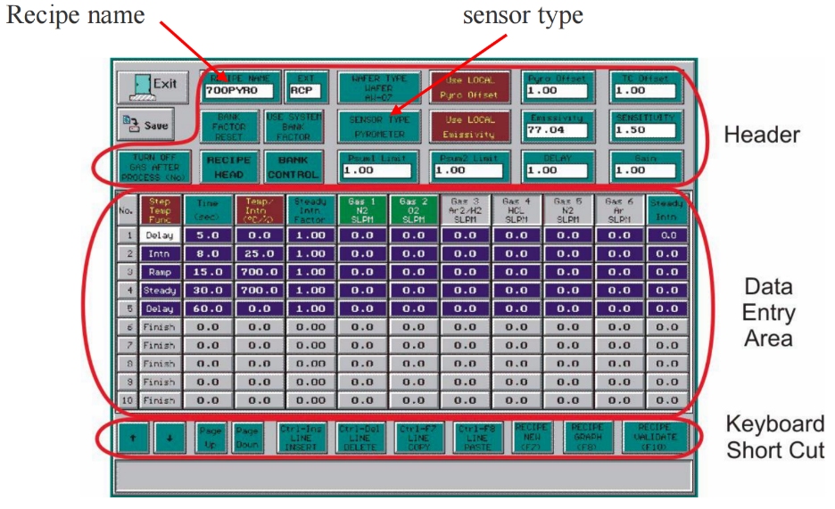
    - All recipe’s must be approved by qualified staff before running a process

- Daily Power-up & Power-down Procedures
  - Daily Power-Up
    - Ensure all gas valves are turned off
    - Verify there is no restriction to the process or cabinet exhaust and that they are set to the proper pressure and flow rate
    - Turn on the chamber cooling water
    - Turn on the quartz isolation tube cooling CDA/nitrogen.
    - Enable the lamps using the front panel Lamp Power switch. The green Lamp ON light indicates the lamps are enabled. You will also hear a "clunk" when the switch is turned on. This is the sound of the contactor engaging
    - Open the chamber door about 1 cm. This will ensure the quartz chamber will not over pressurize if there is a problem with the gas system
    - Turn on the gas valves
  - Daily Power-Down
    - Make sure it has been at least 5 minutes since the last use or until the chamber has cooled to room temperature
    - Turn off the gas valves
    - Turn off the oven unit LAMP POWER switch
    - Turn off the quartz isolation tube cooling CDA/nitrogen
If any accessories are being used with the system, turn them off as necessary

- Warnings
WARNING

- Long, high temperature processes may damage the AccuThermo RTP system
- Make sure both water cooling and air cooling are on before running any process
- Quartz is very delicate, handle with care
- Revision History
Rev | Date | Originator | Description of Changes
1 | 12 September 2016 | Tysen Heaton | Created SOP

