ProTemp Furnace SOP
- Scope
  - This SOP provides instructions to operate the ProTemp Atmospheric Furnaces.
- Table of Contents
1 Scope 1
2 Table of Contents 1
3 Reference Documents 2
3.1 External Documents 2
4 Equipment and/or Materials 2
5 Safety 2
6 General Information 2
7 Pre-Clean 4
7.6 Organic Clean Bath Preparation 4
7.7 SC-1 Bath Preparation 4
7.8 Oxide Removal Bath Preparation 5
7.9 SC-2 Bath Preparation 5
8 Furnace Operating Procedures 6
8.1 Log On 6
8.2 Enable Coral 6
8.3 Check Furnace Status 6
8.3.3 Review Current Status 6
8.4 Load Boat 8
8.4.1 Load Wafers 8
8.4.1.4 Solid Source Doping 8
8.4.1.5 Oxidation/Anneal 9
8.5 Initialize Graph 10
8.6 Change Oxidation Time 10
8.7 Download Recipe File 11
8.8 Select Recipe 12
8.9 Run Recipe 12
8.10 Wait for Run Completion 13
8.11 Unload Boat 13
8.12 Unload Wafers 13
8.13 Measure Monitor Wafers 13
8.14 Place System in Standby 13
8.15 Disable Tool in Coral 13
9 Solid Source Instructions 13
9.1 Install the desired boat 13
9.2 Dehydrate Sources 14
10 Process Notes 15
10.1 Process Summary 15
11 Revision History 16

Figure 1, Boat Fork 3
Figure 2, Solid Source Doping Loading Diagram 9
Figure 3, Oxidation/Anneal Loading Diagram 9

Table 1, Furnace Pre-Clean 5
Table 2, Log In Information 6
Table 3, Recipe File Location 11
Table 4, Oxidation Process Summary Data 15

- Reference Documents
External Documents
    - SMBB Lab User Guide
- Equipment and/or Materials
  - ProTemp Oxidation Furnaces
  - Quartzware
  - Boat fork
  - Monitor wafers
    - Phosphorous Doping: <100> P-Type bare silicon
    - All Other Processes: <100> N-Type or P-Type bare silicon
  - Filler wafers
- Safety
  - Follow all Nanofab safety procedures.
  - Ensure all Cooldown cycles are complete before handling any quartzware, wafers, or samples.
CAUTION
All recipes include the necessary cool down time to ensure the quartzware, wafers, and samples are cool enough to be touched and handled.
Do not touch or handle quartzware, wafers, or samples unless the current run is COMPLETE.
CAUTION
- General Information
  - Ensure all samples are authorized to be loaded into a furnace.
  | !!! WARNING !!! |  
     | No photoresist, kapton tape, metals, glass, or other foreign material is allowed in any furnace.  Only quartz, silicon, silicon carbide, silicon dioxide, silicon nitride, and/or Polysilicon are allowed without PRIOR approval of lab staff. |     
  | !!! WARNING !!! |  
    - Only the following substrates or samples are allowed in the Clean Ox furnace:
- Bare silicon wafers that have received NO prior processing
- Wafers with an oxide that was thermally grown in the Clean Ox furnace
- Wafers with LPCVD Undoped Polysilicon deposition
- Wafers with LPCVD Nitride deposition
    - The following substrates or samples are allowed in the Doped Ox furnace:
- All samples approved for processing in the Clean Ox furnace
- Wafers that have been processed through PECVD Oxide deposition
- Wafers that have been processed through PECVD Polysilicon deposition
- Wafers that have been processed through PECVD Nitride deposition
- Wafers that have been processed through LPCVD Doped Poly Deposition
- Wafers that have been processed through LPCVD LTO Deposition
- Wafers that have been processed through LPCVD PSG Deposition
- Wafers that have been doped by any method
    - For any substrates or samples not listed above, contact Staff to determine the authorized furnace.
  - Ensure all samples are clean, dry, and particle-free.
  - Place quartzware on a quartz plate, silicon carbide cantilever paddle, or a cleanroom wiper.
    - Do NOT directly place quartzware on stainless steel.
  - Do NOT touch boats or boat covers with your hands.
    - Use the boat fork (see Figure 1, Boat Fork) to move boats and boat covers.
      - Insert the tines of the fork into the pick-up tubing on the boat or boat cover.
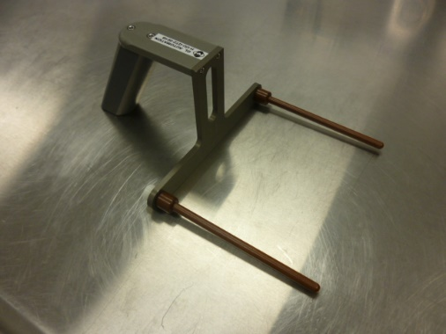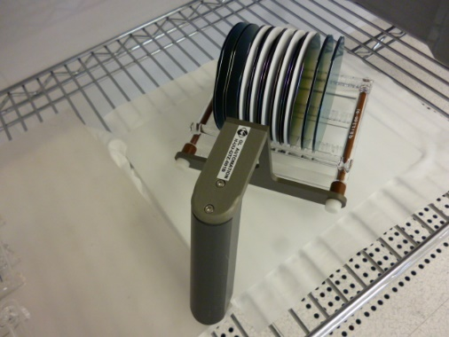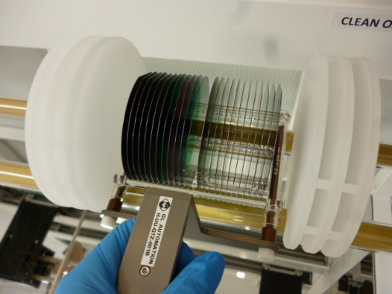
Figure 1, Boat Fork
  - Before touching a quartz baffle, put on a second pair of clean blue nitrile gloves.
  - Solid Source wafers that have been out of the furnace more than one (1) hour need a dehydration bake per section 9 Solid Source Instructions.
- Pre-Clean
  - For new, unused bare silicon wafers, a Pre-Diffusion Clean prior to processing through any furnace cycle is recommended.
  - For all other samples/substrates/wafers, a Pre-Diffusion Clean prior to processing through any furnace cycle is REQUIRED.
  - Complete the Pre-Diffusion Clean in the Pre-Diffusion wet bench.
The dedicated baths should be used for whole wafers, since the SC-1 bath includes a megasonic clean for improved particle removal. However, for partial wafers the specified mixtures may be used in smaller beakers/containers, if necessary.
  - Refer to Table 1, Furnace Pre-Clean for the correct mixtures, temperatures, and times.
  - If the Organic Clean bath temperature is above 100°C and has not been used within the last 2 hours, add 100ml of Hydrogen Peroxide.
    - Wait at least 5 minutes before using the bath.
Organic Clean Bath Preparation
    - If using an alternate bath container, ensure the container is compatible with temperatures up to 200°C (e.g., pyrex, quartz, teflon).
    - Add the necessary amount of Sulfuric Acid to an empty container.
    - Turn on the heater.
    - Wait for the heater to exceed 100°C.
    - Add the necessary amount of Hydrogen Peroxide.
    - Wait until the bath temperature has reached setpoint.
    - Wait at least 5 minutes before using the bath.
SC-1 Bath Preparation
    - If using an alternate bath container, ensure the container is compatible with temperatures up to 100°C (e.g., pyrex, quartz, teflon).
    - Add the necessary amount of Ultra Pure Water (UPW) to an empty container.
    - Add the necessary amount of Ammonium Hydroxide.
    - Turn on the heater.
    - Wait for the heater to exceed 65°C.
    - Add the necessary amount of Hydrogen Peroxide.
    - Wait until the bath temperature has reached setpoint.
    - Wait at least 5 minutes before using the bath.
Oxide Removal Bath Preparation
    - If using an alternate bath container, ensure the container is compatible with Hydrofluoric Acid (e.g., plastic, teflon).
    - Add the necessary amount of Ultra Pure Water (UPW) to an empty container.
    - Add the necessary amount of Hydrofluoric Acid.
    - Wait at least 5 minutes before using the bath.
SC-2 Bath Preparation
    - If using an alternate bath container, ensure the container is compatible with temperatures up to 100°C (e.g., pyrex, quartz, teflon).
    - Add the necessary amount of Ultra Pure Water (UPW) to an empty container.
    - Add the necessary amount of Hydrochloric Acid.
    - Turn on the heater.
    - Wait for the heater to exceed 65°C.
    - Add the necessary amount of Hydrogen Peroxide.
    - Wait until the bath temperature has reached setpoint.
    - Wait at least 5 minutes before using the bath.
Table 1, Furnace Pre-Clean
Step | Description | Container Type | Ratio¹ | Chemical | Quantity  (ml) | Temp  (°C) | Time  (mm:ss)
1 | Organic clean (pirahna) | Pyrex  Quartz  Teflon | 5  1 | Sulfuric Acid  Hydrogen Peroxide, 30% | 2500  500 | 120 | 10:00
2 | Rinse |  |  | Ultra Pure Water (UPW) |  |  | 5:00
3 | SC-1 | Pyrex  Quartz  Teflon | 5  1  0.4 | Ultra Pure Water (UPW)  Ammonium Hydroxide  Hydrogen Peroxide | 6250  1250  500 | 75 | 10:00
4 | Rinse |  |  | Ultra Pure Water (UPW) |  |  | 5:00
5 | Oxide Removal | Plastic  Teflon | 50  1 | Ultra Pure Water (UPW)  Hydrofluoric Acid, 49% | 2000  40 |  | 01:00
6 | Rinse |  |  | Ultra Pure Water (UPW) |  |  | 5:00
7 | SC-2 | Pyrex  Quartz  Teflon | 6  1  1 | Ultra Pure Water (UPW)  Hydrochloric Acid, 37%  Hydrogen Peroxide | 3900  650  650 | 75 | 10:00
8 | Rinse |  |  | Ultra Pure Water (UPW) |  |  | 5:00
9 | Spin-Rinse Dry |  | As programmed
¹Maintain this ratio when using the alternate bath containers.
²If the Organic clean bath temperature is greater than 100°C and has been unused for more than 2 hours, add 100ml of Hydrogen Peroxide prior to use.
- Furnace Operating Procedures
Log On
    - From the ProTemp host computer, select the Tymplex program.
      - If necessary, open the Tymplex program.
    - From the 0 Overview screen, click the Log In button.
    - Type the Username and password (in CAPS) for the applicable furnace. (See Table 2, Log In Information.)
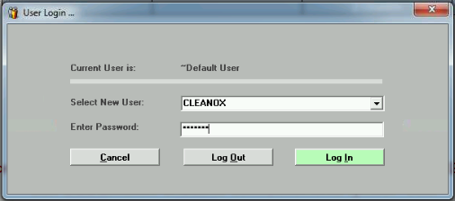
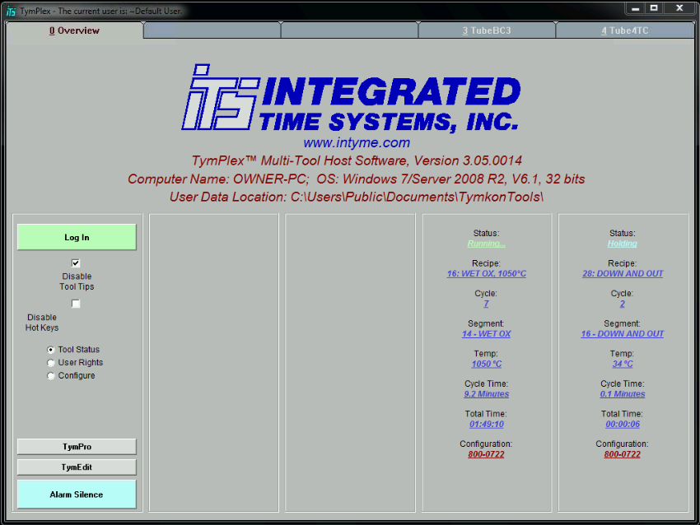
    - From the User Login … dialog box, click the Log In button.
Overview Tab
Log In Button
Table 2, Log In Information
Furnace | Clean Ox | Doped Ox
Username | CLEANOX | DOPEDOX
Password | CLEANOX | DOPEDOX
Enable Coral
    - Enable the furnace in Coral.
Check Furnace Status
    - Select the main tab for the desired furnace.
    - Select the Operate subtab.
Review Current Status
If the current recipe is “IDLE WITH COMPLETED SAMPLES ON BOAT”, samples from the previous run have not been removed from the boat.
      - If the current recipe is “IDLE WITH COMPLETED SAMPLES ON BOAT”, do the following:
        - If there are no instructions from the previous user, contact that user before removing any samples and monitor wafers.
        - If the instructions from the previous user are “Do Not Disturb”, do not proceed.
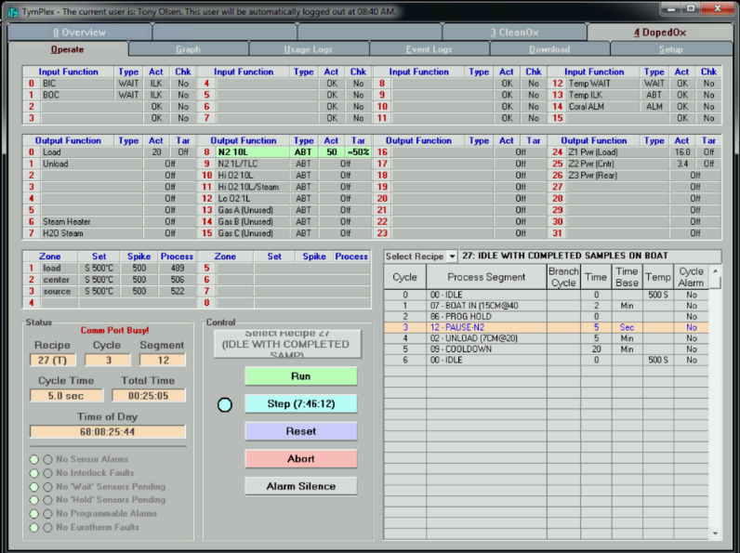
        - If the instructions from the previous user authorize you to handle their samples, continue.
Operate subtab
Doped Ox Furnace main tab
Blue dot
Current Recipe
      - If there is a blue dot next to the Step button, the furnace is on Hold.
        - Click the Run button.
        - Wait for the current run to complete.
The Alarm Silence button will be replaced by a yellow *** Complete *** button with a yellow dot.
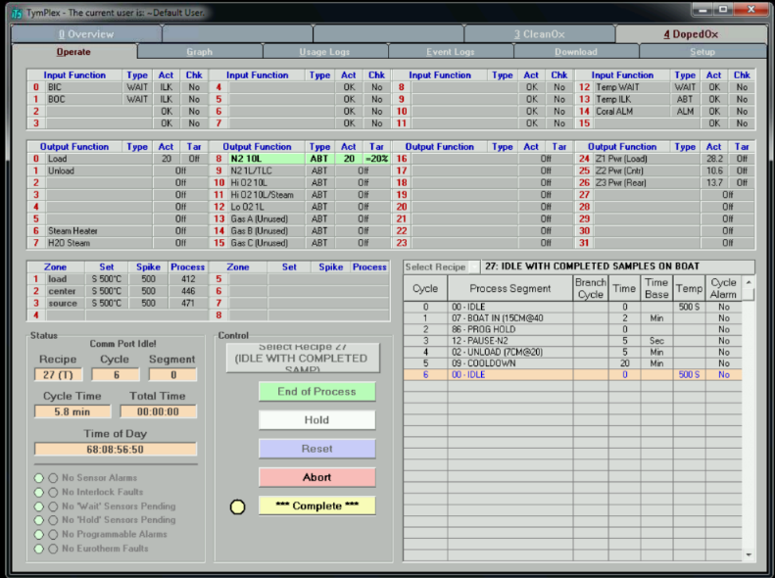
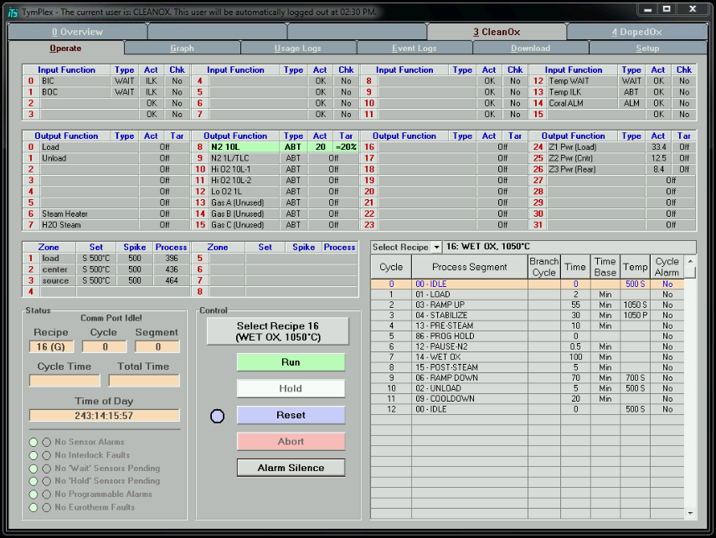
      - If there is a yellow dot next to the *** Complete *** button, the current recipe has completed.
Yellow Dot
Reset button
        - Click the *** Complete *** button.
        - Click the Reset button.
      - If the cantilever is in and there is a blue dot next to the Reset button, download and run the “BOAT OUT” recipe per paragraphs 8.7 Download Recipe File through 8.9 Run Recipe.
      - If the cantilever is in and there is a yellow dot next to the *** Complete *** button, click the *** Complete *** button.
        - Download and run the “BOAT OUT” recipe per paragraphs 8.7 Download Recipe File through 8.9 Run Recipe.
      - If the cantilever is out, the furnace is ready for use.
      - If samples from another member are loaded on the boat AND he/she has authorized you to handle their samples, follow their instructions to remove the samples.
Load Boat
Load Wafers
  | !!! WARNING !!! |  
     | No photoresist, kapton tape, metals, glass, or other foreign material is allowed in the furnace.  Only quartz, silicon, silicon carbide, silicon dioxide, silicon nitride, and/or Polysilicon are allowed without PRIOR approval of lab staff. |     
  | !!! WARNING !!! |  
      - Unless otherwise noted, load all wafers with the polished side toward the door of the furnace.
      - Load the wafers with the wafer flat up.
      - Load one wafer per slot.
Solid Source Doping
Solid Source wafers that have been out of the furnace more than one (1) hour need a dehydration bake per section 9 Solid Source Instructions.
The solid source wafers should always have a filler or sample wafer in the adjacent slots – even when stored.
        - Remove the necessary filler wafers (adjacent to the solid source wafers) and place them in empty slots at either end of the boat.
        - Load all sample and monitor wafers with the polished side (side to be doped) toward the solid source wafer.
        - Load a monitor wafer onto the boat in slot 14 (see Figure 2, Solid Source Doping Loading Diagram).
Monitor wafers for Phosphorous Doping are <100> P-Type bare silicon. Monitors wafers for Boron Doping are <100> N-Type bare silicon.
        - Load sample wafers in slots 9-13 and/or 15-18, starting at the center.
        - Load filler wafers in slots 4-7, 20-23, and all unused sample slots.
DOOR
E = Empty/Extra Slot F = Filler wafer M = Monitor wafer S = Sample Wafer
Quartz Baffle |  |  |  |  |  |  |  |  |  |  |  |  |  |  |  |  |  |  |  |  |  |  |  |  |  |  |  |  |  |  |  |  |  |  |  |  |  |  |  |  |  |  |  |  |  |  |  |  |  |  |  |  |  |  | Quartz Baffle
Slot #  Wafer |  | 1  E |  | 2  E |  | 3  E |  | 4  F |  | 5  F |  | 6  F |  | 7  F |  | 8  E |  | 9  S |  | 10  S |  | 11  S |  | 12  S |  | 13  S |  | 14  M |  | 15  S |  | 16  S |  | 17  S |  | 18  S |  | 19  E |  | 20  F |  | 21  F |  | 22  F |  | 23  F |  | 24  E |  | 25  E |  | 26  E |  |  | Slot #  Wafer

Figure 2, Solid Source Doping Loading Diagram

Oxidation/Anneal
        - Load a monitor wafer onto the boat in slot 14 (see Figure 3, Oxidation/Anneal Loading Diagram).
Monitor wafers are bare silicon. Samples that are bare silicon may be used as monitors.
        - Load sample wafers in slots 8-13 and/or 15-20, starting at the center.
        - Load filler wafers in slots 1-7, 21-25, and all unused slots.
        - Ensure there is a sample, monitor, or filler wafer in every slot.
DOOR
F = Filler wafer M = Monitor wafer S = Sample Wafer
Quartz Baffle |  |  |  |  |  |  |  |  |  |  |  |  |  |  |  |  |  |  |  |  |  |  |  |  |  |  |  |  |  |  |  |  |  |  |  |  |  |  |  |  |  |  |  |  |  |  |  |  |  |  |  |  | Quartz Baffle
Slot #  Wafer |  | 1  F |  | 2  F |  | 3  F |  | 4  F |  | 5  F |  | 6  F |  | 7  F |  | 8  S |  | 9  S |  | 10  S |  | 11  S |  | 12  S |  | 13  S |  | 14  M |  | 15  S |  | 16  S |  | 17  S |  | 18  S |  | 19  S |  | 20  S |  | 21  F |  | 22  F |  | 23  F |  | 24  F |  | 25  F |  |  | Slot #  Wafer

Figure 3, Oxidation/Anneal Loading Diagram

Polished Side
Initialize Graph
    - Select the Setup subtab.
    - Ensure the Enable Datalog check box is checked.
    - Press the Create New Datalog File button.
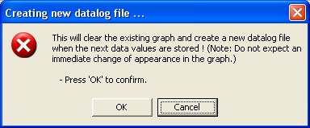
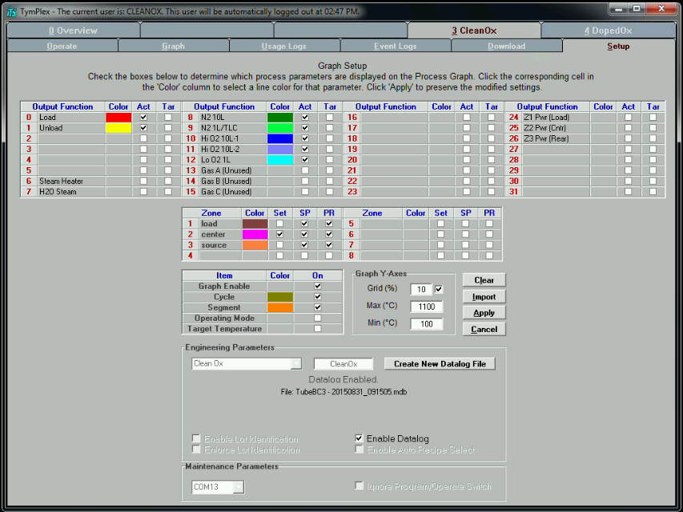
    - At the Creating new datalog file … box, click OK .
Setup subtab
Enable Datalog checkbox
Create New Datalog File button
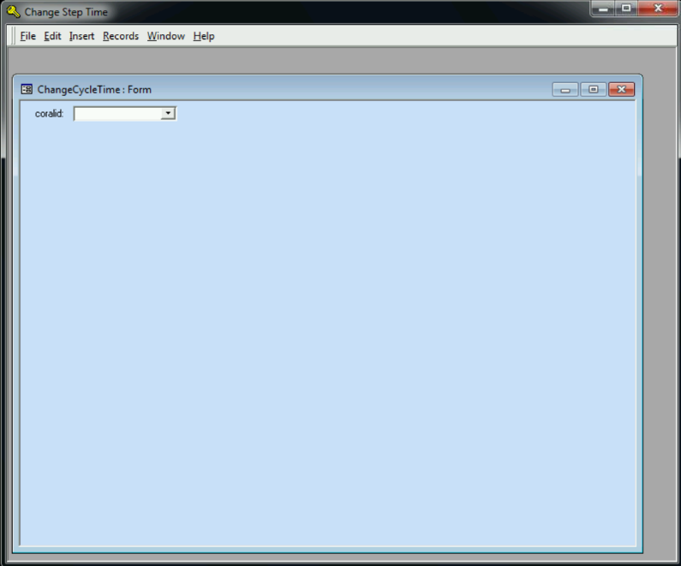
Change Oxidation Time
    - From the desktop, open the “Change OxTime” utility.
    - Enter/select your Coral ID.
    - Following the prompts, change the oxidation time, if needed.
Download Recipe File
    - To download a new recipe file, select the Download subtab.
    - Click the Download File to Tymkon button.
    - From the dialog box, locate and select the correct recipe file (see Table 3, Recipe File Location).
    - From the Ready to Download dialog box, click the Begin Download button.
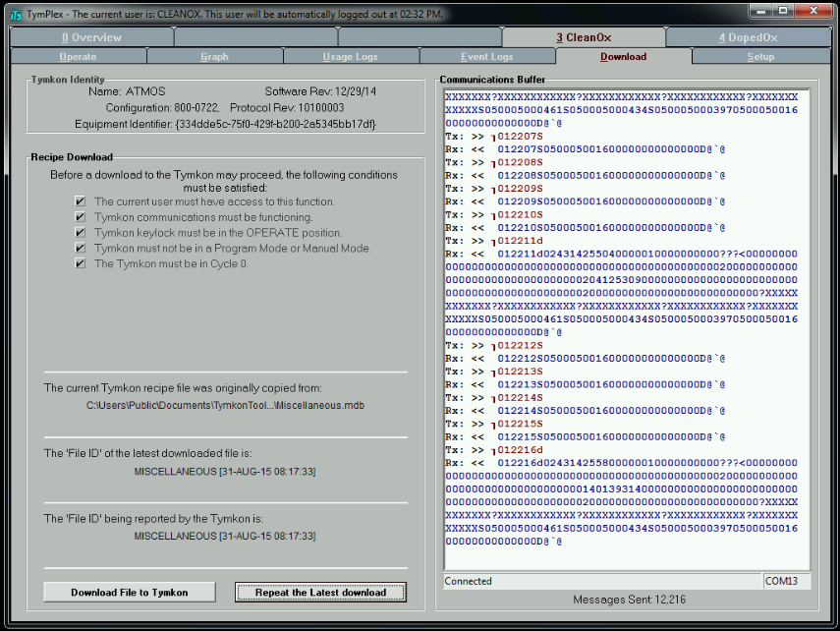
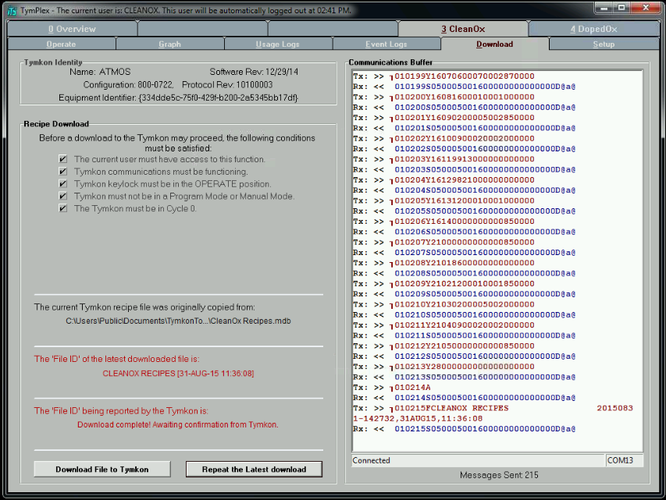
    - Wait for the recipe to complete downloading. (Sections will change from red to black text.)
Download File to Tymkon button
Download subtab
This text changes from red to black when download is complete.
Table 3, Recipe File Location
Furnace | Path | Recipe Type | Recipe File
CleanOx | [MainPath]\CleanOx\CleanOx Recipes | Dry Oxidation  Wet Oxidation | Clean DryOx Recipes.mdb  Clean WetOx Recipes.mdb
DopedOx | [MainPath]\DopedOx\DopedOx Recipes | Anneal  Boron Doping  Dry Oxidation  Phosphorous Doping  Wet Oxidation | Doped Anneal Recipes.mdb  Boron Solid Source Recipes.mdb  Doped DryOx Recipes.mdb  Phos Solid Source Recipes.mdb  Doped WetOx Recipes.mdb
[MainPath] = C:\Users\Public\Documents\TymkonTools\UserData
Select Recipe
    - Select the Operate subtab.
    - Click the Select Recipe pull down box.
    - Select the desired recipe.
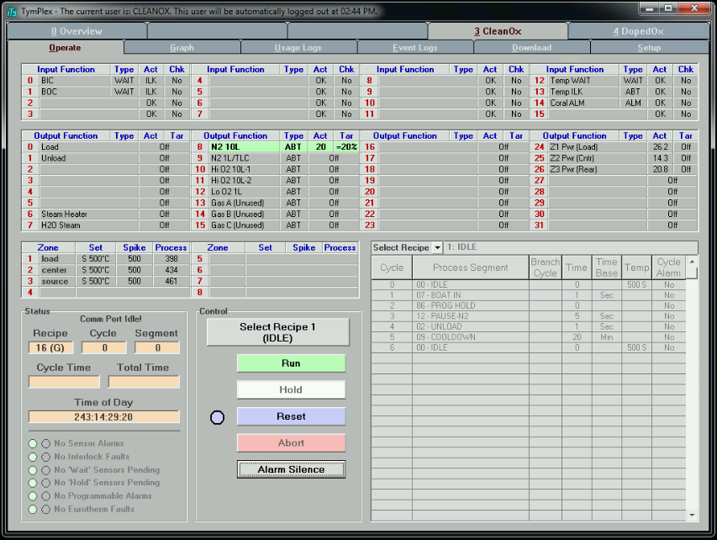
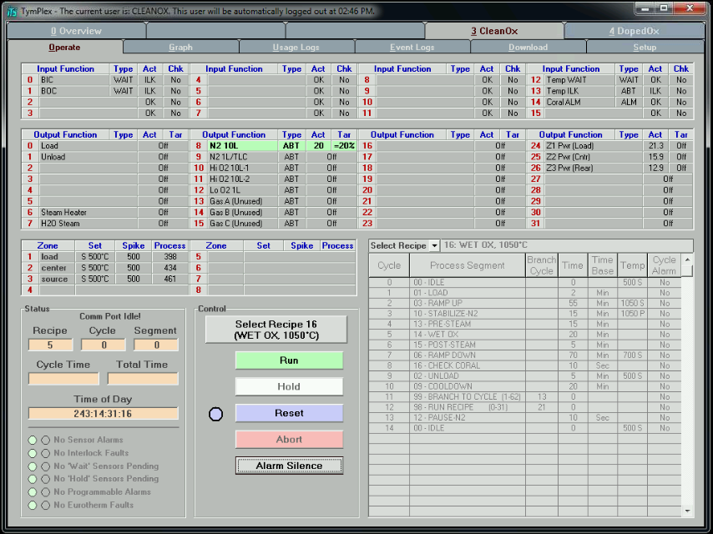
    - Activate the recipe by clicking the Select Recipe # (recipe name) button.
Select Recipe pull down box
Select Recipe button
Run Recipe
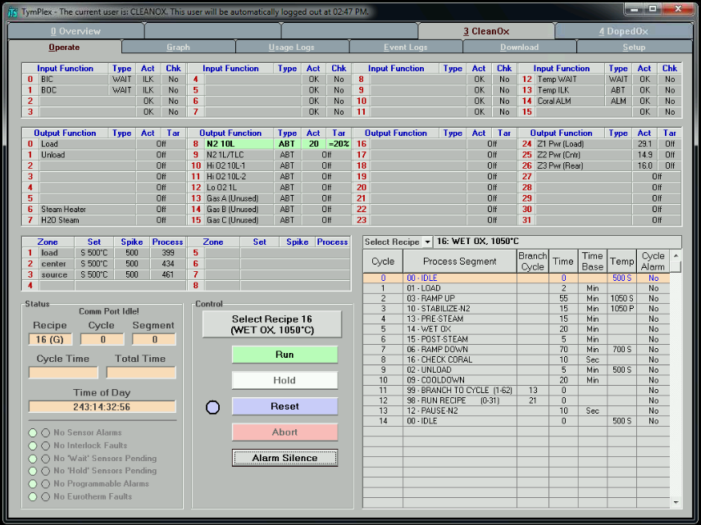
    - From the Operate subtab, click the Run button.
Run button

Wait for Run Completion
    - Wait for the cooldown cycle to complete.
The boat will be out, the current recipe will be “REMOVE SAMPLES” and the current cycle will be “REMOVE SAMPLES”. If this recipe is not reset within a programmed amount of time, the system will start the “IDLE WITH COMPLETED SAMPLES ON BOAT” and the load will push back into the furnace.
    - Click the Reset button.
    - At the Reset the current recipe ? dialog box, click the OK button.
Unload Boat
    - Ensure the run has completed.
CAUTION
All recipes include the necessary cool down time to ensure the quartzware, wafers, and samples are cool enough to be touched and handled.
Do not touch or handle quartzware, wafers, or samples unless the current run is COMPLETE.
CAUTION
Unload Wafers
    - Remove the monitor wafers and samples from the boat.
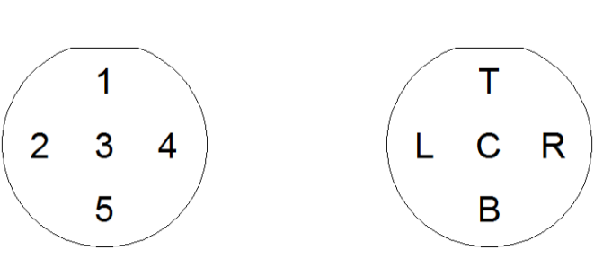
Measure Monitor Wafers
    - Measure the thickness at 5 sites on each monitor wafer.
Place System in Standby
    - Select the “VACUUM IDLE” recipe.
    - Run the recipe.
The cantilever will go in, the system will pump down, and go on hold.
Disable Tool in Coral
    - Disable the furnace in Coral.
    - Record the thickness measurements.
- Solid Source Instructions
Install the desired boat
    - Ensure the unwanted quartz boat on the cantilever is sufficiently cool.
The programmed cooldown cycle will be finished and the host computer will show *** Complete *** .
    - Using the boat fork, carefully remove the unwanted boat and place it on a quartz plate for storage.
    - Using the boat fork, carefully place the desired boat on the cantilever.
Dehydrate Sources
    - If the solid sources have been out of the furnace for more than 1 hour, dehydrate the sources.
      - Using the boat fork, place the boat with the solid sources on the cantilever.
      - Ensure each slot adjacent to a solid source wafer has a filler wafer.
      - Process the “DEHYDRATE SOURCES” recipe.
      - When completed, the sources are ready to be used for doping.

- Process Notes
Process Summary
    - Table 4, Oxidation Process Summary Data lists the basic information for the various processes. Contact staff for help selecting a recipe and oxidation time.
Table 4, Oxidation Process Summary Data
Furnace | Recipe | N2  (slm) | O2  (slm) | N2/TLC (slm) | Temp (°C) | Approx. Time  (min) | Thick (Å)
CleanOx, Doped Ox | DRY OX (All temps) |  | 4 |  | 1000 | 60 | 550
 |  |  |  |  | 1050 | 27  31  53  78 | 400  500  750  1000
 | CLEAN OX (All temps) |  | 3.5 |  | 850 | 100 | 800
 |  |  |  |  | 950 | 32  57  80 | 1000  1500  2000
 |  |  |  |  | 1000 | 30  41  55 | 1500  2000  2500
 |  |  |  |  | 1050 | 30  48  102  300  600 | 2200  3000  5000  10000  14000
Doped Ox | ANNEAL (All temps) | 5
 | BORON DOPING | 8
 | PHOS DOPING | 8
Note: Oxidation times can be approximated by this formula:
$$New Time=\frac{\left(Known Time\right)*{\left(New Thickness\right)}^{2}}{{(Known Thickness)}^{2}}$$
- Revision History
Rev | Date | Originator | Description of Changes
3 | 10 Jun 19 | T. Olsen | Update document to new format.
2 | 29 Jun 18 | T. Olsen | General update and re-order sub-sections.
1 | 28 Mar 16 | T. Olsen | Initial Release

