Suss Aligner SOP
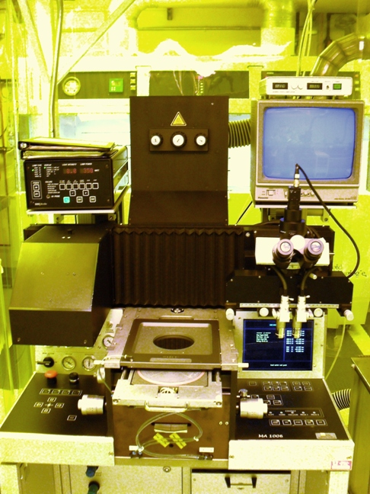
- Scope
  - This document provides the procedure for operating the Suss Aligner.
- Table of Contents
1. Scope 1
2. Table of Contents 1
3. Reference Documents 2
3.1 Referenced within this Document 2
3.2 External Documents 2
4. Equipment and/or Materials 2
5. Safety 2
6. Setup Procedures 2
6.1 Turn on UV Lamp Supply 2
6.2 Turn on Machine 3
6.3 Insert Mask 3
6.4 Set Exposure and Gap 3
7. Alignment Procedure 4
7.1 Load Wafer 4
7.2 Align Wafer 4
7.3 Expose 5
8. Shutdown Procedure 5
9. Process Notes 6
9.1 Test Run Results 6
10. Revision History 6

Figure 1, UV Power Supply 3
Figure 2, Left Side Controls 3
Figure 3, Right Side Controls 4

Table 1, Test Results 6

- Reference Documents
Referenced within this Document
    - None
External Documents
    - None
- Equipment and/or Materials
  - Suss Aligner
  - Mask
  - Wafer/Sample
- Safety
  - Follow all Nanofab safety procedures.
- Setup Procedures
Turn on UV Lamp Supply
    - Press Start. See Figure 1, UV Power Supply.
NOTE: Display flashes “cold” until the lamp is warmed-up and ready
    - Make sure LED is on CI1 (Constant Intensity is set to 10mW/cm^2)
Start Button
Figure 1, UV Power Supply
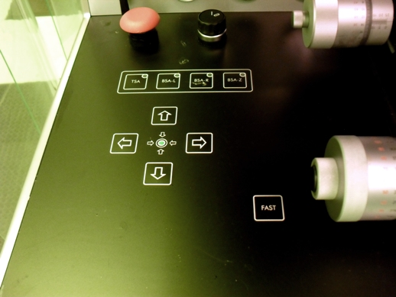Turn on Machine
Power Switch
Figure 2, Left Side Controls
    - Turn on black knob with 0/1 written on it, on left side of machine. See Figure 2, Left Side Controls.
Insert Mask
    - Lift up mask holder.
    - Insert mask into mask holder (mask goes between pins, chrome side up).
    - Put mask holder down and push gently to snap into place.
    - Wait for system to boot up.
    - Turn on Mask Vacuum (knob on left-hand side).
    - Press enter for regular alignment.
Set Exposure and Gap
    - Press edit twice. See Figure 3, Right Side Controls.
      - Arrow to Exp-Type
      - Press edit and use arrows to set desired type.
        - Soft for features greater than 5 microns
        - Hard for features less than 5 microns
        - Vacuum for features less than 2 microns (wafers only)
        - Prox-1 and Prox-2 for features greater than 15 microns
      - Press enter. See Figure 3.
      - Arrow to Algn-Sep for the gap setting
      - Press edit, arrow to desired value, then press enter
      - Arrow to On Time
        - Press edit
        - Use arrows to adjust time, then press enter
    - Press enter again to return to main menu
    - Select Save and press enter
NOTE: Your program should appear on screen
- Alignment Procedure
Load Wafer
    - Pull slider out (when it is all the way out, the vacuum is off)
    - Insert water
    - Make sure the cross hairs are lined-up on the front of the machine (glass slides protruding from the front center of the machine, just below the slider).
    - Rotate knobs to align
    - Push slider in
    - Press ‘Load Mask’ (light should go off). See Figure 3.
    - Press ‘First Exp’ (so that the light goes off). See Figure 3.
    - Press ‘Align Check’ (so that the light goes on). See Figure 3.
    - Press ‘Start’ (microscope moves over). See Figure 3.
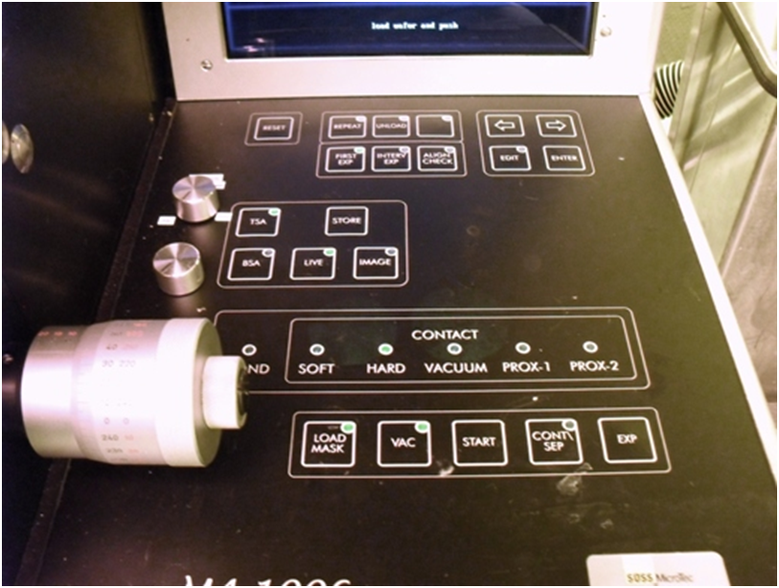
Figure 3, Right Side Controls
Align Wafer
    - To align microscope to the mask:
      - Align Check can be on or off, Live must be on, TSA on left side must be on
      - Use arrow buttons on the left side to move the objectives
      - The outside knobs on the microscope are for distance alignment
      - The small inner knobs on the microscope move the objectives up/down independently
      - The knob coming out at an angle from the microscope is for rotation (theta)
    - To align wafer to the mask:
      - Use the large knobs on the middle of the machine. Rotate knobs to align. (right y, leftx, back left=theta)
      - Course Focus is the back vertical knob on top. RESET is used for ESC.
    - Press ‘Cont/Sep’ (light should go off)
Expose
    - Press ‘Exp’ twice (microscope moves off and exposure lamp moves over). See Figure 3.
    - Slider pops out
NOTE: If vacuum is too low, an error can appear at the end of the exposure, reading briefly “no vacuum, pull slider”, followed by “z-axis error”. Pressing ‘RESET’ will allow for unloading the wafer.
- Shutdown Procedure
  - Remove wafer and push slider in.
  - Turn off Mask Vacuum.
  - Press Load Mask (light goes on)
  - Unload Mask
  - Turn off machine
  - Leave UV light on.

- Process Notes
Test Run Results
Table 1, Test Results
Type of Contact | Exp. Time (s) | Aln-Sep (microns) | Development Time (s) | Results
Soft | 5 | 15 | 45 | poor; width of border of micro '5' feature= 9.10 microns
Soft | 7 | 15 | 45 | poor
Hard | 6 | 15 | 45 | good
Hard | 5 | 15 | 45 | good; width of border= 2.35 microns
Hard | 4 | 15 | 45 | good; width of border= 2.82 microns
Vacuum | 5 | 15 | 45 | worse than Hard, better than Soft; width of border= 5.49 microns
Vacuum | 5 | 15 | 60 | better than the previous vacuum test-run; width of border= 2.98 microns
- Revision History
Rev | Date | Originator | Description of Changes
1 | 12 Jan 2010 | Sam Bell

