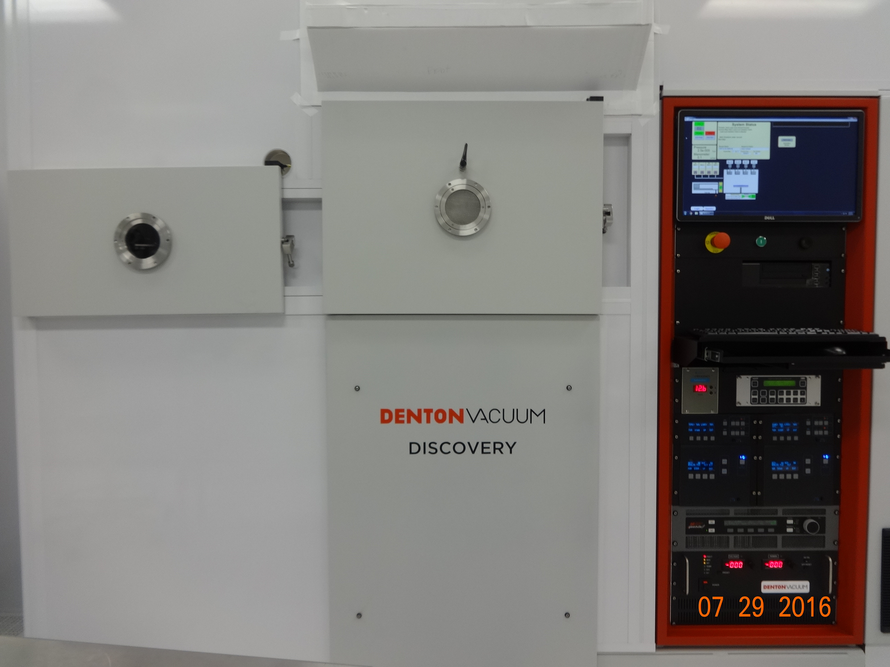
Denton 635 Sputter SOP
- Scope
  - This document provides operating procedures for the Denton 635 automated sputter system..
- Table of Contents
1. Scope 1
2. Table of Contents 1
3. Reference Documents 2
3.1 Referenced within this Document 2
3.2 External Documents 2
4. Equipment and/or Materials 2
5. Safety 2
6. Setup Procedures 3
6.1 Reserve Equipment 3
6.2 Log-in and Verify System Status 3
6.3 Check and Edit Deposition Recipe 3
7. Sputter Procedure, Automated Operation 5
7.1 Venting Load Lock 5
7.2 Loading Wafers or Substrates 5
7.3 Starting Auto Deposition Process 5
8. Denton 635 Configuration and Capabilities 6
8.1 Four Confocal Cathodes 6
8.2 Sputter Power Supplies 6
8.3 Substrate Sputter Pre-clean with RF2 Supply 7
8.4 Substrate Rotation, 50 % = 13 RPM 7
8.5 Cryo Pumped Deposition Chamber 7
8.6 Chamber Pressure Range < 1-90 mT controllable with APC and 100 sccm Ar MFC controller 7
8.7 Water-cooled Stage 7
8.8 Heated Stage (option in place of water cooled stage) 7
8.9 PEM Controllable Reactive Sputtering (Nitrogen or Oxygen) 7
9. Revision History 8

Figure 1, Operator Screen 3
Figure 2, Example, Deposition Recipe List 4
Figure 3, Example, Deposition Recipe 5
.
- Reference Documents
Referenced within this Document
    - None.
External Documents
    - None.
- Equipment and/or Materials
  - Denton 635 sputter system, pre-installed targets, heated or cooled stage, Ar, N2 and O2 gasses and substrate transport pallet
  - Wafer/sample
  - Glass slide for metrology data
  - Kapton tape
- Safety
  - Follow all Nanofab safety procedures.
  - With heated stage pallet must cool to < 150 C for transfer.
  - Be cautious when removing hot wafers, substrate or pallet.
  - Allow time for cooling in vented load-lock until cool enough to handle safely.
- Setup Procedures
Reserve Equipment
    - Reserve and enable Denton 635 sputter system in CORAL
    - Pre-coordinate sputter process with nanofab staff so that your required master recipe and/or system target and heated/cooling chuck configuration is ready.
Log-in and Verify System Status
    - If necessary, login as “operator” using password “operator”.
    - On Operator screen verify main chamber Pressure is less than 1e-006 Torr, see Figure 1

Figure 1, Operator Screen
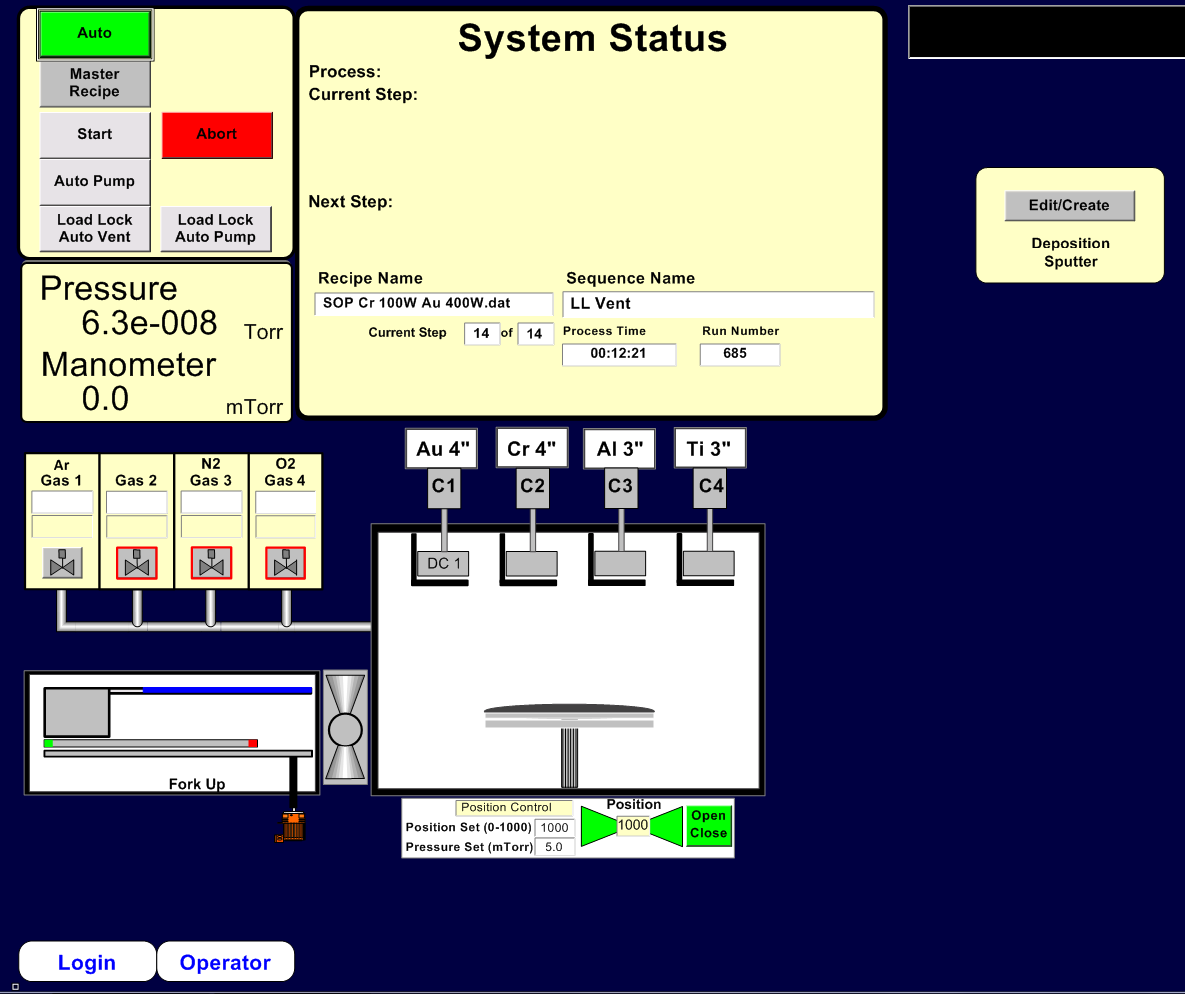
    - On instrument rack below keyboard verify cryo temperature is 20° K or less on red LED display for adequate vacuum pumping capability.
    - All cathodes must have a target installed prior to performing any sputtering process. The installed target material and cathode number is displayed on the screen above the cathode icon.
Check and Edit Deposition Recipe
    - Option to speed up loading, jump to section 7.1 Venting Load Lock only, then return here to edit recipe.
    - On Operator screen click on Edit/Create button to edit the deposition time on deposition sputter recipe.
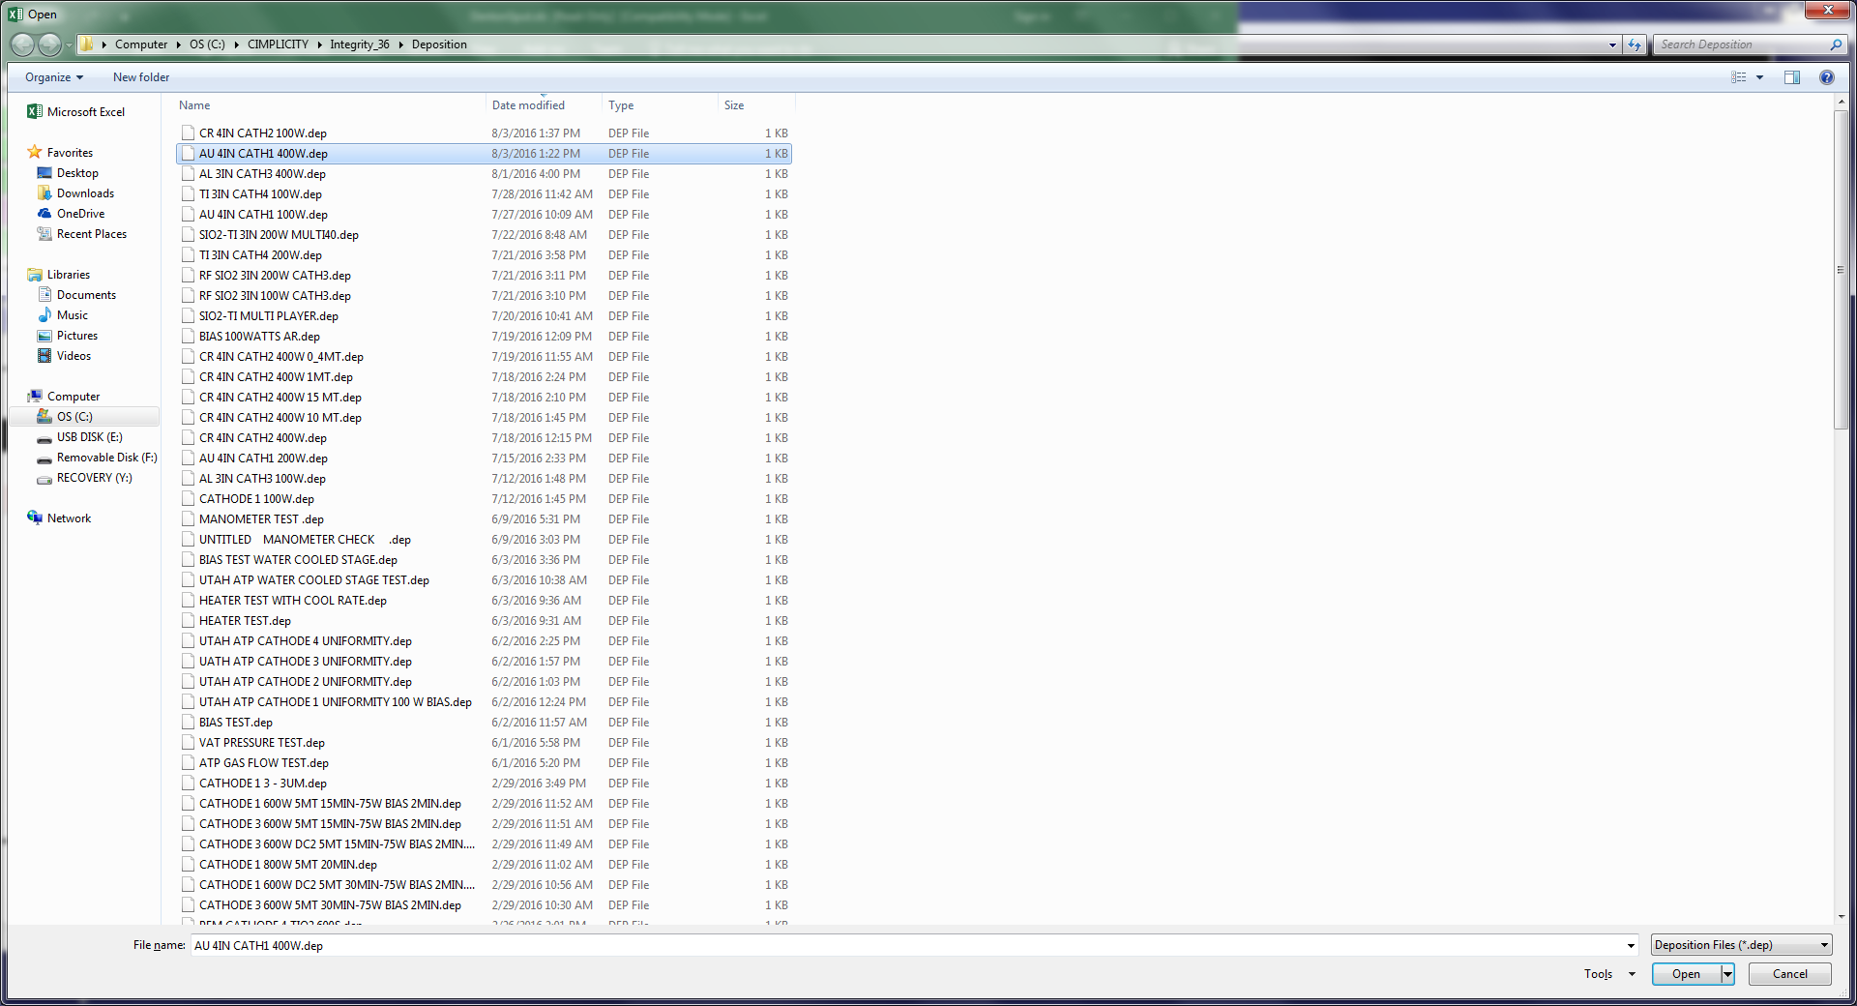
    - After a short delay, a list of deposition recipes (*.dep files) will be displayed. Select the one that corresponds to the deposition you will run and click open in lower right corner. See figure 2

Figure 2, Example, Deposition Recipe List

    - An Excel based deposition recipe will be displayed with each column representing a processing step. The deposition step will typically be the second to last step and the top row is deposition time in seconds which is the only entry authorized for operator editing. The deposition step can also be identified by shutter OPEN parameter in the deposition column. See Figure 3.
    - Check and edit the time if necessary. (based upon your desired thickness and the sputter deposition rate as found in the design a process software on the Nanofab website)
    - Then press SAVE button and click yes to overwrite file.
Note: Additional editing may invalidate the deposition recipe within the master recipe and result in process error or unexpected result.
    - Use the red close button (not the X) to close and exit the Excel recipe worksheet and click yes to overwrite and to close all sheets.
    - Repeat the time editing process for a different second thin film layer, if desired.
  - The stage must have a pallet in place prior to performing any sputtering process.
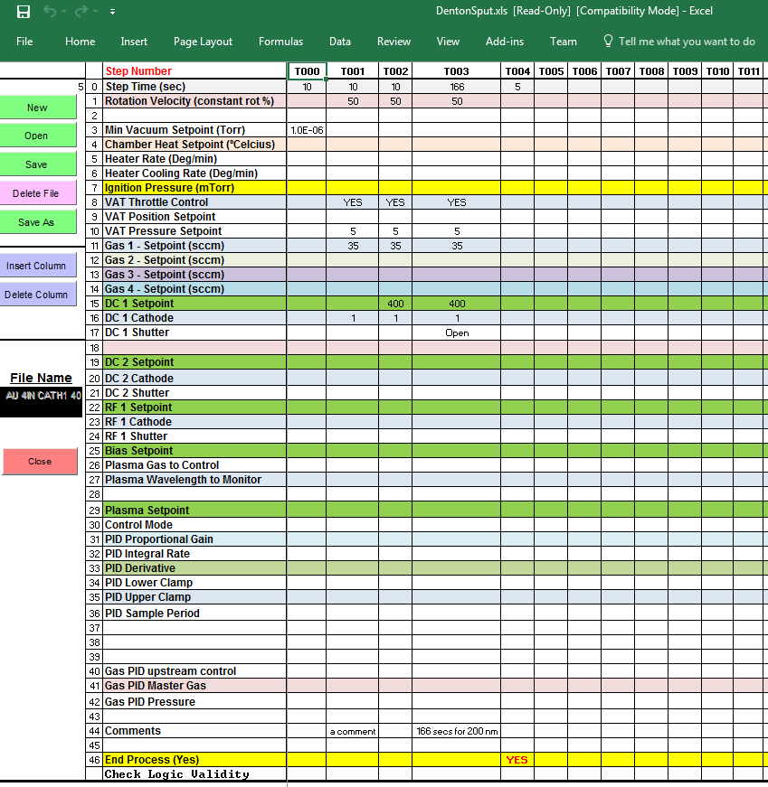
Figure 3, Example, Deposition Recipe
- Sputter Procedure, Automated Operation
Venting Load Lock
    - On Operator screen, the AUTO button should be green, if not click the AUTO button.
    - Click on the Load Lock Auto Vent button below the AUTO button. The System Status box will show the steps being performed and pressure. The load lock door will open when complete.
Loading Wafers or Substrates
    - Carefully remove the transport pallet and place it on a worktable for loading, it will either be on the transfer arm or in the bottom of the load lock.
Note: The transfer arm is a cantilever design, be careful to not bend or deflect the arm.
    - The transport pallet for the water-cooled stage is a solid round aluminum disc with a recess for a 200 mm wafer. It assists with heat conduction from the substrate into the water-cooled stage in the deposition chamber. Be careful not to drop or damage this pallet as damage can both reduce heat transfer during deposition and cause handling and transfer problems.
    - For lift-off applications, place wafers or substrates and a metrology glass slide directly on the pallet.
    - For non-critical temperature applications, nanofab staff may provide a 200 mm wafer to place on the pallet and minimize deposition build-up, insert into recess then place wafers or substrates and a metrology glass slide on the wafer.
    - Very carefully move the pallet from the work-table and place on the forked transfer arm, positioning as close as possible to the left side of fork.
Note: The samples must be centered on the pallet so the pallet will balance on the fork.
    - Close the load lock door and secure the latch to hold it closed.
Starting Auto Deposition Process
    - The Master Recipe combines and includes the following steps: Load-lock Auto Pump, Auto Transfer (load pallet into chamber), one or more auto deposition recipes, Auto Unload and Load Lock Auto Vent. The Master Recipe is limited to 200 steps and created by nanofab staff.
    - On Operator screen, click on Master Recipe button, then in pop-up window Open button.
    - Select the Master Recipe that includes the deposition recipe(s) you want to run, then close the pop-up window.
    - Verify the desired Master Recipe name is displayed on the Operator screen in the System Status box.
    - Click on the Start button.
    - Watch the steps in the System Status box and after the load lock starts pump down, verify load lock pressure is decreasing. If it’s not decreasing check that the load lock door latch has the door closed. Shortly after the vacuum starts to drop, the latch will release and cause a thud sound and the vacuum will hold the door closed.
Caution: do not re-latch load lock!
    - The wafer will automatically be transferred into the process chamber, and the software will pump down the chamber, flow sputter gases, set the correct pressure, pre-sputter, and open the shutter for the correct time.
    - Once the deposition steps begin, the recipe column will be displayed on the right side of the screen. The Chamber viewport shutter can be opened momentarily to observe plasma and pallet. Do not wedge viewport shutter open or view for extended time.
    - Enter the Process Run Data in CORAL.
    - When deposition is complete, the sample will be automatically returned to the load lock. After the load lock has vented and opened, remove the pallet and place on a worktable. If the heated stage has been used, you must wait until the substrate is less than 40 Celsius to handle it.
    - Remove your substrates and return the pallet to the bottom of the load lock if you’re done processing.
    - Close the load lock door and secure the latch to hold it closed.
    - Click on the Load Lock Auto Pump button below the AUTO button. Watch the steps in the System Status box and after the load lock starts pump down, verify load lock pressure is decreasing.
    - Take thickness and resistivity measurements then record process settings and measurements in Coral and disable the tool.
Note: the Load lock and pallet should be left under vacuum to minimize pump time for next process run.
- Denton 635 Configuration and Capabilities
Four Confocal Cathodes
    - Standard targets 4" Au, 4" Cr, 3" Al, 3" Ti.
    - Other targets can be installed, exchanging with an existing “standard” target by arrangement with staff and system availability. A 1 hour technician time charge will be required for target swap and return to standard target, with chamber pump down targeted for an un-used overnight period.
    - Cathodes and targets in 4” diameter were specified to provide +/- 5% or better uniformity on 200 mm wafer/pallet area. The 3” cathodes with current throw distance position are also providing 5% or better uniformity.
    - Film thicknesses are controllable from a few nm to hundreds of nm with power and time parameters.
Sputter Power Supplies
    - DC1 can operate in DC or Pulsed DC for reactive sputtering of metallic targets for higher deposition rate than provided by RF. Local configuration required, see staff.
    - DC2, basic DC supply, primary use co-sputtering.
    - RF1, auto-tuning RF supply for sputtering non-conductive targets or co-sputtering.
    - Recipe-switch control of any supply to any cathode, 5 second minimum no-load switch time required. Includes simultaneous operation of 2 or 3 supplies for co-sputtering.
Substrate Sputter Pre-clean with RF2 Supply
    - Thermal oxide removal rate ~ 11 nm/min at 100 W Ar gas, 33 nm/min at 300 W.
Substrate Rotation, 50 % = 13 RPM
Cryo Pumped Deposition Chamber
    - Typical base pressure < 5 x 10^-8 Torr.
    - Auto-Regen automated process available for over-night cryo pump regen’s.
Chamber Pressure Range < 1-90 mT controllable with APC and 100 sccm Ar MFC controller
Water-cooled Stage
    - Standard configuration is water-cooled stage installed and using aluminum pallet.
    - Supports liftoff deposition at 100-200W deposition power.
Heated Stage (option in place of water cooled stage)
    - Heated stage can provide substrate heating up to 500° C (heated stage installed) with proper substrate and transport pallet.
    - Open-center stainless steel ring transport pallet required.
    - Higher temperatures must use graphite or Si wafer with SS pallet.
    - Can be installed/removed by staff for configuration charge, estimated 1.0 to 1.5 hour each change (2 required).
    - Requires post deposition cool-down for wafer transfer plus cooling time to arranged temperature for subsequent user under reservation time if not changed back to water cooled stage.
    - Cool-down prior to conversion to cooled stage
    - Best to schedule for un-reserved time following heated run
PEM Controllable Reactive Sputtering (Nitrogen or Oxygen)
    - Plasma Emission Monitor (PEM) available for each cathode (hardware enabled by staff in chamber).
    - PEM control system modulates reactive gas flow (N2 or O2) to maintain constant intensity.
    - Characterization of selected intensity and spectra to resulting film properties required for each application, contact staff.
    - Uses pulsed DC supply operation to minimize arcing and maximize sputter rate of metallic targets.

- Revision History
Rev | Date | Originator | Description of Changes
1 | 08 Aug 2016 | S. Pritchett | Initial SOP
2 | 12 Apr 2017 | S. Pritchett | Incorporate mark-ups

