Nanospec 3000 SOP
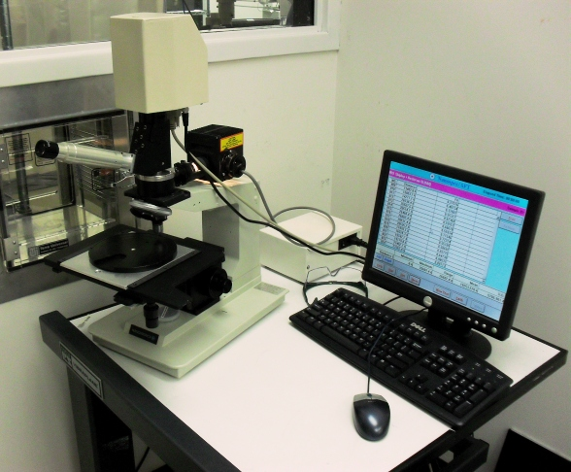
- Scope
  - This document provides procedures for measuring film thickness with the Nanospec 3000.
- Table of Contents
1. Scope 1
2. Table of Contents 1
3. Reference Documents 2
3.1 Referenced within this Document 2
3.2 External Documents 2
4. Equipment and/or Materials 2
5. Safety 2
6. Setup Procedures 2
6.1 Load Sample 2
6.2 Select Program 2
6.3 Calibration 3
7. Measurement Procedures 4
7.1 Film Thickness Measurement 4
8. Revision History 5

Figure 1, Measurement Screen 3
Figure 2, Microscope Components 4
Figure 3, Programs List 5

- Reference Documents
Referenced within this Document
    - None
External Documents
    - None
- Equipment and/or Materials
  - Nanospec
  - Wafer/Sample
  - Calibration Wafer
- Safety
  - Follow all Nanofab safety procedures.
- Setup Procedures
Load Sample
    - Slide out microscope stage.
    - Place sample in the center of the stage, polished side up.
    - Slide in the stage.
    - Focus on the sample. See Figure 2.
Select Program
    - If in the measurement screen, check the top to see which program is selected.
      - If it is the program you need;
        - Press New Test. See Figure 1, Measurement Screen.
        - Enter your sample number.
        - Skip to section 7
      - If you need a different program proceed to step 6.2.2
    - Click Calib. See Figure 1.
    - Select a program from the list. See Figure 3, Programs List.
    - When prompted by the yellow filter warning, turn the yellow filter on or off. See Figure 2.
      - If the warning says “Yellow filter”, turn on the yellow filter.
      - If the warning says “No filter”, turn off the yellow filter.
Calibration
    - If prompted to “Measure New Reference?” , click Yes.
    - When prompted by the dark reference measurement,
      - Move the sample out of the way of the microscope reticule.
      - Click Ok.
    - When prompted to focus on reference sample,
      - Place calibration wafer on top of your wafer, polished side up.
      - Move calibration wafer under the microscope reticule.
      - Focus on the calibration wafer.
      - Click Ok.
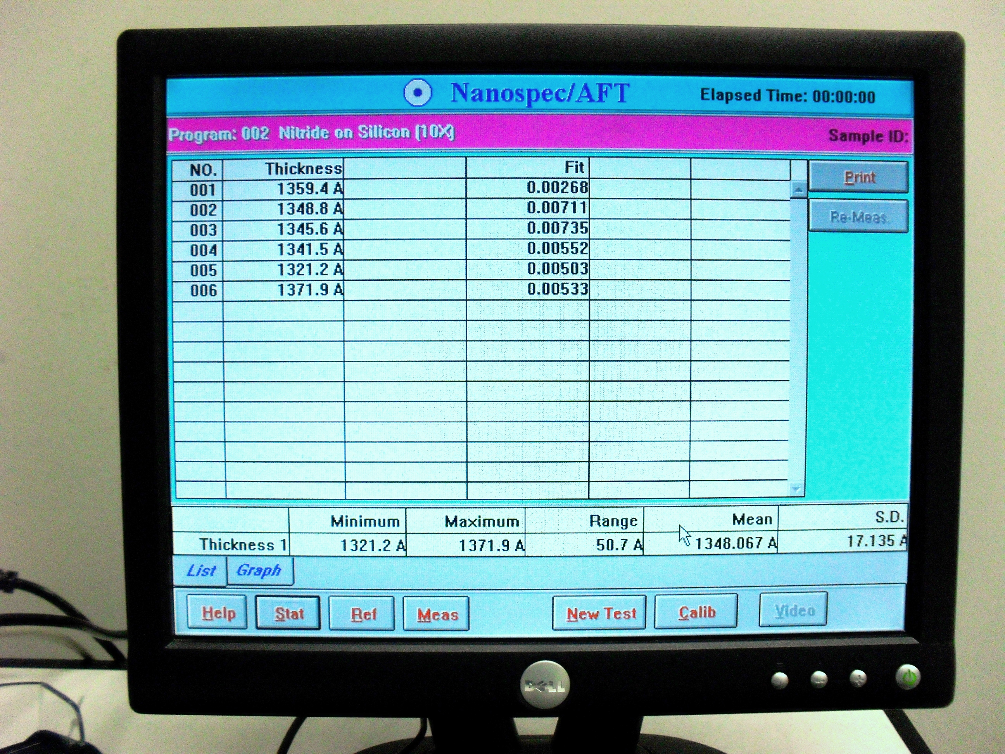
Figure 1, Measurement Screen
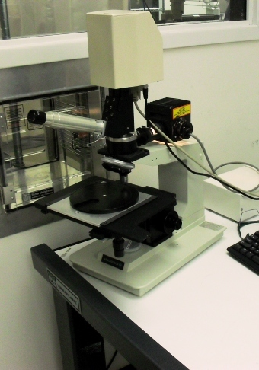
Yellow Filter Switch
Focus Wheel
X/Y Knob
Figure 2, Microscope Components
- Measurement Procedures
Film Thickness Measurement
    - Use X and Y knob to move sample to measurement point. See Figure 2.
    - Focus on the sample.
    - Click the Meas button to take a measurement. See Figure 1, Measurement Screen.
    - Repeat as necessary.
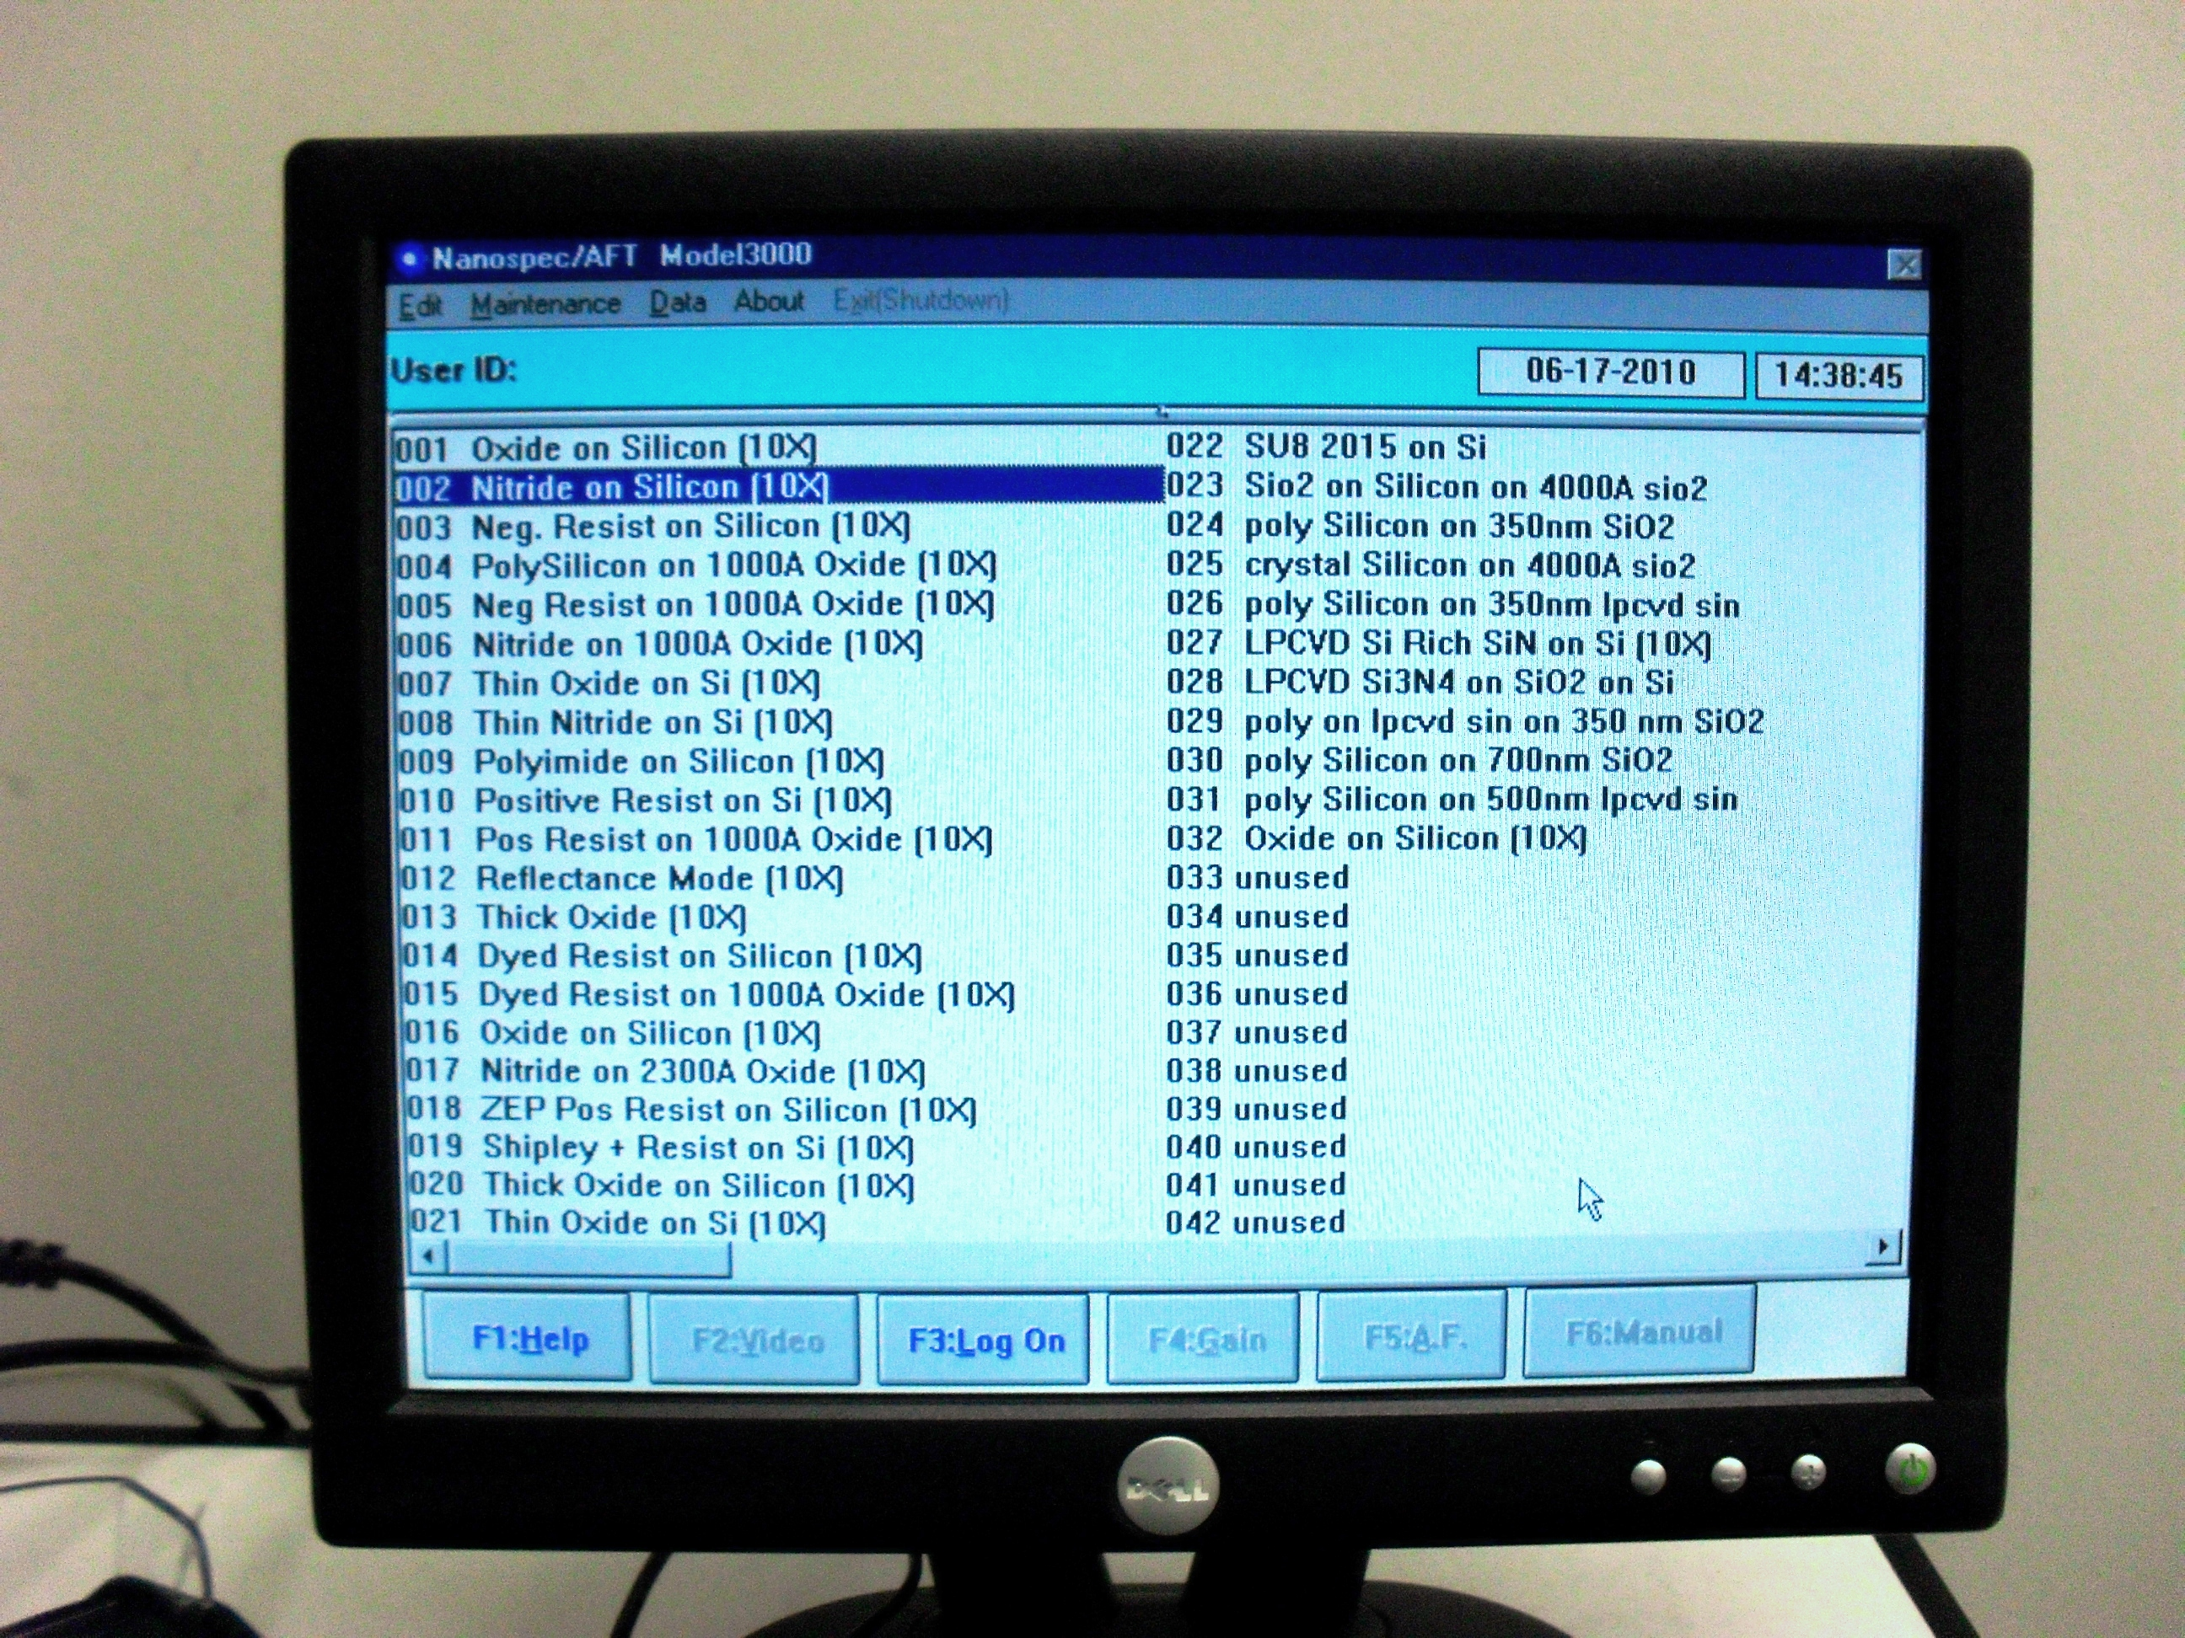
Figure 3, Programs List

- Revision History
Rev | Date | Originator | Description of Changes
1 | 17 June 2010 | Sam Bell

