Denton 635 – clear Screenlock.log file every 2-3 months

If not maintained log file will grow until hard drive is 100% full and interrupt operation of Denton 635 software. Ryan tried writing a batch file but doesn’t work.

This can be done in operator login
Start task manager and stop process “ScreenlockServer.exe*32”

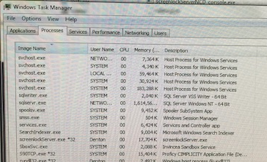

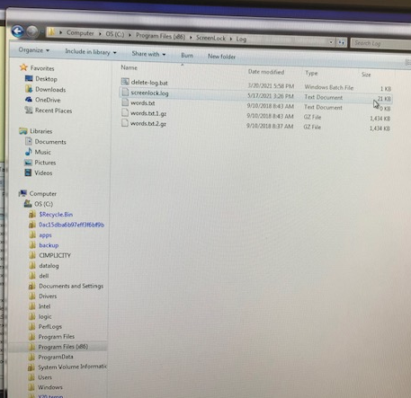
Open file manager to OS(C:)> ProgramFiles (x86)>ScreenLock> Log

Delete “Screenlock.log”

Back up to folder OS(C:)> ProgramFiles (x86)>ScreenLock

Locate screenlockServer.exe and double click to run

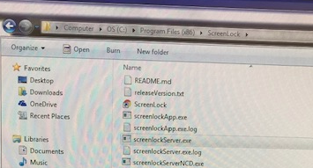

If you bypassed screen lock directly, then all is OK. If you enabled in CORAL then disable will start a 2nd screenlock and display will be almost white and hard to read. You can enable and disable again to restore to normal “locked” appearance.

