TM Vacuum Sputter System SOP
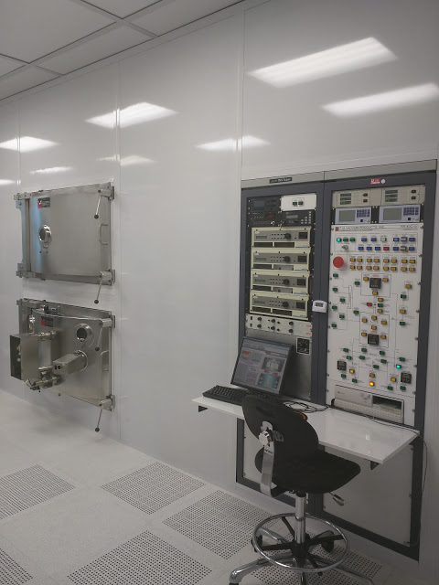
- Scope
  - This document provides the procedures and requirements to operate the TM Vacuum Sputter system.
- Table of Contents
1 Scope 1
2 Table of Contents 1
3 Reference Documents 2
3.1 Referenced within this Document 2
3.2 External Documents 2
4 Equipment and/or Materials 2
5 Safety 2
6 Setup Procedures 2
7 Load Samples 2
8 Pump Down the Load-lock Chamber 6
9 Transfer Carousel to the Main Chamber 7
10 DC Sputter 8
11 Transfer of Carousel back to Load-Lock 14
12 Unload Samples from the Load-lock 14
13 Troubleshooting 15
13.1 Plasma does not Ignite 15
14 Process Notes 16
14.1 TMV Parameters 16
14.2 TMV Target Positions 16
15 Revision History 17

Figure 1, TMV Chambers 3
Figure 2, Ion Gauges 3
Figure 3, Control Mode 3
Figure 4, Load Lock Control Panel 4
Figure 5, Sample Loading 4
Figure 6, Chuck Positions 5
Figure 7, Handle (Secured Position) 5
Figure 9, Load Lock Vacuum Panel 6
Figure 11, Main Menu 7
Figure 12, Gate Valve Buttons 7
Figure 13, Automatic Control Panel 8
Figure 14, Substrate Index Rotation Control Window 9
Figure 15, MKS Pressure Controller 10
Figure 16, Sample Rotation Selector 10
Figure 17, Power Supply/Cathode Selection Screen 11
Figure 18, DCGs 11
Figure 19, Plasma Supply Control 12
Figure 20, Cathode Shutter Control 13
Figure 21, TMV Target Positions 16

Table 1, Power Setpoints 12
Table 2, Cathode Materials 13
Table 3, Sputter Parameters 16

- Reference Documents
Referenced within this Document
    - None
External Documents
    - None
- Equipment and/or Materials
  - TMV Sputtering System
  - Wafer
  - Kapton Tape
  - Nylon Screws
  - Flashlight
  - Crowbar
- Safety
  - Follow all Nanofab safety procedures.
  - Place carousel only on clean stainless steel surfaces.
  - Ask for assistance moving carousel if too heavy to remove/mount alone.
  - Do NOT use a chair/stool with wheels to stand on while attempting to remove/mount the carousel.
  - Use only kapton tape or plastic screws to secure samples to the rotating chuck.
- Setup Procedures
  - Reserve and enable TMV system in Coral.
System will not vent without being enabled.
  - Record all information on log sheet.
- Load Samples
  - Use flash light to check that the carousel is in the load-lock chamber. See Figure 1, TMV Chambers.
  - Check to see that the following buttons are lit on the control panel.
Load Lock
Main Chamber
Figure 1, TMV Chambers
[A] load-lock cryo-pump (yellow button)
[B] load-lock high-vac valve (green button)
[C] main chamber cryo-pump (yellow button)
[D] main chamber high-vac valve (green button)
    - If not lit, DO NOT turn on the ion gauge for either the main chamber or the load-lock, and contact the fab staff.
  - If there is a reading on top left IG display, press Chamber Gauge button to turn it OFF. See Figure 2, Ion Gauges.
  - 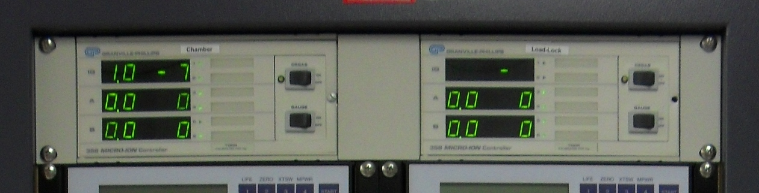Check reading A on Main Chamber ion gauge; the reading should be 0.0. See Figure 2.
Chamber IG
Load Lock IG
Gauge Buttons
Figure 2, Ion Gauges
Reading A
  - If load-lock Ion Gauge is on (top right IG display), press Gauge to turn it OFF. See Figure 2.
  - Turn CONTROL MODE key to AUTO position. See Figure 3, Control Mode.
The AUTO light should be on.
  - 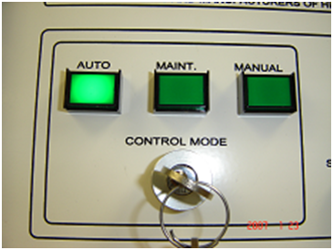If load lock AUTO PUMP is on, turn it OFF. See Figure 4, Load Lock Control Panel.
Figure 3, Control Mode
  - Press AUTO VENT on the Load-lock panel. See Figure 4.
    - If AUTO VENT does not work, (light does not come on, no gas sound), press TRANSFER GATE VALVE CLOSE, then try AUTO VENT again.
  - If AUTO VENT still does not work, put the key in MANUAL mode.
    - Close the load-lock high-vac valve (light off).
    - 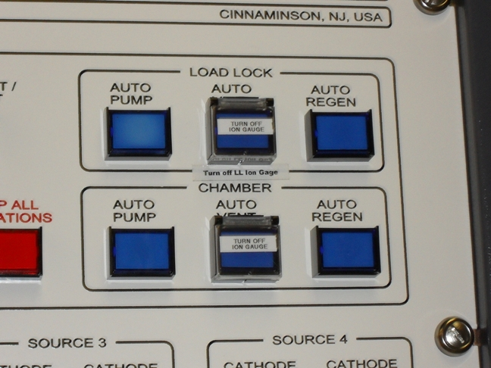Open the load-lock vent valve (light on).
Load Lock AUTO PUMP Button
Load Lock AUTO VENT Button
Figure 4, Load Lock Control Panel
    - Close the load-lock vent valve after the door opens (light off).
    - Return the key to AUTO mode.
  - Once the load lock door pops open, press AUTO VENT again to stop the nitrogen flow.
Pay attention to glove cleanliness when handling the carousel so as not to contaminate your sample.
If you are only using 1 or 2 chucks, you may load the wafers onto the chuck(s) without removing the carousel.
  - If you are using more than 2 chucks, remove the carousel from the load-lock.
    - Lift the carousel off the pins.
    - 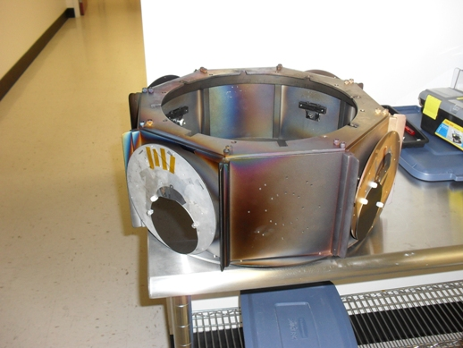Rotate the carousel 1/16 of a turn.
Carousel
Nylon Screw
Chuck
Wafer
Figure 5, Sample Loading
    - Slide the carousel down off of it’s mount.
  - Load samples on rotating chucks. See Figure 5.
Only 2 of the chucks are able to rotate. If you need chuck rotation, load your samples on the chucks with small gears on the back.
    - Attach samples on the chuck with the nylon screws or kapton tape.
1
7
8
6
5
4
3
2
Sample Holders
Front of TMV
Chuck Positions as Loaded into the Load Lock
Figure 6, Chuck Positions
The nylon screws are located in the small black toolbox.
  - Note the position of your samples on the carousel. See Figure 6, Chuck Positions.
  - Mount the carousel in the load lock (ask for help from others).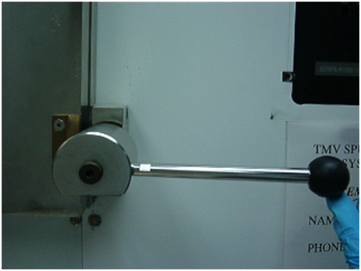
Figure 7, Handle (Secured Position)
    - Slide the carousel up over the mounts.
    - Rotate the carousel 1/16 of a turn.
    - Bring the carousel down on the mount pins.
  - Close the load-lock door. See Figure 7, Handle (Secured Position).
    - Secure the top door handle. Do NOT overtighten.
    - Use a crowbar on the lefthand side to help seal the door during pumpdown.
- Pump Down the Load-lock Chamber
  - Press Load lock AUTO PUMP. See Figure 4, Load Lock Control Panel.
The light for the Roughing Pump will come on.
Within 30 seconds the load lock handle will fall. This indicates that the door is sealed and the load-lock is pumping down.
After about 8 minutes the LOAD LOCK ROUGHING VALVE light will be OFF (automatically) and LOAD LOCK HIGH VAC VALVE light will be ON.
Load Lock High Vac Valve Light
Roughing Pump Button
Load Lock Roughing Valve Light
Figure 9, Load Lock Vacuum Panel
Check that the Load Lock Cryo-Pump is ON after the Load Lock opens.
  - Turn off the roughing pump by pressing ROUGHING PUMP on the front control panel. See Figure 9, Load Lock Vacuum Panel.
  - Set the timer for 5 minutes.
  - Start the timer.
  - Enter Coral run data while the load-lock is pumping down.
  - When the 5 minutes are up, press GAUGE on the load-lock ion gauge to turn it on. See Figure 2, Ion Gauges.
  - If the Main Chamber Ion Gauge is OFF, turn it ON by pressing GAUGE on the Chamber Ion gauge controller. See Figure 2, Ion Gauges.

- Transfer Carousel to the Main Chamber
  - Check to make sure the ion gauges are either both ON or both OFF or transfer gate valve will not open.
CAUTION
The Ion Gauges are extremely sensitive. They should only be turned on when the machine is under high vacuum and not sputtering.
  - Transfer to the main chamber may begin once the load lock IG pressure is less than 3 x 10⁻⁶ Torr.
  - On the TMV computer (monitor) go to the MAIN MENU.
  - 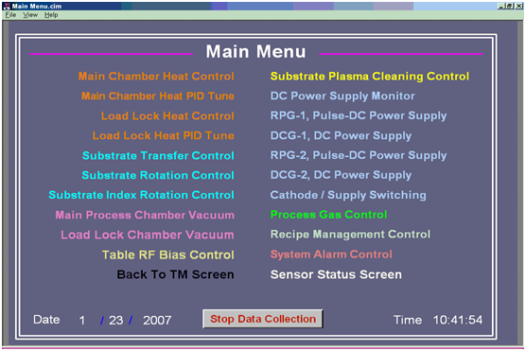Click “Substrate Transfer Control”. See Figure 8, Main Menu.
Figure 8, Main Menu
You will see Load lock, chamber and gate valve animated photographs here.
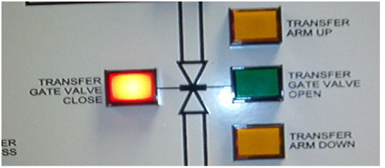 You can see if the gate valve is open or closed on this screen. Red = closed, Gray = open.
Transfer Gate Valve Open Button
Figure 9, Gate Valve Buttons
Transfer Gate Valve Close Button
  - Press the TRANSFER GATE VALVE OPEN on the front panel (manually). See Figure 9, Gate Valve Buttons.
You will hear a loud noise of the valve opening.
    - Check on the monitor to see if the gate valve is open or closed.
If gate valve is Open then proceed to next step otherwise contact Nanofab staff.
  - 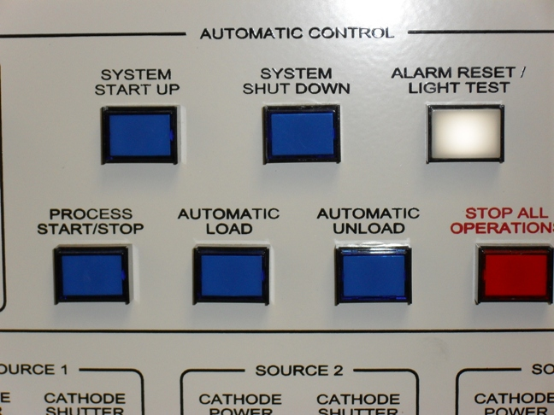Press AUTO LOAD button on the control panel. See Figure 10, Automatic Control Panel.
Auto Load Button
Figure 10, Automatic Control Panel
Auto Unload Button
On the Computer Screen you will see animated pictures of carousel transferring to the main chamber.
The transfer process will take about 5 minutes.
The software will say “Transfer Arm is not at Home” during the transfer.
    - Wait until the software says “Transfer Arm Is At Home”.
  - When the Transfer Arm has returned home, press TRANSFER GATE VALVE CLOSE (red button) on the front panel. See Figure 9, Gate Valve Buttons.
You will hear loud noise of gate valve closing.
  - Wait till Chamber IG pressure is below 9 x 10⁻⁷ Torr. See Figure 2, Ion Gauges.
This is called the base pressure.
  - Write this value in the log book.
- DC Sputter
  - Turn OFF the Main Chamber ion gauge by pressing the gauge switch. See Figure 2.
There should be no reading on the IG display.
  - Rotate the control mode key to the MANUAL position. See Figure 3, Control Mode.
  - Go to the Main Menu.
  - From the Main Menu on the computer click “Substrate Index Rotation Control”. See Figure 8, Main Menu.
  - Click INDEX POWER. See Figure 11, Substrate Index Rotation Control Window.
  - Wait for carousel to stop (on the picture).
  - Check your sample position inside the main chamber using the flashlight.
  - Note the chuck number on the carousel.
  - Click NEXT INDEX to bring the samples in front of your desired metal target. See Figure 18, TMV Target Positions.
  - 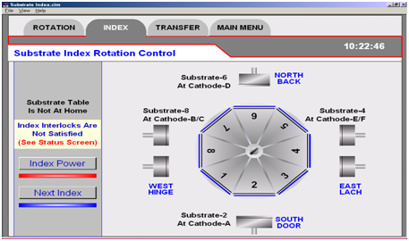Click on MAIN MENU.
Index Power
Next Index
Figure 11, Substrate Index Rotation Control Window
  - Click on PROCESS GAS CONTROL from the MAIN MENU.
    - Click on CHAMBER BARATRON VALVE.
    - Wait for 10 seconds until the indicator on the control panel lights up and stops blinking.
    - Click on REMOTE PRESSURE SET POINT OFF.
    - 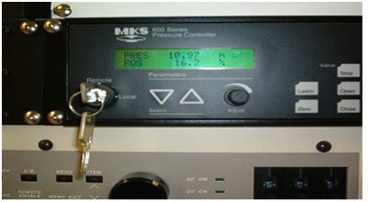Click on the SET PRESSURE VALUE. See Table 3, Sputter Parameters.
Pressure Readout
Figure 12, MKS Pressure Controller
      - Type 20 to get 20 mTorr pressure.
    - Click CHAMBER PROCESS GAS.
    - Click INDIRECT.
    - Click GAS-3 (Ar gas).
Flow rate of Argon is 150 sccm.
    - If reactive sputtering with O2, click GAS 2.
      - See staff for assistance switching from O2 to N2.
  - Read the chamber pressure on MKS Pressure controller. See Figure 12, MKS Pressure Controller.
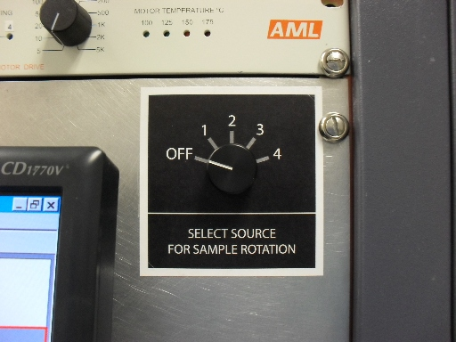The reading should match the pressure you entered in step 12.8.4.1.
Figure 13, Sample Rotation Selector
1 = Cr

2 = Ir or TiW

3 = Ti

4 = Au or Pt
  - Ensure that the AML (sample rotation power source) is on.
  - Rotate the Sample Rotation Selector knob to the target location. See Figure 13.
Make sure to turn the Sample Rotation Selector knob to OFF before changing targets.
    - Using the flashlight, check inside the chamber (through the window) to see if your samples are at desired location and the chuck is rotating.
  - Click on MAIN MENU.
  - From the main menu, click on CATHODE/SUPPLY SWITCHING.
    - 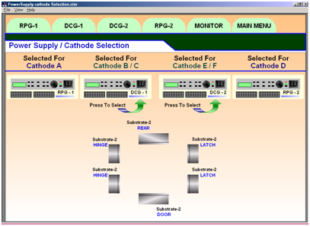Ensure that the picture of the target you see on the monitor matches with the white board on TMV.
Figure 14, Power Supply/Cathode Selection Screen
Each target lists the power supply that connects to it.
    - Click on the desired metal target.
    - Make sure the connection is between DCG-1 / DCG-2 and the desired metal target and there is NO OTHER connection to any other metal target.
    - If the connection is in RPG-1 or RPG-2 then click on the generator picture.
  - 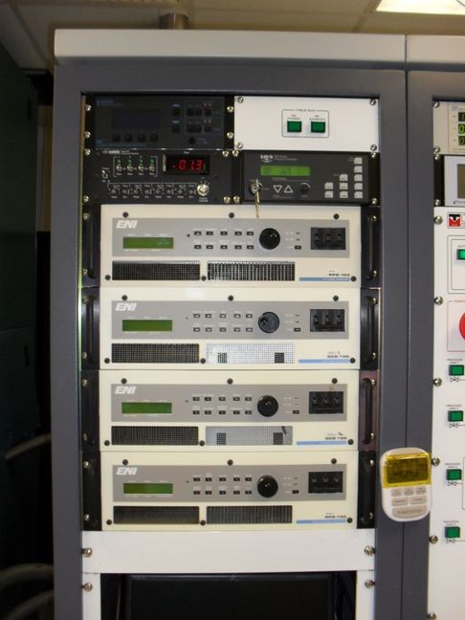Turn on the DCG (either DCG-1 or DGC-2). See Figure 15.
DCG 1
DCG 2
DCG Power Switches
MKS Pressure Controller
Figure 15, DCGs
Remote Enable Lights
    - Wait a few moments till the generator is ready (wait for click).
    - Make sure that the remote enable light is on for the power supply you turned on.
The power supply display will indicate that is it stable.
  - Back on the computer monitor, click on the appropriate DCG tab.
  - Click on the number next to TYPE IN SETPOINT.
    - Adjust the number until you get the desired power for your sputtering. See Table 1, Power Setpoints. Check the display on the EVI power supply for actual power read out.
Table 1, Power Setpoints
Power (Watts) | Set Point DCG | Set Point RPG
50 (max power for liftoff) | 0.94 | 0.42
100 | 1.92 | 0.92
150 | 2.88 | 1.4
200 | 3.86 | 1.9
250 | 4.85 | 2.38
300 (do not exceed 300 W) | 5.84 | 2.87

DO NOT exceed 300W
(50 W max for liftoff, photoresist will hard bake at higher power)
CAUTION

  - On the computer monitor, click on PLASMA to begin sputtering. See Figure 16.
  - Look through the chamber porthole to see if plasma is formed.
The plasma is a purple or blue glow also the Voltage should drop when the plasma ignites.
    - 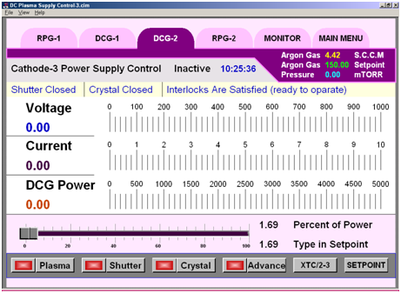If yes proceed to next step, otherwise click on PLASMA again (to Stop) and go to section 15 Troubleshooting.
Figure 16, Plasma Supply Control
Plasma Button
  - Pre-sputter for desired time (usually 2 min).
The Voltage should read between 200-700 Volts and the Current should read between 0.1-0.5 Amps.
Table 2, Cathode Materials
Target | Cathode Shutter #
Cr | 1
TiW | 2
Ir | 2
Ti | 3
Au | 4
Pt | 4
  - Adjust Gas Pressure to desired level.
  - Set timer to the desired sputter time. See Error! Reference source not found..
  - Press CATHODE SHUTTER button on the front panel. See Table 2, Cathode Materials.
Shutter should be opened manually from the front panel and not from the software.
  - Start the timer.
  - Check inside the chamber from the window if shutter is open fully and if chuck is rotating.
    - Any abnormalities need to written on the log book (in comment section).
  - When the desired time has elapsed, press CATHODE SHUTTER on the panel manually to close the shutter. See Figure 17.
  - 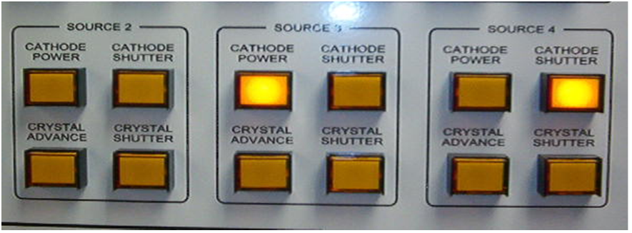If more samples on other chucks need to be sputtered with the same target then do the following:
Cathode Shutter Buttons
Figure 17, Cathode Shutter Control
    - Turn OFF the Rotation Control.
    - Click MAIN MENU.
    - Click SUBSTRATE INDEX ROTATION CONTROL.
    - Click on NEXT INDEX until your samples are in front of desired metal target.
    - Repeat from Step 12.22.
  - When finished sputtering with the target, click on PLASMA (to stop).
  - Turn off the DCG power. See Figure 15.
  - If you need to sputter another layer of different metal then repeat the process from Step 12.12.
  - When Sputtering is completely finished, click on MAIN MENU.
  - Click on PROCESS GAS CONTROL.
    - Click on GAS 3 to stop gas flow.
    - Click on INDIRECT to stop.
    - Click on CHAMBER PROCESS GAS.
    - Click on REMOTE PRESSURE SET POINT ON.
    - Click on CHAMBER BARATRON VALVE.
  - Click on MAIN MENU.
  - Rotate the Sample Rotation Selector knob to OFF. See Figure 13.
- Transfer of Carousel back to Load-Lock
  - Make sure the DCG power is off, the gas pressure is zero, and the Sample Rotation Selector is OFF.
  - Press Gauge to turn ON the Main Chamber ion gauge.
  - Make sure that the Load Lock Ion Gauge is also ON.
  - On the computer go to the MAIN MENU click “Substrate Transfer Control”.
    - The computer screen should show the transfer gate valve closed (red triangles).
  - Press TRANSFER GATE VALVE OPEN on the front panel (manually).
You will hear loud noise of valve opening.
  - Check on the monitor to see if gate valve is open or closed (red triangles are gone).
    - If gate valve is OPEN then proceed to next step otherwise contact fab staff.
  - Turn the key to AUTO mode on the control panel.
  - Press AUTOMATIC UNLOAD on the control panel.
You will see animated pictures of transfer of carousel from main chamber to load-lock.
The transfer process will take about 5 minutes.
    - Wait until the software says “Tranfer Arm is at Home”.
    - Contact staff if transfer fails.
  - Press TRANSFER GATE VALVE CLOSE on the front panel.
You will hear loud noise of gate valve closing.
- Unload Samples from the Load-lock
  - Turn off the load lock ion gauge.
    - Make sure that there is NO reading on load lock ion gauge.
  - Press AUTO VENT on the load-lock panel.
You will hear loud noise of air rushing to load lock.
  - Wait for 1-2 min and Load-lock door will OPEN automatically.
  - Press AUTO VENT on load-lock panel to stop gas flow.
  - Unload the carousel. Ask for assistance if needed.
    - Remove samples.
  - Mount the carousel in the load-lock chamber. Ask for assistance if needed.
  - Put the bottom load-lock locking handle in a horizontal position.
  - Turn on N2 on wall behind TMV.
  - Press Auto Pump on the load lock control panel.
    - When the roughing pump light comes on, start the roughing pump.
  - Once the load lock high-vac valve has opened as indicated on the control panel, turn off the roughing pump.
  - Turn off the N2 gas.
  - Turn off the load lock Auto Pump
  - Make sure your run has been entered into Coral.
  - Disable the TMV system in Coral.
- Troubleshooting
Plasma does not Ignite
    - Go to the Process Gas Control page.
    - Click on the pressure set point.
    - Increase the set point.
    - Click Ok.
    - Go back to the DCG page.
    - Click Plasma to start sputtering.
    - Check the Voltage, it should drop to within the 200-700V range when the plasma ignites.
    - If the plasma still does not ignite, try opening the shutter.
    - If the plasma does ignite, close the shutter, if open.
    - Go back to the Process Gas Control page to correct the gas pressure setpoint.
- Process Notes
TMV Parameters
Table 3, Sputter Parameters
Shutter # | Metal | Power  (Watts) | Pressure  (mTorr) | Time  (min) | Thickness  (nm) | Dep Rate  (nm/min)
1 | Cr | 100 | 10 | 10 | 101 | 10
2 | TiW | 45 | 10 | 30 | 191 | 6.4
2 | Ir | 100 | 10 | 10 | 80 | 8
3 | Ti | 90 | 10 | 10 | 70 | 7
4 | Au | 45 | 10 | 10 | 190 | 19
4 | Pt | 90 | 10 | 20 | 336 | 16
TMV Target Positions
Source 3 Shutter

Back
Ti
DCG2

DCG1
Cr
Front
Source 1 Shutter
Source 2 Shutter
DCG1

Source 4 Shutter
DCG2
Top
TiW
DCG1
Top
Au
DCG2
Bottom
Pt
DCG2
Bottom
Ir
DCG1
Figure 18, TMV Target Positions
TMV DOOR
- Revision History
Rev | Date | Originator | Description of Changes
1 | 10 May 2010 | L. Williams | Initial release.
2 | 20 May 2010 | Sam Bell | Added figures and tables.
3 | 28 Dec 2010 | Sam Bell | Deleted fig. 9, added text
4 | 4 Apr 2011 | Sam Bell | Changed rotation control figure and procedure pp 11, 14, 15. Updated Table 3, pp 16

