Xetch System SOP
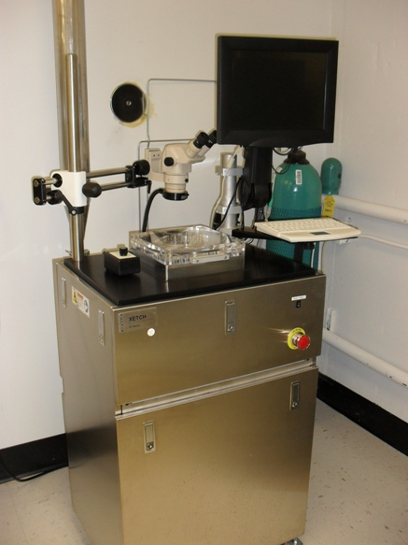
- Scope
  - This document provides procedures and process information for etching silicon wafers with the Xetch xenon difluoride etching system.
- Table of Contents
1. Scope 1
2. Table of Contents 1
3. Reference Documents 2
3.1 Referenced within this Document 2
3.2 External Documents 2
4. Equipment and/or Materials 2
5. Safety 2
6. Setup Procedures 3
6.1 Start-up 3
6.2 Xetch Log In 4
6.3 Sample Loading 5
6.4 Close the lid. 5
7. Etching Procedures 5
7.2 Enter the Etch Menu 5
7.3 Select a Recipe 5
7.4 Start the Etch 6
7.5 Unload Sample 6
8. Shutdown Procedures 6
8.1 Shutdown 6
8.2 Figures 6
9. Process Notes 7
9.1 Etch Characteristics 7
10. Revision History 7

Figure 2, Computer Power Switch 3
Figure 1, Main Power 3
Figure 3, CDA and N2 Valves 3
Figure 4, Startup Options 4
Figure 5, Login 4
Figure 6, Load/Unload Sample 5
Figure 7, Main Menu 6
Figure 8, Etch Menu 7

Table 1, Recipe Parameters 5

- Reference Documents
Referenced within this Document
    - D150 GRC SOP
External Documents
    - Xetch System Manual, Xactix Inc. Copyright 2000-2002.
- Equipment and/or Materials
  - Wafer/Sample
  - Xetch XeF2 etching system
- Safety
  - Follow all Nanofab safety procedures.
- Setup Procedures
Start-up
    - GRC. Should always be ON
      - Not in Alarm. Observe GRC status through chase door. Contact Nanofab staff if problems.
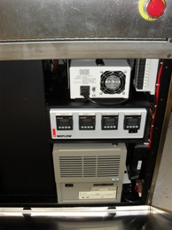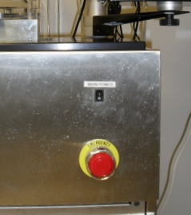
Computer Power
Figure 1, Computer Power Switch
Figure 2, Main Power
Main Power Switch
CAUTION
Failure to turn on the GRC may result in the release of toxic gases in to the atmosphere
    - Xetch main power should always be on. If off, turn on. (See Figure 2, Main Power.)
    - Xetch computer should always be on.
      - 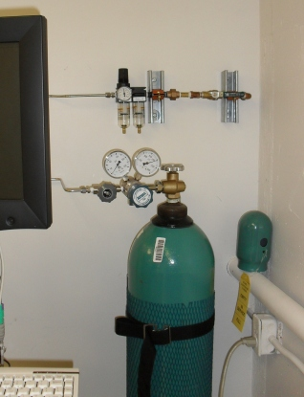Behind lower front panel you will find switch of the computer power. (See Figure 1.)
N2 Bottle Valve
CDA Valve
CDA Regulator
N2 Regulator
N2 Valve
Figure 3, CDA and N2 Valves
      - N2 flow should be regulate to 15-20 psi. (See Figure 3.)
      - To Re-adjust regulator if necessary, contact Nanofab staff.
    - Compressed Air flow.
      - CDA valve should be open, and flow regulated to 70-80 psi. (See Figure 3.)

    - Turn on vacuum pump.
Switch on vacuum pump with the red switch on the wall.

NOTE: If vacuum pump does not turn on, contact Nanofab staff.

    - When the Windows log-in box appears on the screen, click OK.

NOTE: User name: Administrator, Password: leave blank

    - Enable in coral

NOTE: If coral does not allow you to enable, turn off computer for about 5 min. (See figure. 1)

    - Double click on the Xactix Xetch icon on the desktop.
    - Click on NORMAL to enter Xetch start-up. See Figure 4, Startup Options.
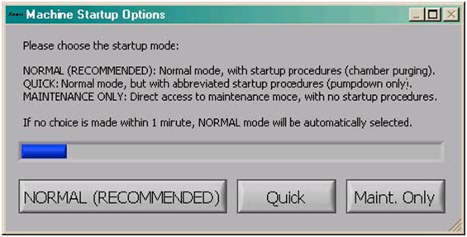
Figure 4, Startup Options
NOTE: The system will begin a cycle of pumps and purges which takes about 10 minutes.
Xetch Log In
    - Enter labuser for the user name and password. See Figure 5, Login.
    - Click Login button.
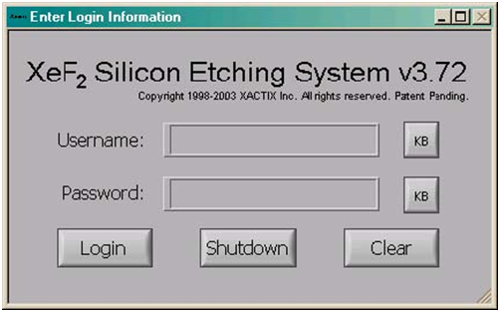
Figure 5, Login
NOTE: This will take you to the Main Menu.
Sample Loading
    - Press Load/Unload Sample button on the Main Menu. See Figure 7.
    - Press Yes.
NOTE: The system begins chamber purges and flushing cycles to evacuate the chamber.
    - Swing the microscope out of the way of the chamber.
    - Open the chamber lid when the dialogue box comes up. See Figure 6, Load/Unload Sample.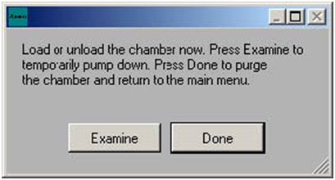
Figure 6, Load/Unload Sample
    - Load a sample.
Close the lid.
    - Press the Done button. See Figure 6.
NOTE: The system will go through a cycle of pumps and purges.
NOTE: This will take you to the Main Menu.
- Etching Procedures
  - Record Information on Log Sheet
    - You will need to record E.R. or Etch depth, and cycles in comments at disable.
Enter the Etch Menu
    - Select the Etch Menu button on the main menu. See Figure 7.
    - Enter the lot # of the sample being etched.
    - Press Done.
    - This will open the Etch Menu.
Select a Recipe
    - Select a recipe from the drop down menu, labeled “current recipe” at top left of the screen. See figure 8). See Table 1, Recipe Parameters.
Table 1, Recipe Parameters |  |  |  |  |  | Expected Etch  Depth  (see NOTE)
Recipe | # of Cycles | Etch Time (seconds) | Total etch time (minutes) | XeF2 press. (Torr) | N2 press. (Torr)
Test 1 | 15 | 11 | 2.75 | 1.0 | 10.0 | ~ 6 um
Test 2 | 64 | 11 | 11.7 | 1.0 | 10.0 | ~ 26 um
Raj | 90 | 11 | 16.5 | 1.0 | 10.0 | ~ 33 um
NOTE: Etch depth based on 4” Si wafer with <10% exposed area.
    - Modify the recipe as needed to account for wafer size, exposed area, and/or desired etch depth.
      - Change the number of cycles on the Etch Menu to increase/decrease total etch time. See Figure 8, Etch Menu.
Start the Etch
    - Press the Start Etch button to start etching.
NOTE: The system will automatically start and finish the etch process.
    - Use the optical microscope to view your sample during the etch process.
NOTE: The Change Cycles button may be used at any time during an etch to add/delete cycles to/from the etch in-progress.
NOTE: The Stop button may be used to end an etch prematurely.
Unload Sample
    - When the etch is complete, follow the procedure in 6.3 to unload the sample.
- Shutdown Procedures
Shutdown
    - Turn off vacuum pump.
Figures
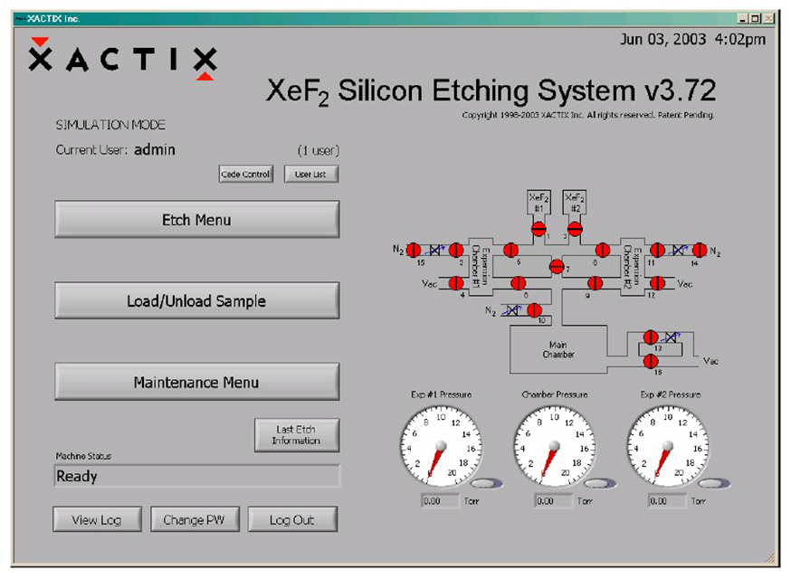
Figure 7, Main Menu
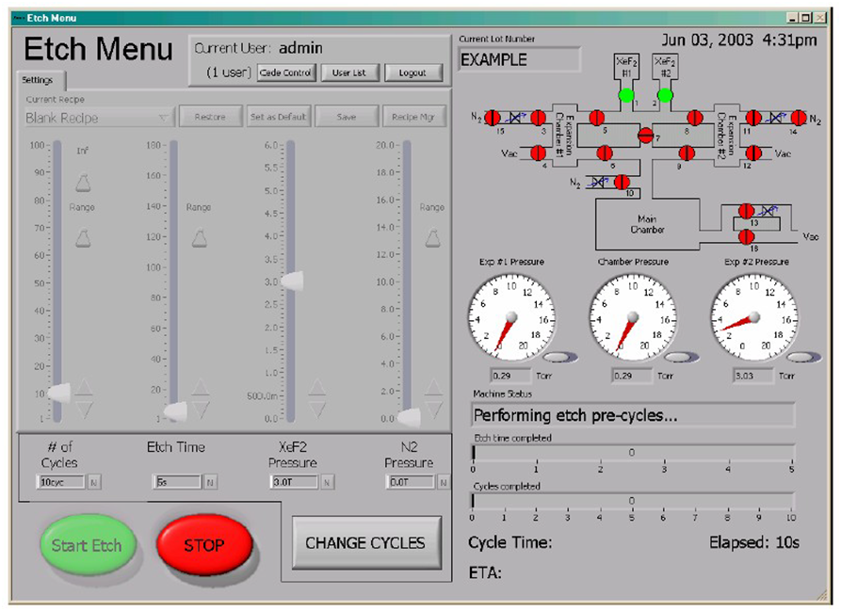
Figure 8, Etch Menu
- Process Notes
Etch Characteristics
    - For a 4” Si wafer with 10% exposed area, expected etch rate is ~2 um/min.
- Revision History
Rev | Date | Originator | Description of Changes
1 | 15 Dec 2009 | Sam Bell

