4 Point Probe SOP
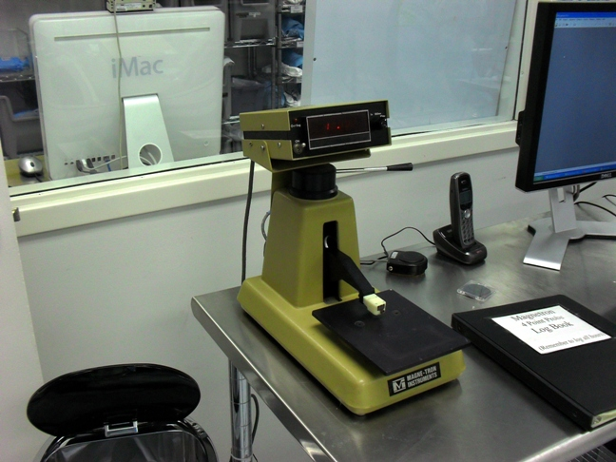
- Scope
  - This document provides the procedure for measuring and calculating sheet resistance and resistivity with the 4 point probe.
- Table of Contents
1. Scope 1
2. Table of Contents 1
3. Reference Documents 2
3.1 Referenced within this Document 2
3.2 External Documents 2
4. Equipment and/or Materials 2
5. Safety 2
6. Measurement Procedures 2
7. Calculation Procedures 3
8. Revision History 3

Figure 1, 4 Point Probe Controls 2

- Reference Documents
- Referenced within this Document
    - None
- External Documents
    - None
- Equipment and/or Materials
  - 4 Point Probe
  - Wafer/Sample
- Safety
  - Follow all Nanofab safety procedures.
- Measurement Procedures
  - Turn on the Probe.
    - Turn on the power switch. See Error: Reference source not found.
  - Load the Sample.
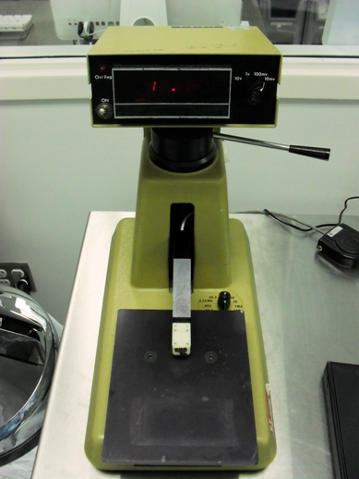
Voltage Knob
Current Knob
Contact Lever
Power Switch
Figure , 4 Point Probe Controls
  - Turn the current down to 1 mA using the knob on the base of the probe station. See Error: Reference source not found.
  - Turn the contact lever to the left to contact the substrate with the probe tips. See Error: Reference source not found.
  - Turn the voltage and current knobs until you get a reading that is not 1 or 0. See Error: Reference source not found.
  - Note the measured voltage and the current you are applying.
  - Use the equations below to calculate sheet resistance and resistivity.
- Calculation Procedures
  - On the desktop of the computer next to the 4 point probe, find the Excel sheet named Resistivity Calculator and plug in your values.
  - Sheet Resistance (Rs) = resistivity/thickness of conductive layer(s) = 4.53*V/I
  - Where V is the voltage measured by the 4 point probe and I is the current applied to the probes.
  - For Example:
  - 0.2 um film of gold on a glass substrate measures 2.05 mV on the 10 mV scale with a current setting of 44.5 mA.
  - The sheet resistance would be:
  - Rs (Ohm/square) = 4.53*V/I = 4.53*.00205V/.0445A = 0.209 Ohm/square.
  - And the resistivity would be:
  - Resistivity (Ohm-cm) = Rs*t = .209 Ohm/sq *0.2 um *.0001 cm/um = .00000418 Ohm-cm = 4.18 uOhm-cm.
  - Another Example:
  - 2” N-type wafer with a specified resistivity of 1-10 Ohm-cm and a thickness of 10-12 mils (250-300 um).
  - The voltage measured is 123.4 mV on the 100 mV scale and the current is 4.53 mA.
  - Rs = 4.53 * V/I = 4.53 * 0.1234V/.00453A = 123.4 Ohm/sq.
  - Resistivity = Rs*t = 123.4 Ohm/sq * 275 um * .0001cm/um = 3.4 Ohm-cm, which is in the specified range of 1-10 Ohm-cm.
- Revision History
Rev | Date | Originator | Description of Changes
1 | 02 June 2010 | Sam Bell

