Heidelberg Pattern Generator SOP

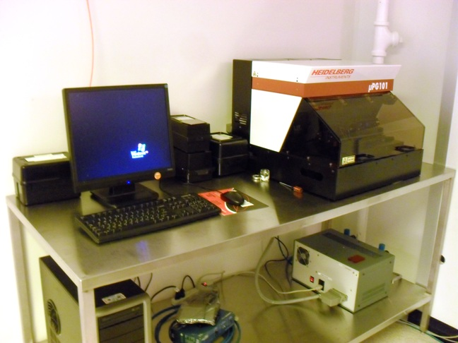

1. Scope
   1. This document provides the operating procedures for the Heidelberg Pattern Generator with Version 3.12.5 software.
2. Table of Contents

1. Scope 1

2. Table of Contents 1

3. Reference Documents 2

3.1 Referenced within this Document 2

3.2 External Documents 2

4. Equipment and/or Materials 2

5. Safety 2

6. Pattern Design and Conversion 2

6.1 Design Data 2

6.2 General Design Rules 3

6.3 DXF Specific Design Rules (AutoCAD) 3

6.4 CIF Specific Design Rules 3

6.5 BMP Specific Design Rules 4

6.6 GDSII Specific Design Rules 4

6.7 Convert to CIF format 4

7. µPG Normal Operations 4

7.1 Reserve and Enable µPG in Coral 4

7.2 Setup PC 5

7.3 Load Design 5

7.4 Set PG Parameters 6

7.5 Load Mask 7

7.6 Manual Alignment 10

7.7 Begin Expose 11

7.8 Unload Mask 12

8. Troubleshooting Problems 13

9. Alignment Options 13

10. Revision History 15

1. Reference Documents

Referenced within this Document

* + 1. None

External Documents

* + 1. None

1. Equipment and/or Materials
   1. Mask
   2. USB Drive
2. Safety
   1. Follow all Nanofab safety procedures.
3. Pattern Design and Conversion

Design Data

* + 1. The μPG 101 can expose designs created in one of the following formats
* CIF: *Caltech Intermediate Form*, easy-to-use language for direct definition of

structures in a text file (recommended format)

* DXF: Standard AutoCAD format
* BMP: Standard MS-Windows® Bitmap format. This is the only format

useable for grayscale exposures (3D resist structuring

* GDSII: Standard format for dense binary (2 dimensional) designs

NOTE: To get the correct results, certain rules have to be followed when creating the design.

General Design Rules

* + 1. Maximum design size is 100 mm x 100 mm.
    2. Use polygons or circles that enclose areas, these may overlap and will be combined for exposure with an OR function.
    3. Defined areas will be exposed by default (you can select darkfield or lightfield later in the μPG program).
    4. Do not use special characters (spaces, punctuation marks, umlauts ..) in the design name.
    5. It is recommended to center the design (0, 0 at center of pattern), otherwise the μPG program will calculate offsets using max and min x and y and center the design.

DXF Specific Design Rules (AutoCAD)

* + 1. Use a 100% AutoCAD compatible editor.
    2. The design has to be created in metric units.
    3. Do not use single lines without width.
    4. All polylines must be closed (use close command for last segment). Keep in mind interiors of polyline structures will be filled out completely, covering any structures within.
    5. Do not cross polylines, or create doubled vertices (vertices with no distance between them). This will create data error.
    6. As far as possible, only use the structure types “polyline”, “circle”, and “text”.
    7. Only one text font is provided. This will replace any other font used in the design creation. The only supported text attributes are “rotated”, “mirrored”, and “scaled”.
    8. Try to use as few layers as possible. All exported layers will be merged via an OR operation.
    9. Do not use special characters in the layer names.
    10. Polylines with width must not change their width (no tapered lines).
    11. When inserting blocks, the same scaling has to be used for x and y.
    12. External blocks are not supported.

NOTE: Zoom Extents will find any unexpected features outside normal design viewing window.

* + 1. Save file as .dxf, use LinkCAD to convert to .cif., see following section Convert to CIF format

CIF Specific Design Rules

* + 1. Use only one layer. If several layers exist in a design file, only the layer with the most references will be written.
    2. Maximum definition or reference depth is 50.
    3. The subroutine with the highest number definition will be taken as main routine.

BMP Specific Design Rules

* + 1. Maximum image file size is 4 GB.
    2. For grayscale exposures, use 8-bit format. The 256 gray values will be interpolated down to 100 gray values.
    3. Create the design in a 90° counter-clockwise rotated version, as the design will be rotated 90° clockwise during data processing.

GDSII Specific Design Rules

* + 1. No Inclusions:Do not include other GDII files or text libraries, they will be ignored.
    2. No nodes:Node statements in GDSII are ignored.

Convert to CIF format

* + 1. Start LinkCad software on cad station.
    2. Select import format (i.e. DXF) from dropdown list.
    3. Select Export format CIF, then click on next.
    4. Check Units and scaling factor and adjust for input drawing, try using defaults for ARC Precision and Layer Options, if text is in design remove check to ignore text.
    5. Click Next
    6. Try using defaults for CIF Export Options, click Next
    7. Select your import file for conversion in the browsing window, click Open
    8. Note error Log Messages if present and click Next (not shown if no errors)
    9. Check correct Layers included in File Structure screen, click Next
    10. Click Save to use same name with CIF extension, then Quit
    11. Find the saved .CIF file and double click to launch in viewer
    12. Confirm conversion was successful, note origin, design size and offsets
    13. Exit .CIF viewer

1. µPG Normal Operations

Reserve and Enable µPG in Coral

* + 1. Reserve time for the Pattern Generator on the computer reservation system.
    2. Enable the PG in Coral before beginning operation.
    3. Keep track of the following data to input into the Coral log:

|  |  |
| --- | --- |
| 1. | Substrate |
| 2. | Photoresist Type |
| 3. | Design file name |
| 4. | File type |
| 5. | Laser power |
| 6 | Pixel energy |
| 7. | Size-X |
| 8. | Size-Y |
| 9. | Inverted Y/N |
| 10. | X offset |
| 11. | Y offset |
| 12. | Number of Stripes |
| 13. | Alignment No/Auto/Manual |
| 14. | Total exposure time |

Setup PC

* + 1. Go to the µPG PC
    2. Click on labuser icon to get to the desk top
    3. Copy design file onto the PC
       1. Insert flash drive
       2. Go to the Utah Users folder on the desktop
       3. Find your directory or create a new folder titled ‘your name’
       4. Copy your design file(s) into this folder
    4. Start Exposure Wizard. *See* *Figure 1, Exposure Wizard Icon*

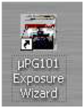

Figure 1, Exposure Wizard Icon

* + 1. Wait for system initialization, lid must be closed for initialization or stage movement
    2. Make sure the box for Show Advanced Options is checked and press Next

NOTE: Settings from previous exposure will be defaults without Advanced Options and not in standard selection menus

Load Design

* + 1. Press Load Design, See Figure 2, Image Preview
       1. Select your file
       2. Enter units – default 1000 for DFX ( for CIF units = 1)
    2. Wait for preview image to process
    3. Click on image to check it and close preview after checking
       1. If not correct, either return to Load Design step and load the correct design or select EXIT to quit Wizard
    4. Make sure size x, y and offset x, y look correct
    5. Note size and offset for Log
    6. Click Next

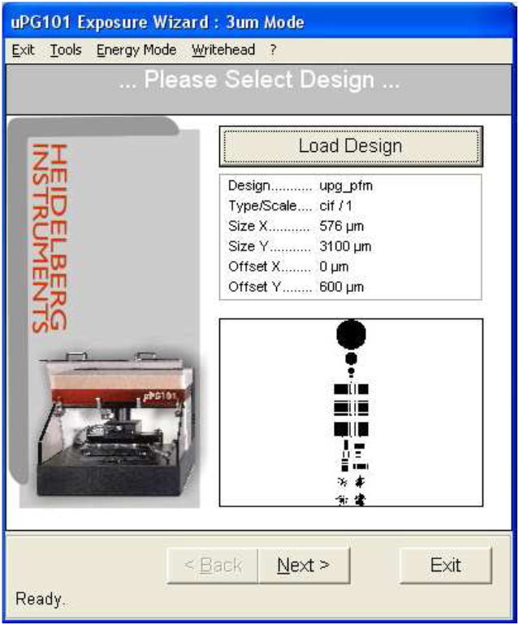

Default exposes dark area

Check ‘inverted’ box to expose white space

Figure 2, Image Preview

Set PG Parameters

* + 1. Check and set Options: see Figure 3, Check Options – Expose Window
       1. Power in mW, see current recommendation tag on μPG101
       2. Exposure level %, see current recommendation tag on μPG101
       3. Energy Mode: 1x1 (default for typical masks and resist)
       4. Inverted check on = Light field (opaque where features are drawn) or Inverted check off (default) = dark field (transparent where features are drawn), *see Figure 2, Image Preview*

NOTE: RIE or Wet Etch processes typically use light field mask to protect feature layer with PR. Lift-off processes typically use dark field mask for layer deposition into open areas

* + - * 1. Enter size of frame to expose extending outside design for inverted exposure – 0 to 10000 μm (larger number will increase write time)
      1. If the design is NOT centered and “no alignment” is planned, check Automatic Centering and if check box is active
      2. Click Show Control Panel button

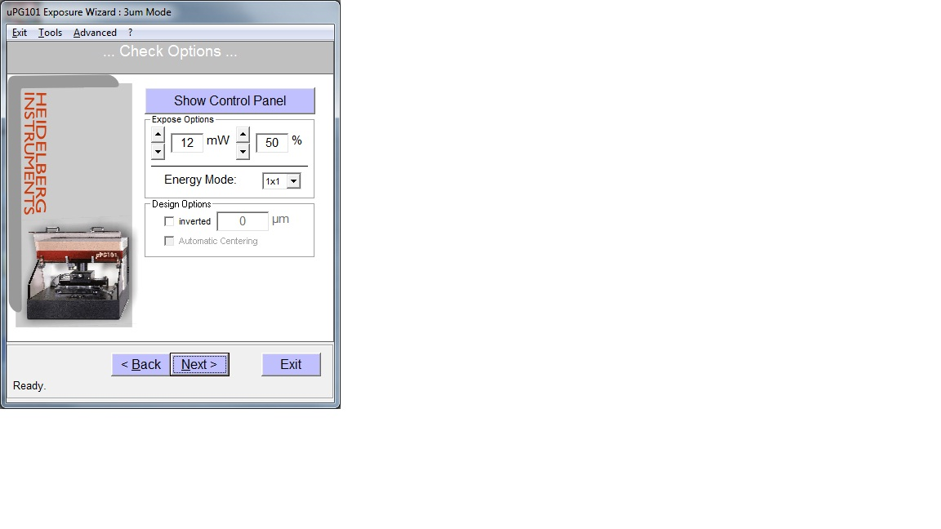

Figure 3, Check Options – Expose Window



Check for non-centered designs

Load Mask

* + 1. Click “To Un/Load” button in Stage Controls, see Figure 6, Controls Window
    2. Load Mask
       1. Open lid
       2. Place a 5 x5” mask against the 3 centering pins in the stage, 1 on the front edge and 2 on the left edge
          1. Contact staff for using substrates 1” or smaller, Writehead cannot auto focus with 1” or smaller size
          2. Or for other size substrates visually center on the stage
          3. If the pins must be removed to accommodate a larger substrate, contact staff

NOTE: Pins are an aid for centering the mask on the stage but not required

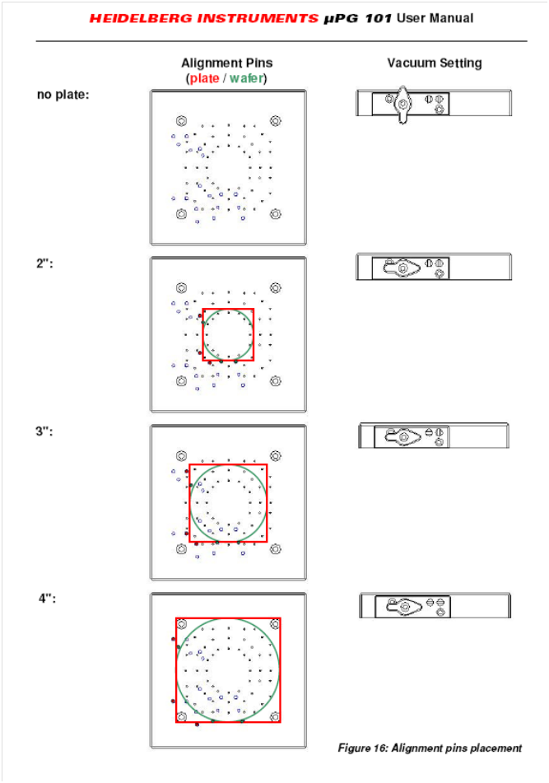

Figure 4, Placement & Vacuum Select

**and 5”:**

**(except 5” requires no pins)**

* + - 1. Check to make sure the mask is photoresist side up

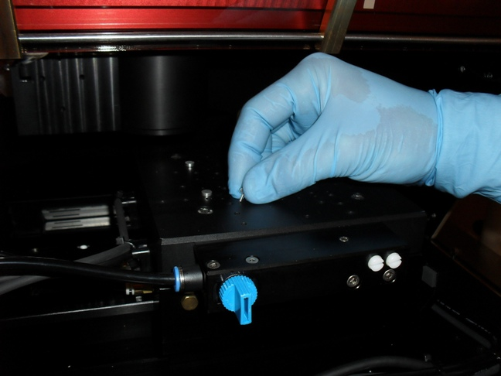

White Knobs

Vacuum Knob

Figure 5, μPG Chuck

**OFF**

**ON**

* + - 1. Turn on vacuum knob, see Figure 5, μPG Chuck
      2. Adjust white knobs for mask size if needed, *see* Figure 4, Placement & Vacuum Select
      3. PULL OUT PINS *IMPORTANT*, if the pins protrude above substrate surface (for non-standard or thin substrates)

|  |  |  |
| --- | --- | --- |
|  | **WARNING**  **Severe damage to the Writehead could occur if pins are above mask surface.** |  |

* + - 1. Shut lid
      2. Click “To Center” on the Stage Control, the stage will move to stage center under Writehead
      3. Click “Focus” on the Writehead Control, the Writehead will move to focus and expose height above substrate

NOTE: Focus is complete when a green rectangle is present above Focus button, do not proceed until green rectangle is present, see Figure 6, Controls Window

* + - 1. Click “Close” in the Controls window
    1. Click “Next” in the Check Options window

Manual Alignment

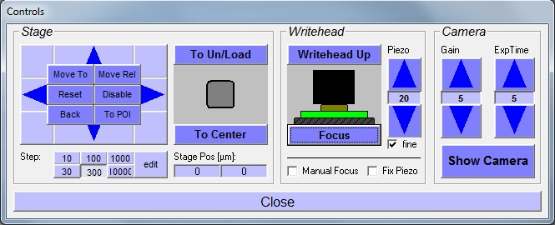

Figure 6, Controls Window

* + 1. Default is no alignment – design centered to stage center
    2. Confirm Offsets are appropriate for design, see Figure 7, Manual Alignment
    3. Contact staff for use of Manual Offsets and Alignment Options , some instructions are provided in last section, Alignment Options

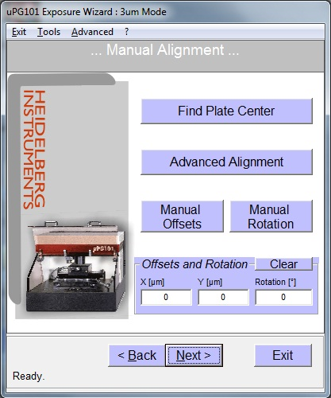

Figure 7, Manual Alignment

* + 1. Click NEXT

NOTE: For non-BMP designs, exposure is rotated in relation to front of Heidelberg, See Figure 8, Stage Coordinates

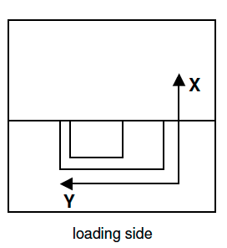

Figure 8, Stage Coodinates

Begin Expose

* + 1. Check parameters, see Figure 9, Expose
    2. Check Auto Unload after Exposure
    3. Click EXPOSE

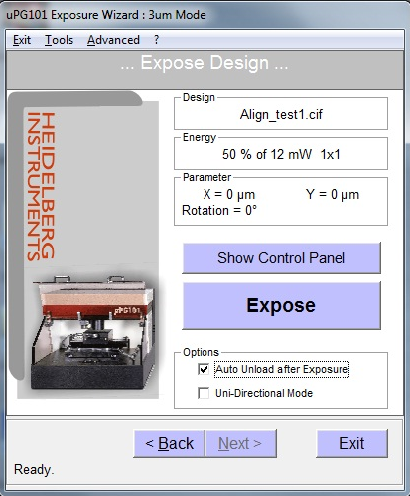

Figure 9, Expose

Unload Mask

* + 1. Unload mask when exposure is complete
       1. Turn off vacuum
       2. Wait 10 seconds
       3. Unload mask
       4. Replace pins at 5” mask locations if removed
       5. Click OK in pop-up window
       6. Click Exit Wizard
    2. Enter information into Coral
    3. Log out of μPG PC

1. Troubleshooting Problems
   1. Terminating the Program during Normal Operation
      1. Click the blue Abort! Button
2. Alignment Options
   1. Manual Alignment Options, contact staff
      1. Option - Find Plate Center
         1. Select check box fast mode and start to auto locate substrate edges and calculate offsets to center design on substrate, see (insert ref)
         2. Select accept to apply calculated offsets
         3. Select exit or cancel to exit window without offsets

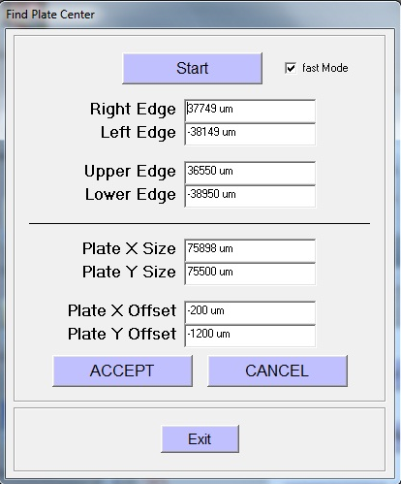

Figure 10, Find Plate Center

* + 1. Option, Advanced Alignment - Contact staff to assist using Advanced alignment, see (insert ref)

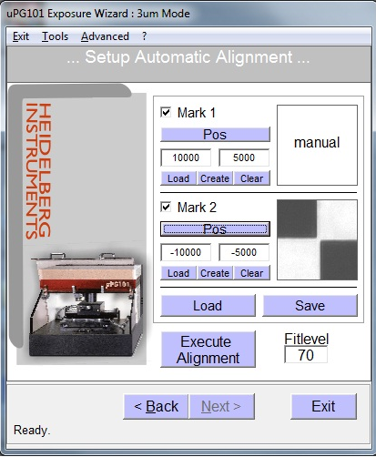

Figure 11, Setup Automatic Alignment

* + - 1. For POS enter design position of mark center in µm from design center, required for either Manual or Auto
      2. Only use Load or Create to use mark image for Auto align
      3. Check Mark 1 & Mark 2 to locate marks and calculate offsets and rotation
      4. Check Mark 1 only to locate one mark and calculate offset
      5. Select Execute alignment and use Stage Controls in Controls window to move to mark location
      6. For Manual, select POI and move crosshair to center of mark
    1. Option Manual Offsets
       1. Select Manual Offsets
       2. Enter offset value in pop-up windows for x and y offsets
    2. Option Manual Rotation
       1. Select Manual Rotation
       2. Enter offset value in pop-up windows for rotation in degrees
    3. Click Next after completing any desired positioning selections to exit Manual Alignment Window

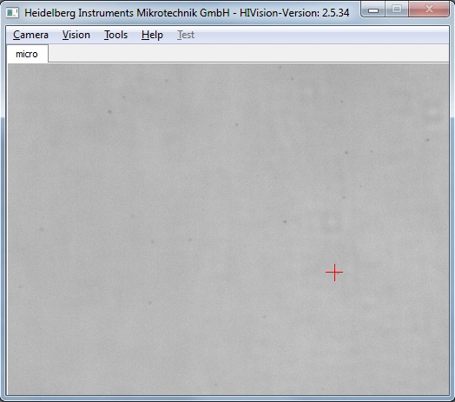

Figure 12, Camera View Window for Positioning & Alignment

1. Revision History

|  |  |  |  |
| --- | --- | --- | --- |
| **Rev** | **Date** | **Originator** | **Description of Changes** |
| 1 | 18 Oct 2011 | Sam Bell |  |
| **2** | 8 Aug 2012 | Steve Pritchett | Modify for software version on new Heidelberg |