Keithley Test Station SOP

1. Scope
   1. This document provides procedures for IV and resistance, CV, Diode, and Transistor measurement using the Keithley test station.

1. Table of Contents

1. Scope 1

2. Table of Contents 1

3. Reference Documents 1

3.1 Referenced within this Document 1

3.2 External Documents 1

4. Equipment and/or Materials 2

5. Safety 2

6. Setup Procedures 2

7. IV and Resistance Measurement Procedures 3

8. CV Measurement Procedures 5

9. Transistor Measurement Procedures 7

10. Diode Measurement Procedures 7

11. Viewing and Saving Results 8

12. Graph Examples 9

13. Revision History 11

Figure 1, SMU Connections 2

Figure 2, Sample Loading 3

Figure 3, KITE IV Window 3

Figure 4, IV Parameters 4

Figure 5, KITE CV Window 5

Figure 6, Capacitance CV Meters 5

Figure 7, KCON Window 6

Figure 8, Transistor Window 7

Figure 9, Resistor Graph 9

Figure 10, CV Graph 9

Figure 11, Diode Graph 10

Figure 12, Transistor Graph 10

1. Reference Documents

Referenced within this Document

* + 1. None

External Documents

* + 1. Keithley Application Notes for C-V Measurements

1. Equipment and/or Materials
   1. Keithley 4200-SCS
   2. Probe Station
   3. Sample
2. Safety
   1. Follow all Nanofab safety procedures.
3. Setup Procedures
   1. Double click the KITE icon on the desktop.
   2. Click yes.
   3. Check to make sure the program list as shown in Figure 3 says default at the top, if not:
      1. Go to File > Open Project.
      2. Choose the default.kpr file from S4200/kiuser/projects/default.
   4. Check SMU connections.
      1. Check the numbers of the SMU cables that the probes you are using are connected to.

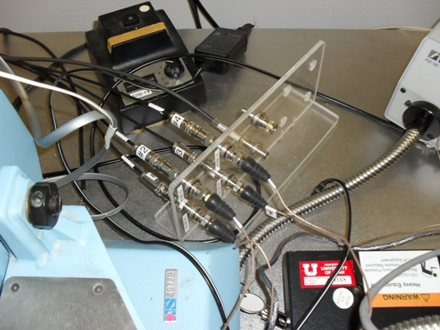

Figure , SMU Connections

Numbers on this side correspond to the KITE Software SMU numbers.

* 1. Load sample. See .
  2. Manually move probes into place *gently*.
  3. Use knobs to lower probes until tips contact measurement points on the sample.

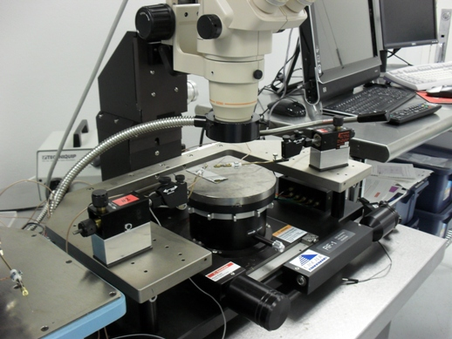

Figure , Sample Loading

Probe Unit

Knobs

Probe Tip

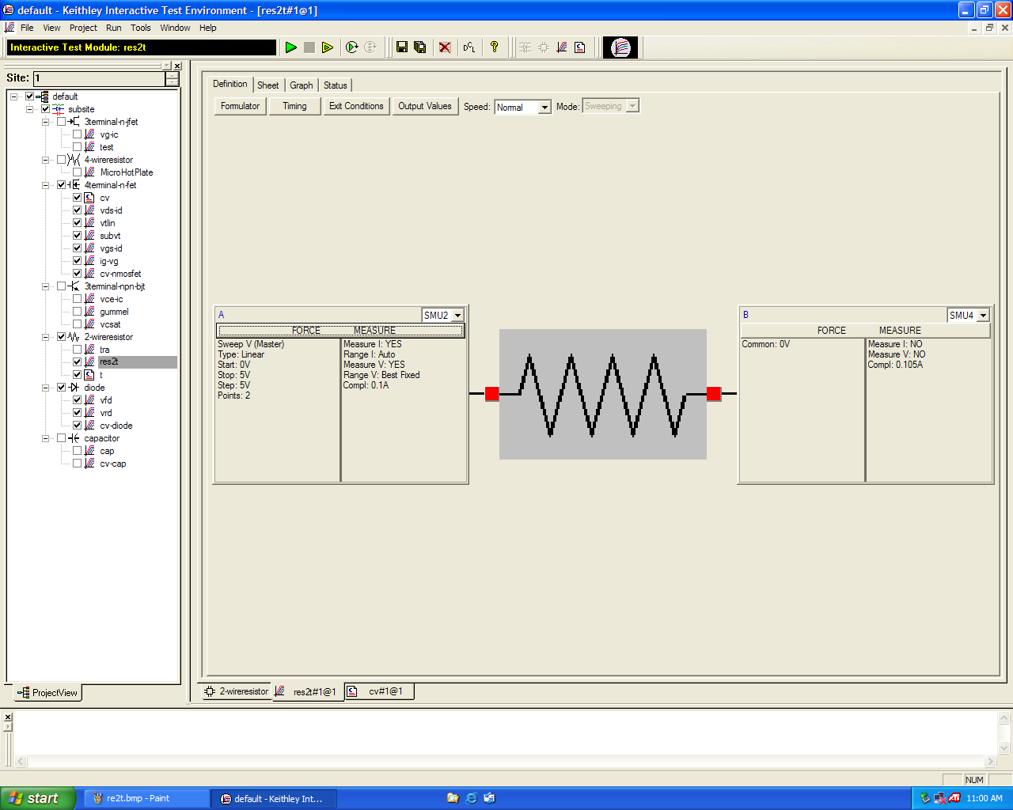

Select SMU number

Click to run test

Click this bar to set test parameters

Program List

Figure , KITE IV Window

1. IV and Resistance Measurement Procedures
   1. Select res2t under 2-wireresistor from the program list. See .
   2. Select SMU number.
      1. Click on the SMU window drop down menu. See .
      2. Select correct SMU number. See .
   3. Set voltage and step values.
      1. Click on the SMU window bar. See .
      2. Select the type of device (generally one Sweep Voltage and one Common).
      3. For the Sweep Voltage device set the voltage and step values. See .
      4. Click OK.



Figure , IV Parameters

* 1. Press green arrow to run test. See .
  2. See Section 11 for viewing and saving results. See Section 12.1 for an example Resistor graph.

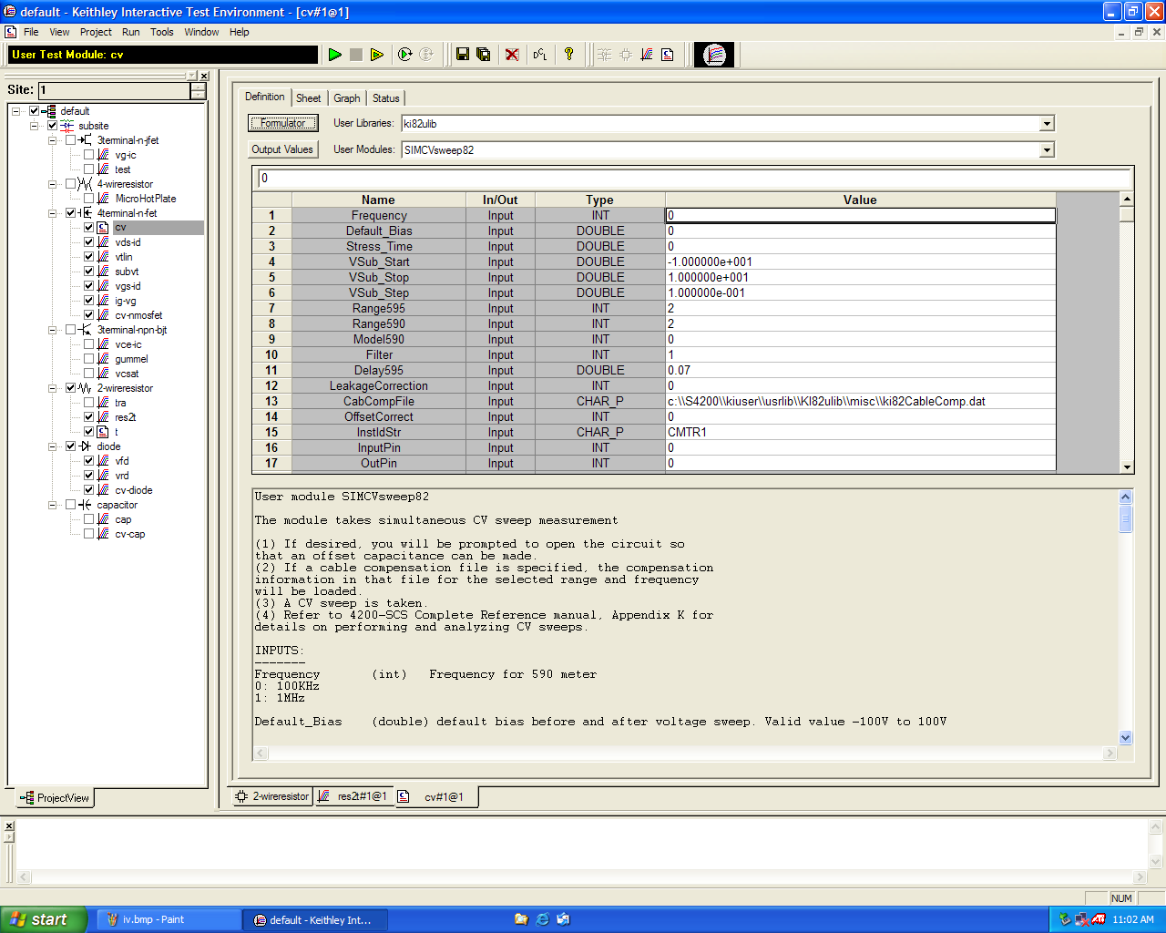

Figure , KITE CV Window

1. CV Measurement Procedures
   1. Turn on capacitance meter, voltage source, and CV analyzer. See .

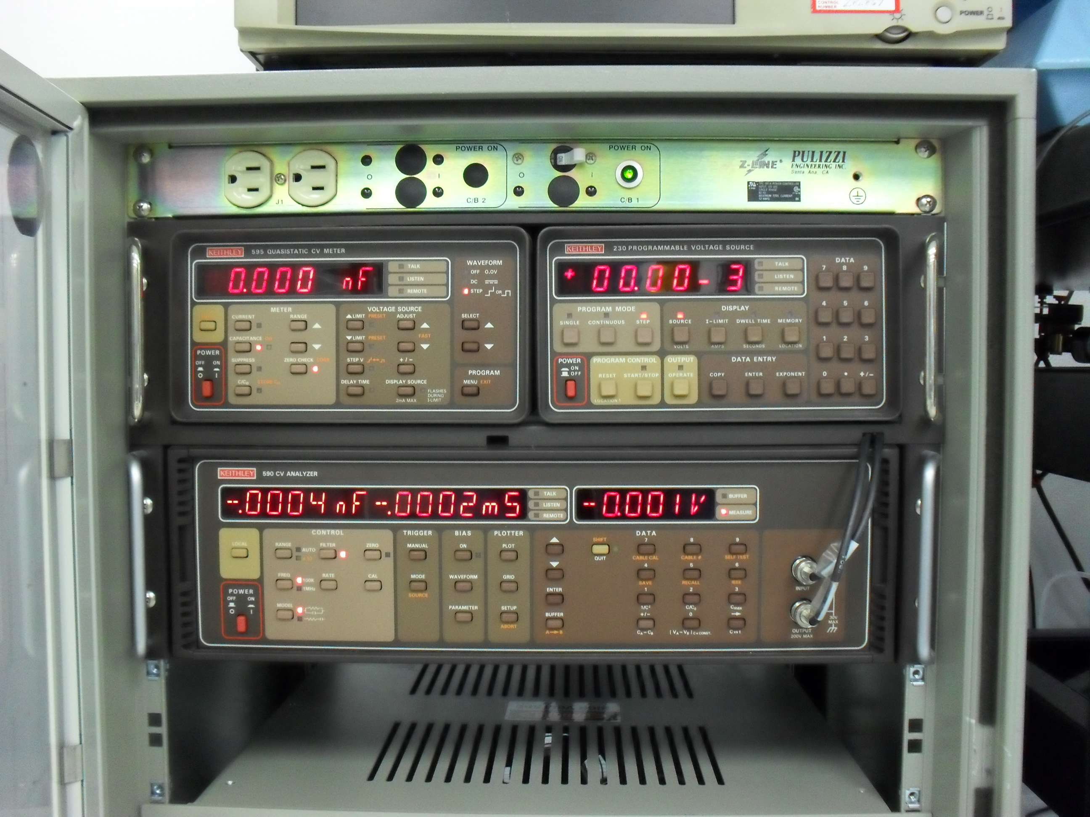

Figure , Capacitance CV Meters

* 1. Exit KITE
  2. Open KCON
  3. Go to Tools
  4. Select Add External Instrument>Capacitance Meter. See .
  5. Connect instruments 590, 595, and 82
  6. Close KCON
  7. Open KITE
  8. Select cv under 4terminal-n-fet from the program list. See .
  9. Set all parameters as needed.
  10. Click green arrow to begin test.

NOTE: See the Keithley Application Notes for C-V Measurements for a more detailed description of the CV measurement process.

* 1. See Section 11 for viewing and saving results. See Section 12.2 for an example CV graph.

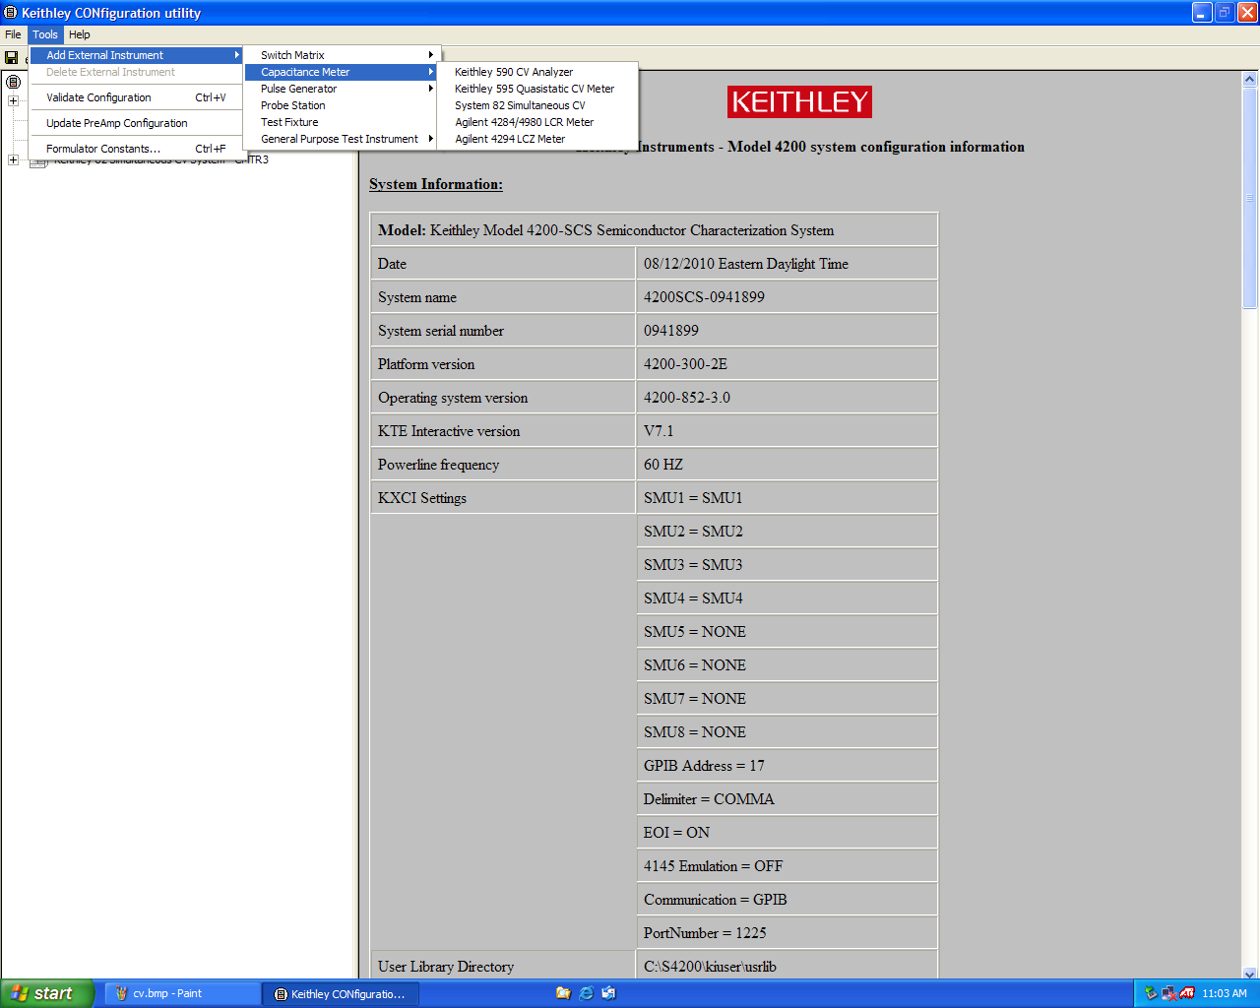

Figure , KCON Window

1. Transistor Measurement Procedures
   1. Click on vg-ic under 3terminal-n-fet on the program list.
   2. Set parameters for each terminal. See.
      1. Click on the correct SMU header for each terminal.
      2. Set SMU parameters according to its function.

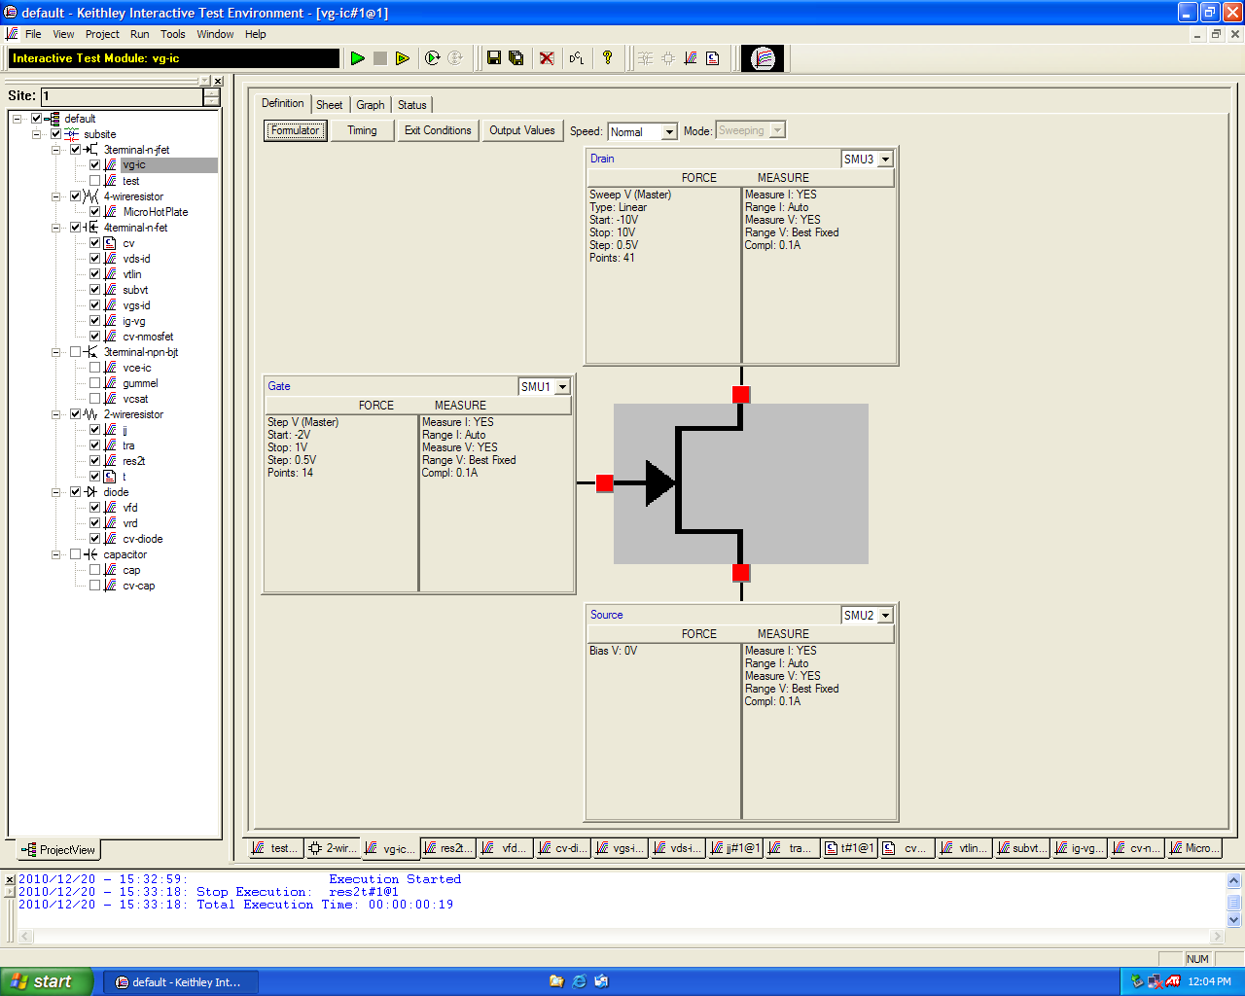

Figure , Transistor Window

* 1. Click the green arrow to start test.
  2. See Section 11 for viewing and saving results. See Section 12.4 for an example Transistor graph.

1. Diode Measurement Procedures
   1. Select the ‘*vfd*’ (voltage forward bias) or ‘*vrd*’ (voltage reverse bias) in the left-side frame and a diode symbol will appear in the right-side frame.
   2. For forward bias testing, select the ‘*vfd*’. Similar to the resistor, there will be 2 dialogue boxes. The **Anode** box should read *SMU1*, while **Cathode** box should read *SMU2*. Select the **Anode** *Force Measure* button to setup the *SMU1* test parameters.
   3. You are now ready to perform diode measurement. Click the *RUN* icon to start measurement. Click on the *GRAPH* tab to view the I-V plot. Save your data as spelled out in resistor testing.
   4. For reverse bias testing, select the ‘*vrd*’. Similar to the resistor, there will be 2 dialogue boxes. The **Anode** box should read *SMU1*, while **Cathode** box should read *SMU2*. Select the **Anode** *Force Measure* button to setup the *SMU1* test parameters. Apply a START VOLT of 0V and STOPVOLT of -20V, 0.1V step by changing the values in the appropriate boxes. If no reverse breakdown is observed, increase the STOP VOLT using -20V intervals (e.g. -40V, -60V …, -140V). Increase voltage step size accordingly.
   5. See Section 11 for viewing and saving results. See Section 12.3 for an example Diode graph.
2. Viewing and Saving Results
   1. Click on Graph tab.
   2. Set up graph parameters by right clicking.
      1. Choose Define Graph
      2. Click on Autoscale to view graph.
   3. To save results:
      1. Click on the Sheet tab.
      2. Press Save As to save results in excel format.
   4. See Section 12 for Graph examples.
3. Graph Examples
   1. Resistor

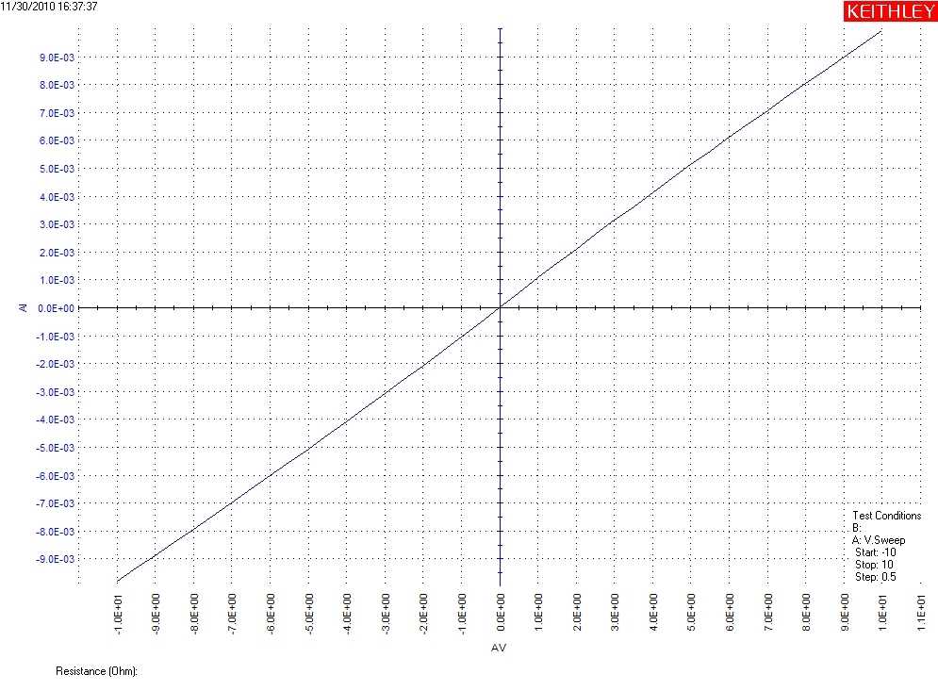

Figure , Resistor Graph

* 1. CV

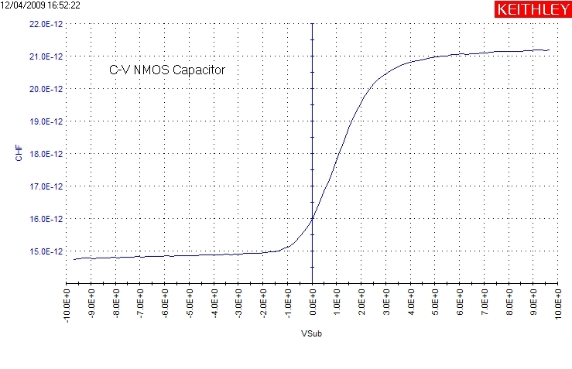

Figure , CV Graph

* 1. Diode

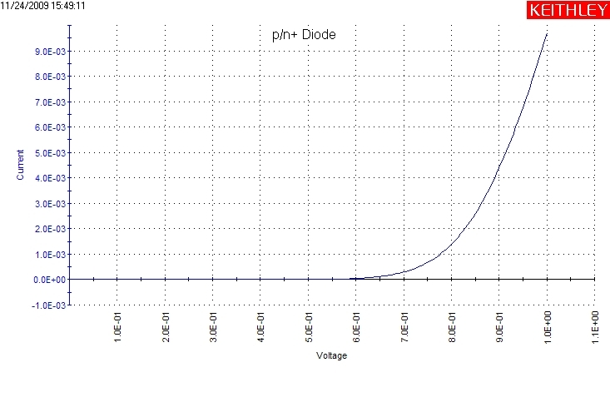

Figure , Diode Graph

* 1. Transistor

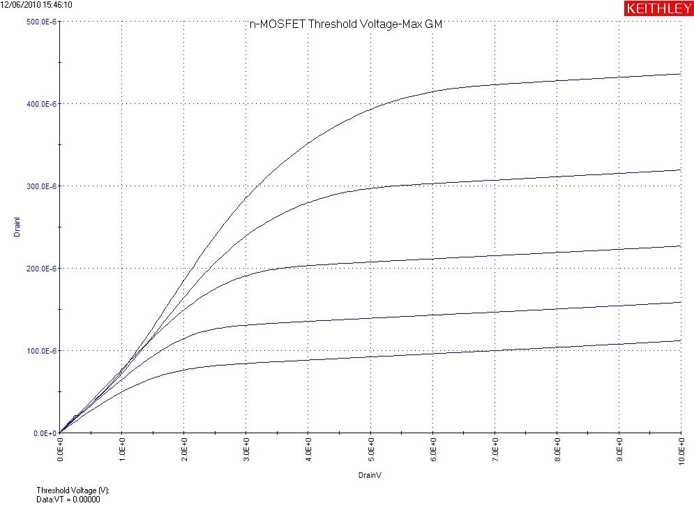

Figure , Transistor Graph

1. Revision History

|  |  |  |  |
| --- | --- | --- | --- |
| Rev | Date | Originator | Description of Changes |
| 1 | 10 Aug 2010 | Sam Bell |  |
|  |  |  |  |