OAI 800 Backside Aligner
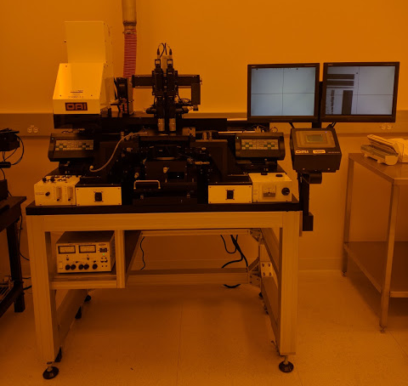
- Scope
  - This document provides the procedure of operating the OAI 800 Backside Aligner
- Table of Contents
1. Scope 1
2. Table of Contents 1
3. Reference Documents 2
3.1 Referenced within this Document 2
3.2 External Documents 2
4. Equipment and/or Materials 2
5. Safety 2
6. Setup Procedures 2
7. Alignment Procedure 3
7.2 Align Wafer 4
7.3 Expose Wafer 5
8. Revision History 6

Figure 1: Objectives/Camera Assembly 2
Figure 2: Process Setting 3
Figure 3: Level Screen 3
Figure 4: Digital Video Image Generator 4
Figure 5: Optics 4
Figure 6: Wafer Alignment 5

- Reference Documents
- Referenced within this Document
- None
- External Documents
- None
- Equipment and/or Materials
  - OAI 800 Backside Aligner
  - Mask
  - Wafer/Sample
- Safety
  - Follow all Nanofab safety procedures.
  - Avoid exposure to UV output beam.
- Setup Procedures
  - Turn on Machine
  - If LCD screen is on, skip to 6.2
  - Ensure that the red switch on the power bar located at the rear of the tool is on and glowing.
  - Ensure that the breaker switch located at the rear of the tool is switched on.
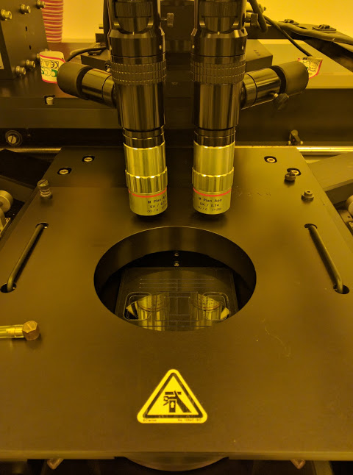
  - Insert Mask
Figure 1: Objectives/Camera Assembly
  - Move the objectives/camera assembly to the back by pressing and holding the two control buttons on the arm and pushing backwards. See Figure 1: Objectives/Camera Assembly.
  - Loosen the screws holding the mask plate down and gently remove the plate by lifting the handles and sliding the mask plate off the aligner stage.
  - Be careful, the mask plate is HEAVY and can damage the camera assembly!
  - Hold the mask plate upside down and pull the silver handle of the mechanical mask clamp to release it.
  - Place your mask on the plate making sure it is centered by pushing it against the pins from the left lower corner.
  - The photoresist side should face up and the shiny side should face the mask holder.
  - Push the black lever on the mechanical mask clamp to clamp the wafer down.
  - Press MANUAL TEST > MASK VACUUM on the LCD screen to hold the mask. The button should turn black.
  - If you hear hissing, turn MASK VACUUM off and reseat the mask. Avoid riding on the 3 pins.
  - Load the mask/mask plate back onto the aligner stage by sliding it into position over the wafer chuck.
  - Be careful not to hit the camera assembly while moving the mask plate in!
  - Screw down the mask plate FIRMLY.
  - All 3 screws should be tight.
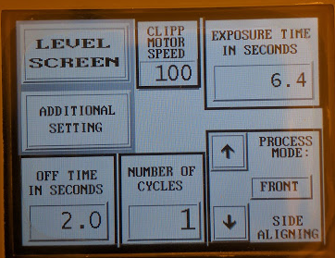
  - Mask sure mask holder handles are completely down or they can damage the microscope objectives.
  - Set Exposure and Gap
  - From the MAIN MENU press PROCESS SETTING > EXPOSURE TIME and enter the desired exposure time in seconds. See Figure 2: Process Setting.
  - Select the desired side alignment from PROCESS MODE in the same menu using the arrows (I MPRINT, IR BACK, BACK, or FRONT).
  - From PROCESS SETTING press ADDITIONAL SETTING and enter the desired gap in microns (Minimum of 250).
Figure 2: Process Setting
  - If multiple exposures are desired on the same wafer, press RETURN and enter NUMBER OF CYCLES and OFFTIME IN SECONDS. See Figure 2.
  - Press LEVEL SCREEN.
- Alignment Procedure
  - Load Wafer
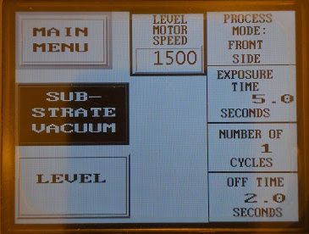
  - Pull the wafer chuck out by gently pulling the stainless steel handle in the front.
  - Be careful not to pull the wafer chuck too hard that it slams into the stopper!
  - Place your wafer on the chuck with the wafer flat at the bottom and photoresist side facing up.
  - From the LEVEL SCREEN select SUBSTRATE VACUUM to hold the wafer to the chuck. The button should turn black. See Figure 3: Level Screen.
Figure 3: Level Screen
  - Ensure the Z-Chuck electromotor is set to ~20 mA. (located on the bottom right corner of the aligner)
  - Gently and slowly push the wafer chuck back in.
  - Press LEVEL from LEVEL SCREEN.
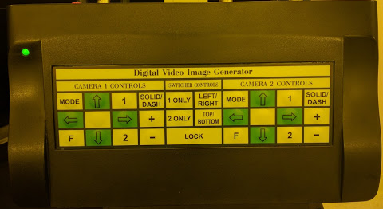
  - Align Wafer
Figure 4: Digital Video Image Generator
  - Mask Alignment:
  - On each DIGITAL VIDEO IMAGE GENERATOR press 1 ONLY to display just the top camera display. See Figure 4: Digital Video Image Generator.
  - If the monitor displays HOLD in the top left of the screen whenever a button is pressed, press and hold LOCK on the DIGITAL VIDEO IMAGE GENERATOR for 3-4 seconds.
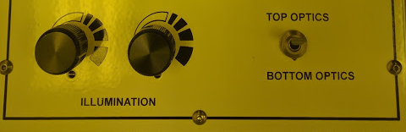
  - Turn on camera illumination by toggling the switch on the bottom left of the machine to TOP OPTICS. See Figure 5: Optics.
  - Adjust the illumination knobs as needed.
Figure 5: Optics
  - Center the object/camera field of view to the center of the mask by pressing the two buttons on the back of the arm and moving the camera assembly.
  - The top button is for X axis movement, the bottom button is for Y axis.
  - Move the individual objectives along the X axis by adjusting the large silver knobs on the side of each objective.
  - Adjust the theta axis by adjusting the micrometer behind the objectives.
  - Adjust the magnification and focus by rotating the adjustment wheels on the microscope objective.
  - The top adjustment knob is magnification, the bottom is focus.
  - Wafer Alignment:
  - Adjust the X axis by adjusting the micrometer on the front center of the wafer chuck.
  - Adjust the Y axis by adjusting the micrometer on the right side of the wafer chuck.
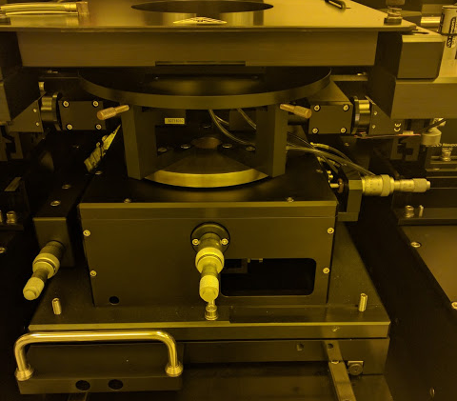
  - Adjust the theta axis by adjusting the micrometer on the front left of the wafer chuck. See Figure 6: Wafer Alignment.
Figure 6: Wafer Alignment
  - On each DIGITAL VIDEO IMAGE GENERATOR press 2 ONLY to display just the bottom camera display
  - Turn on the camera illumination by toggling the switch to BOTTOM OPTICS. See Figure 5: Optics.
  - Adjust the illumination knobs as needed.
  - Move each bottom camera independently along the X axis using the black knobs on the far left and right ends of the machine.
  - Move each bottom camera independently along the Y axis using the silver knobs on top of the bottom camera assembly beside the mask/wafer enclosure.
  - Focus each bottom camera independently using the BOTTOM OPTICS FOCUS located on the front side of the machine.
  - Do not set the right focus below .5 inches or it will interfere with the wafer chuck.
  - NOTE: Wafer alignment marks need to be within the viewing window for bottom side alignment. 45 mm inside, 75 mm outside.
  - Move the top objectives/camera assembly to the back of the mask plate by pressing the two control buttons on the arm.
 | WARNING  Check to ensure the objectives/camera assembly is pushed all the way back and has a clear path to move. Failure to do so will damage the objectives and their mounts.
- Expose Wafer
- Once the wafer is fully aligned, from the MAIN MENU press RUN SCREEN then press MOVE TO CONTACT POSITION.
- Select either CONTACT VACUUM or N2 HARD CONTACT.
- CONTACT VACUUM pulls vacuum between the mask and the wafer.
- N2 HARD CONTACT applies nitrogen under the wafer to push it against the mask.
- Make sure the objectives/camera assembly are high enough and pushed back so that they will clear the mask holder
- Press CYCLE.
- Ensure the monitors are not in the path of the lamp stage.
- Wait for UV Lamp to move over, expose the wafer, and move back over.
- Once the LEVEL button is white on the LCD screen, you are safe to pull the wafer chuck out.
- If the lamp stage does not move back to the starting position, contact NanoFab staff.
- Revision History
Rev | Date | Originator | Description of Changes
1 | 9 Aug 2016 | Cameron Anderson

