Tencor Profilometer SOP
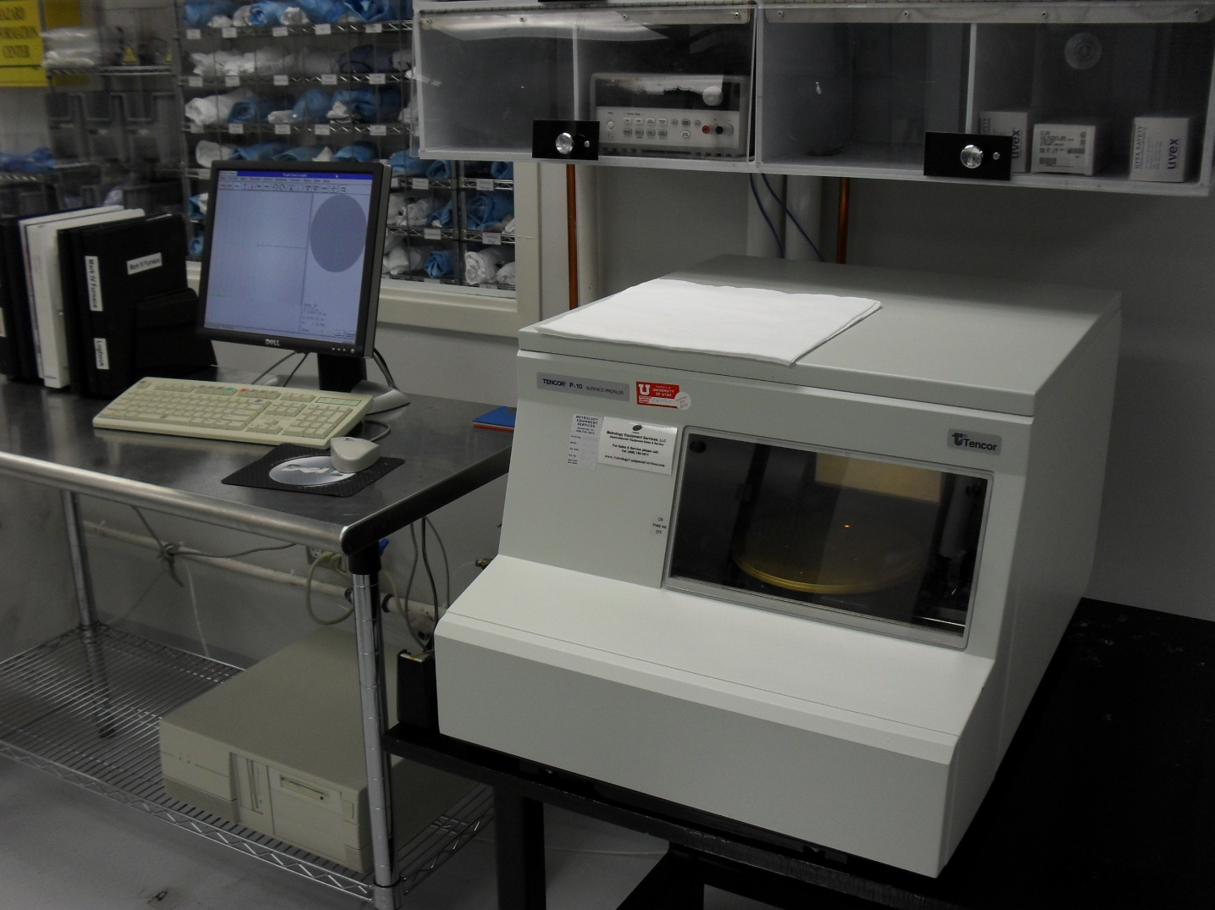
- Scope
  - This document provides the operating procedures for the Tencor profilometer.
- Table of Contents
1. Scope 1
2. Table of Contents 1
3. Reference Documents 2
3.1 Referenced within this Document 2
3.2 External Documents 2
4. Equipment and/or Materials 2
5. Safety 2
6. Setup Procedures 2
6.1 Start Program 2
6.2 Set up a Scan Recipe 2
6.3 Load the Sample 3
6.4 Move the Sample 3
7. Scan and Data Analysis Procedures 4
7.1 Start the Scan 4
7.2 View Scan Results 4
7.3 Exporting Data 4
7.4 Shutdown 4
7.5 Figures 5
7.6 Tables 7
8. Revision History 7

Figure 1, Sample Loading 3
Figure 2, XY Window 5
Figure 3, XY Toolbar 5
Figure 4, Analysis Window 6
Figure 5, Recipe Editor 6
Figure 6, Scan Window 7

Table 1, Default Recipe Parameters 7

- Reference Documents
Referenced within this Document
    - None
External Documents
    - None
- Equipment and/or Materials
  - Wafer/Sample
  - Tencor Profilometer
- Safety
  - Follow all Nanofab safety procedures.
- Setup Procedures
Start Program
    - Double click the PROFILER icon to open the TOP LEVEL MENU.
    - In the TOP LEVEL MENU window click on the SCAN icon.
Set up a Scan Recipe
    - Go to the Recipe Editor window. See Figure 5, Recipe Editor.
      - From the Scan window, click the Recipe button. See Figure 6, Scan Window.
      - From the XY window, click the Cancel button. See Figure 2, XY Window.
You can open an existing recipe from the menu or create a new recipe.
    - Click on the Open button or go to the Recipe menu to open an existing recipe. See Figure 5.
      - Adjust recipe parameters as needed.
OR
    - Create a new recipe.
      - Go to the Recipe menu.
      - Select New.
      - Set the parameters according to feature size/depth. See Table 1, Default Recipe Parameters.
      - Go to the Recipe menu.
      - Select Save As to save your new recipe.
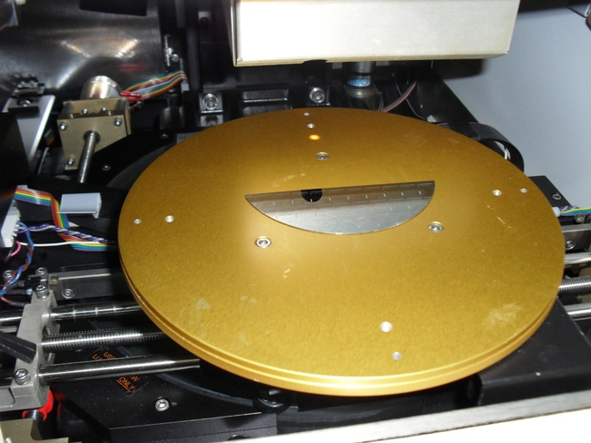Load the Sample
Figure 1, Sample Loading
    - Click on the XY button.
NOTE: Only flat wafers and flat glass are allowed. You may not use dishes or other holders on the stage. Other samples with raised points may damage the stylus.
    - Place sample in the middle of the chuck. See Figure 1, Sample Loading.
    - Press Man Load button. See Figure 3.
    - Press Focus button. See Figure 3.
    - Wait about 1 minute for the yellow bar at the bottom of the screen to disappear.
Move the Sample
    - Use the arrow/rotate buttons in the X-Y window toolbar or the arrow keys on the keyboard to move the sample. See Figure 3, XY Toolbar.
The right hand side of the screen shows the position of the stylus/camera on the chuck.
    - Select SLOW, MED, or FAST for fine, medium, or coarse adjustments.
    - Use the ZOOM IN or ZOOM OUT buttons to view an image more clearly.
The blue line on the cross hairs indicates the scan length and the scan direction.
    - To change the scan length while in the X-Y window, click and drag the cursor over the feature to be scanned. See Figure 2, XY Window.
    - Click on any point in the image window to move the center of the cross hairs to that point.
    - Move the crosshairs to where you want the scan to start.
- Scan and Data Analysis Procedures
Start the Scan
    - Press START. See Figure 3, XY Toolbar.
The stylus will lower, and the scan will begin.
You can view the scan in progress by enlarging the viewing window.
When the scan is finished, it will take you to the Analysis window.
View Scan Results
    - Click the Level button. See Figure 4, Analysis Window.
    - Move the line cursors to two different points that are known to be level.
    - Click the Level button again to level the results.
    - Move the cursor lines to get the height difference between the two cursor positions.
    - An average measurement may be made by splitting each cursor line into two lines each which measures an average height between the two cursor lines.
The height, width, etc. are displayed on the left side of the Analysis window.
    - Save your scan data if you want to export it or access it later.
    - Press the XY button to return to the XY window.
Exporting Data
    - Run a scan and save your data. See 7.1 - 7.2.
    - Exit to the TOP LEVEL MENU.
    - Click on the DATABASE FILE MANAGER icon.
    - Select the SCAN RECIPE or SCAN DATA button on the left side of the screen.
    - Locate the scan data or recipe you want to export and highlight the file.
    - Select FILE -> EXPORT, or click the EXPORT button in the toolbar.
The EXPORT DATA window will appear.
    - In the DRIVE field type the letter of the drive to receive the data.
A = 3.5" floppy, C = hard drive, E = ZIP disk.
    - Select EXPORT TYPE: ASCII or Binary.
Use ASCII format for transferring data to other applications such as spreadsheets, word processors, etc. Binary format is for use on another KLA-Tencor profiler or for backing up and archiving data in its original format.
    - Click OK to export the file.
Shutdown
    - Click Man Load to unload the sample. See Figure 3, XY Toolbar.
    - Remove the sample and close the window.
Figures
CAUTION

Do not remove the sample without first moving the chuck out by selecting MAN LOAD.
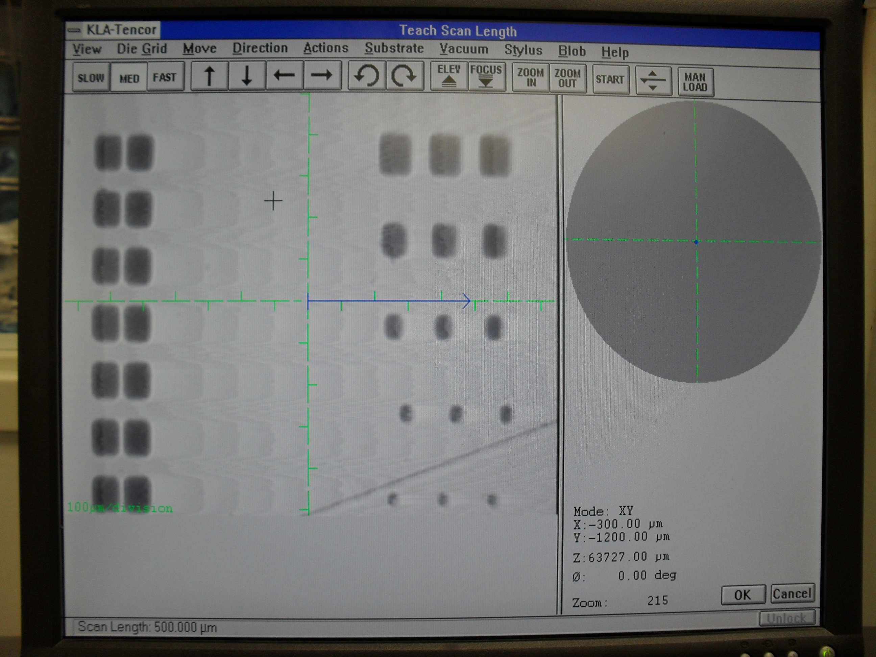
Cursor
Scan Length
Cancel Button
Image of Wafer
Stylus XY Position
Figure 2, XY Window

Movement Speed
Movement Direction
Chuck Rotation
Focus Button
Start Button
Man Load Button
Zoom
Figure 3, XY Toolbar

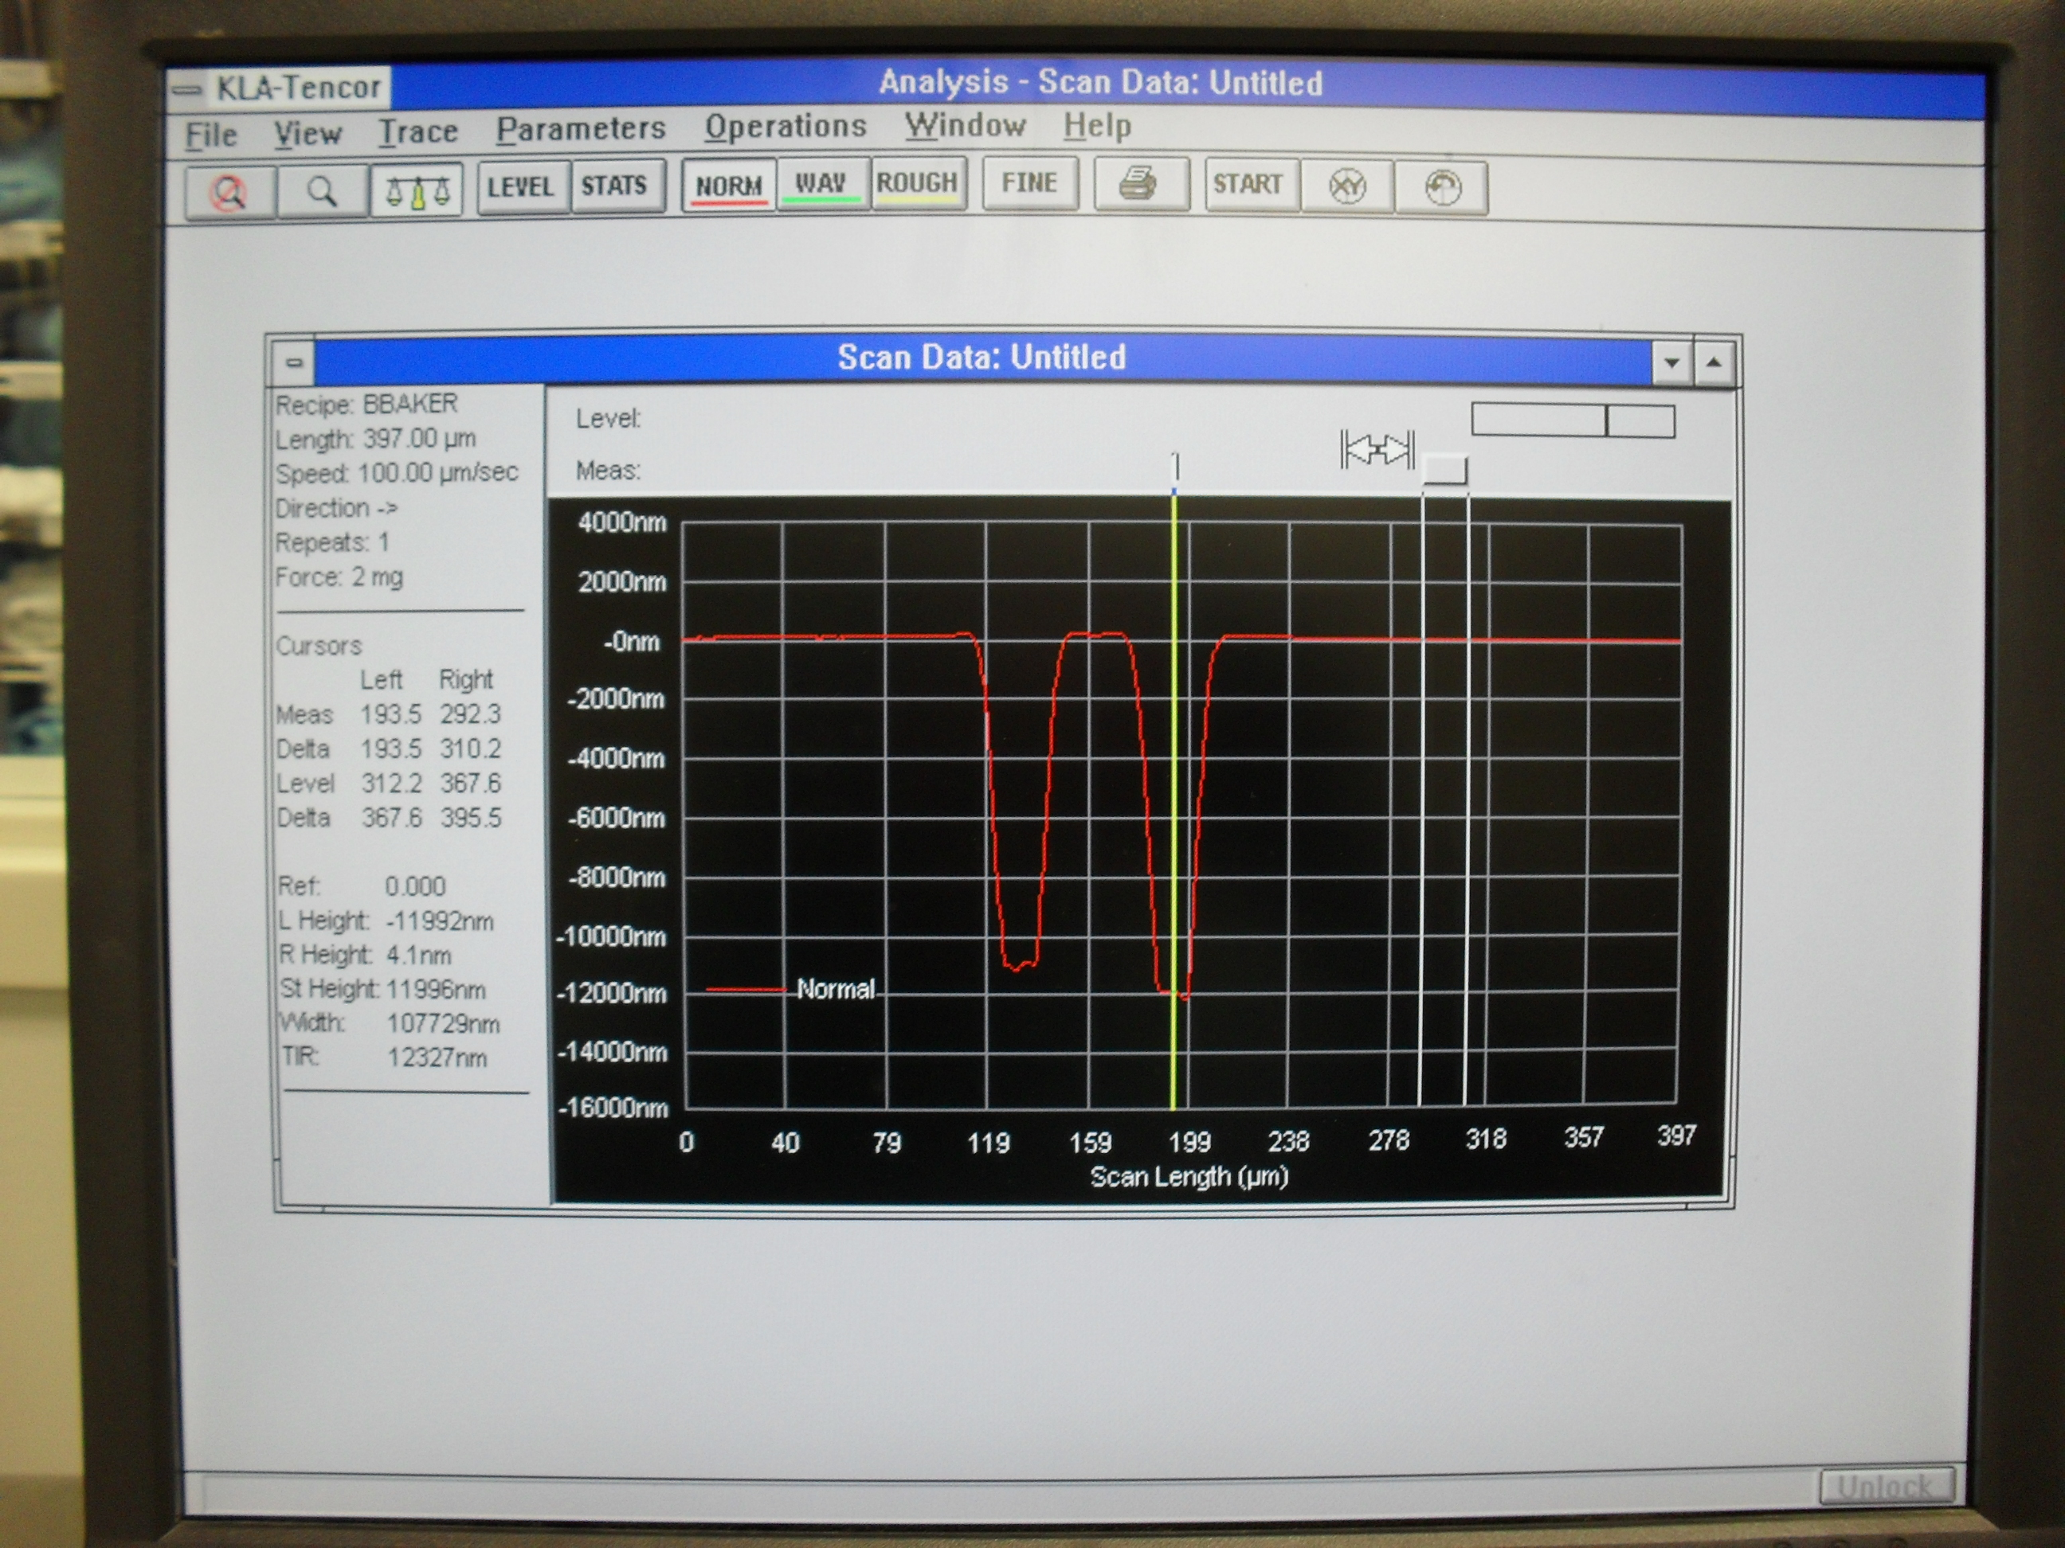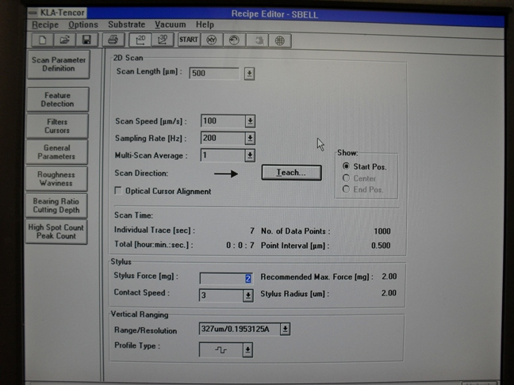
Level Button
Scan Data
Line Cursors
XY Button
Figure 4, Analysis Window
Recipe Parameters
New
Open
Save
Figure 5, Recipe Editor
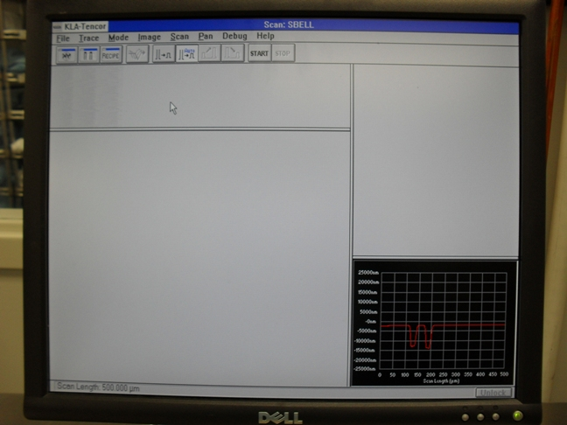Tables
Figure 6, Scan Window
Recipe Button
Table 1, Default Recipe Parameters
Scan Length | 500
Scan Speed | 100
Sampling Rate | 200
Multiscan Avg. | 1
Stylus Force | 2
Contact Speed | 3
Range/Resolution | 327um/0.1953125A
Profile Type | -I¯I_I-

- Revision History
Rev | Date | Originator | Description of Changes
1 | 19 May 2010 | Sam Bell

