YES Vapor Prime Oven SOP
- Scope
  - This document provides the procedure for operating the Yield LP III HMDS Vapor Prime Oven.
- Table of Contents
1. Scope 1
2. Table of Contents 1
3. Reference Documents 1
3.1 Referenced within this Document 1
3.2 External Documents 1
4. Equipment and/or Materials 1
5. Safety 1
6. Setup Procedures 1
7. Film Deposition Procedures 2
8. Revision History 3

Figure 1, Vacuum Pump 2
Figure 2, Control Panel 3

- Reference Documents
Referenced within this Document
    - None
External Documents
    - None
- Equipment and/or Materials
  - YES Vapor Prime Oven
  - Wafer/Sample
  - HMDS
- Safety
  - Follow all Nanofab safety procedures.
- Setup Procedures
  - Check the status of the system: See Figure 2, Control Panel.
      - Vacuum Gauge: <100 Torr
      - Temp. ~150 C
      - HMDS in flask
      - Vacuum pump off
  - Turn on vacuum pump. See Figure 1, Vacuum Pump.
  - Press the black START button. This will vent the system for 5 minutes. See Figure 2, Control Panel.
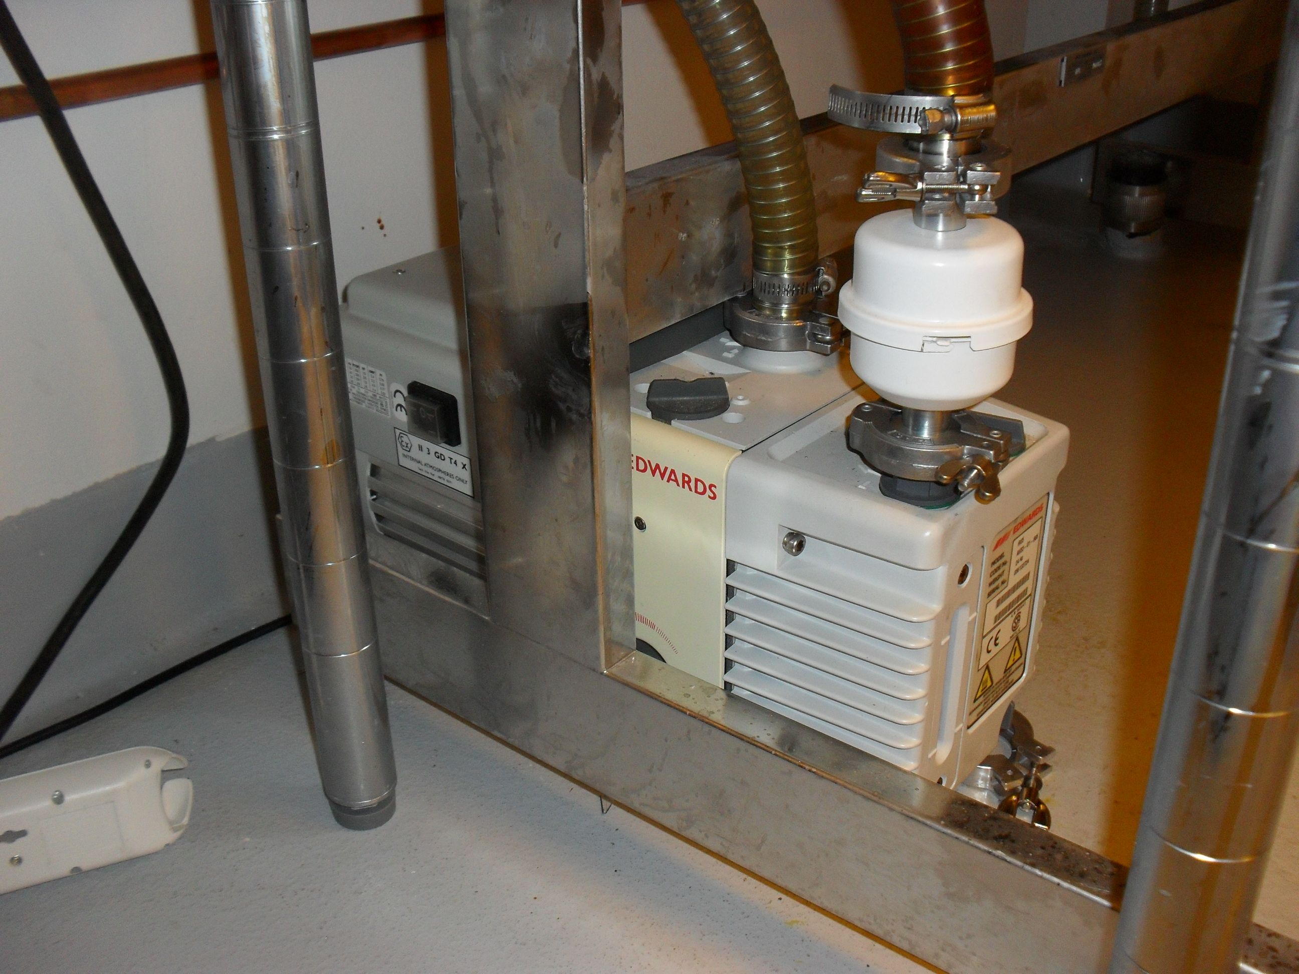
Power Switch
Figure 1, Vacuum Pump
- Film Deposition Procedures
  - Pull the door open and insert wafers.
  - Close the door. This may require a bit of force.
  - Press the black START button again.
NOTE: This will start pump down and deposition process. The total time is ~30 minutes.
  - An alarm will sound when the run is finished.
  - Press the black START button again to vent the system.
  - Pull the door open and remove samples.
  - Close the door and press the black START button.
  - Once the vacuum gauge reads lower than 100 Torr, press the red RESET button. See Figure 2.
NOTE: This will stop the system. Make sure this is done before the next step or it will begin a nitrogen backfill.
  - Turn off the vacuum pump.
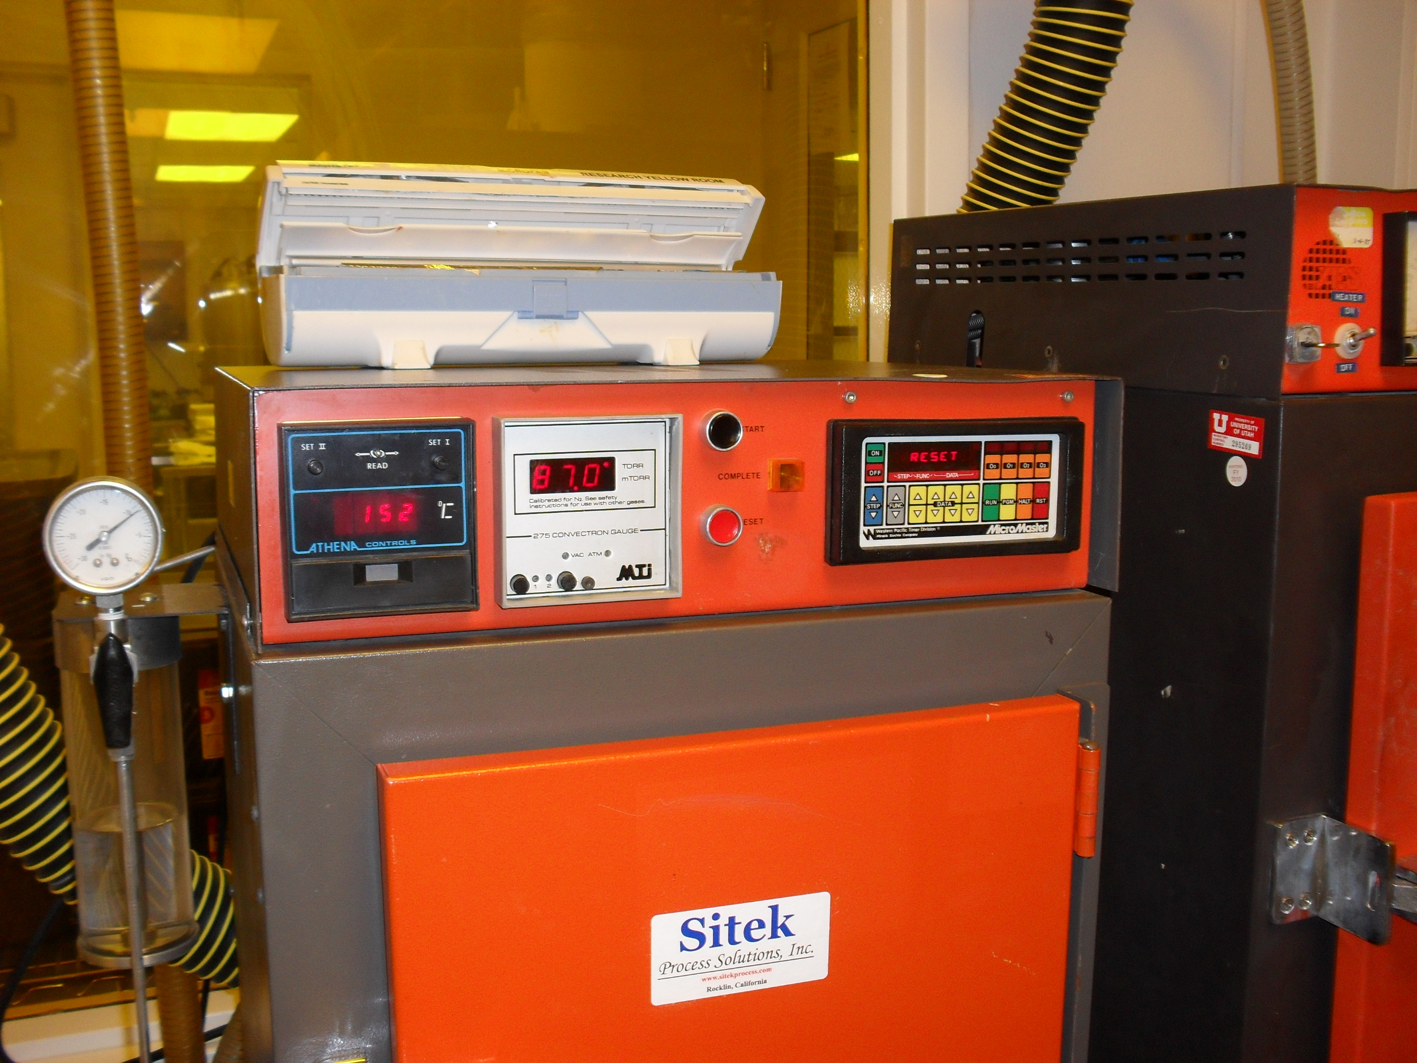
HMDS Flask
Temperature
Vacuum Gauge
Start Button
Reset Button
Figure 2, Control Panel
- Revision History
Rev | Date | Originator | Description of Changes
1 | 14 Jan 2010 | Sam Bell

