MEI Wedge Bonder SOP
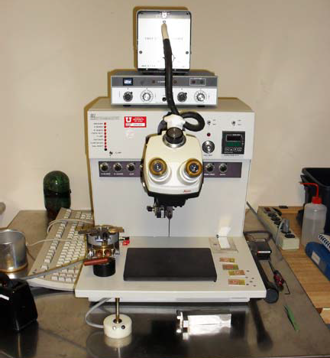

Purpose and Scope
This document provides job breakdowns and reference information for the MEI Wire Bonder operations.

Table of Contents
MEI Wedge Bonder SOP 1
Purpose and Scope 1
Table of Contents 2
Reference Documents 2
Acronyms, Abbreviations and Definitions 2
Equipment and Supplies 2
Safety 2
Forms 3
Job Breakdown 1 – Wire Bonder Power On and Set Up (1 of 1) 4
Job Breakdown 2 – Wire Bonding (1 of 2) 5
Job Reference 1 – Threading the Wedge (1 of 1) 7
Adjustable Machine Settings 8
Non-Adjustable Settings 8
NOTE: Red spool = .001 inch Al wire. 8
Revision History 8

Reference Documents
Reference Documents | SOP Number or link
User Guide | https://www.nanofab.utah.edu/documents/2016/02/smbb-user-guide.pdf/

Acronyms, Abbreviations and Definitions
Term | Description
SOP | Standard Operating Procedure

Equipment and Supplies
Description
MEI Hybrid Wedge Bonder | Located in lab.
Tweezers | Available on the MEI stage.
Wire | Al wire is most commonly used.
2.5 mm Allen Wrench | Available on MEI stage
Scissors | Available on MEI stage
Wafer/Sample | Parts to be wire bonded

Safety
Follow all Nanofab safety procedures.

Safety alert symbol
The Safety Alert Symbol is used in conjunction with signal words to convey a personal injury hazard is present.

Signal words
DANGER | Indicates an imminently hazardous situation, which if not avoided, will result in death or serious injury. The Safety Alert Symbol should always be used.
WARNING | Indicates a potentially hazardous situation, which if not avoided, may result in death or serious injury. If the safety alert symbol is NOT used in conjunction with this signal word, then the hazard conveyed is severe equipment or material damage.
CAUTION | Indicates a potentially hazardous situation, which if not avoided, may result in minor or moderate injury. If the safety alert symbol is NOT used in conjunction with this signal word, then the hazard conveyed is minor equipment or material damage.

Forms

Training Form
Trainee:
Area:
This person has been declared qualified to train others (check if “Yes”)
Item # | Task |  |  |  |  |  |  | Date Training Completed |  |  | Trainer
1 | JB1 Wire Bonder Power On and Set Up
2 | JB2 Wire Bonding
3 | JR1 Threading the Wedge
4
Training Notes (Optional)
Run completion dates: |  | 1) |  | 2) |  | 3) |  |  | 4) |  |  | 5)

Job Breakdown 1 – Wire Bonder Power On and Set Up (1 of 1)
Follow this section to Film Frame a Wafer.
 | Log into HSC and reserve the wirebonder for the desired time and unlock to power up the tool.  Note: Before you start, know the difference between adjustable and non-adjustable machine settings. A set up fee may be charged if non-adjustable machine parameters are changed.  The wedge on the wire bonder is extremely sharp. Be careful when working near the wedge to avoid skin punctures. | 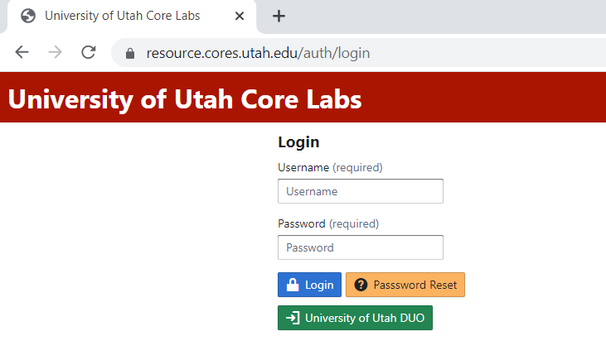
 | - Ensure you are wearing gloves when operating the wedge bonder.  Note: Skin particles can easily plug the wedge which is expensive to clean and set up. If you are caught operating the wedge bonders without gloves you could lose your access and be charged for set up.  - Ensure the power switch is turned on. | 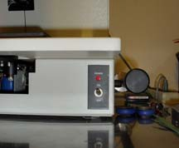
 | - Ensure Ultrasonic generator and lamp power are both turned on.  - Note: the power button on the lamp can be tuned to get the desired brightness.  - Set bond parameters for desired materials.  Note: The time for both bond 1 and bond 2 should be the same if the same material is used for both bond pads. If the bond pads are different materials, it may be necessary to adjust bond 1 vs. bond 2 to different parameters. A good power starting point is 6.5 and a good time is 5.5. These settings have been used to make successful bonds for Al, Au and Cu bonding pads.  - Refer to Adjustable Machine Setting in this document to reference good starting points for various materials. | 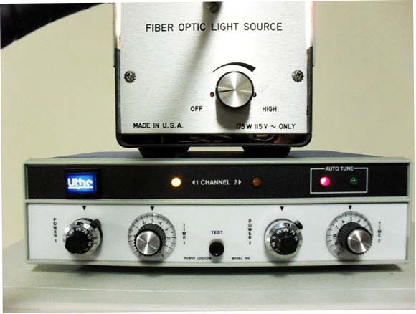

Job Breakdown 2 – Wire Bonding (1 of 2)
Follow this section to wire bond.

 | - Adjust the height of the work piece to get desired wedge to bond height.  Note: A key component to wire bonding is the height of the wedge to the bonding surface. The bonding wedge must be able to make good contact with both bond 1 site and bond 2 site. If these sites are at different elevations, it is best to try to split the difference. | 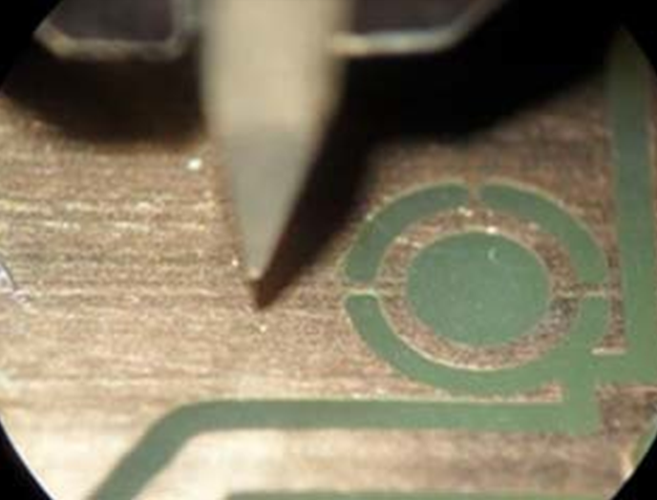
 | Using the bond lever, bring down the wedge to bond site 1. | 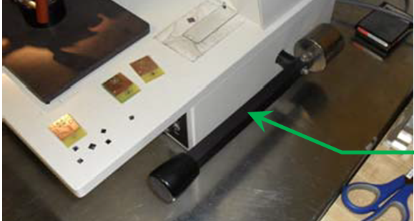
 | - Use the microscope and mouse to position the wedge over bond site 1.  - Hold the bond lever down until the bonding parameters are met for bond site 1.  Note: The bond force, power and time are dependent on the settings made in JB1. Refer to Table 1 machine settings for set up. | 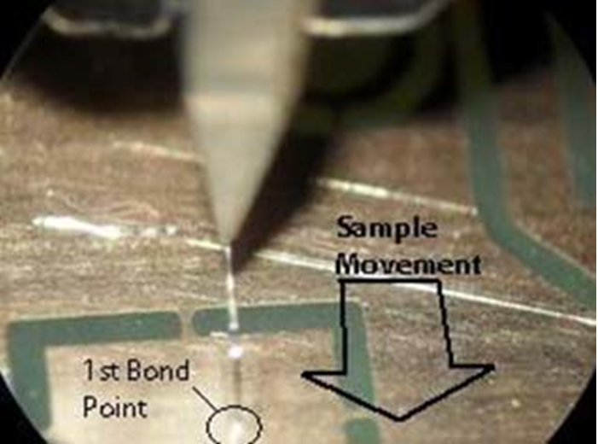
 | Using the mouse, carefully move the substrate to bond site two.  Note: This should only be made in one direction the substrate should move toward you as the wire moves away from you to bond site 2. Never move the wire side to side or in the opposite direction. | 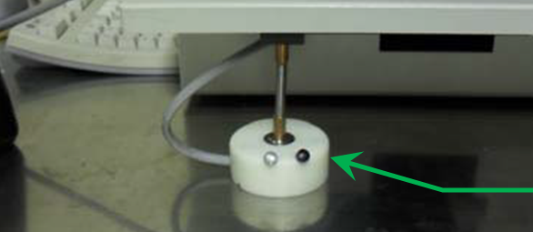

Job Breakdown 1 – Wire Bonding Continued (2 of 2)
 | Once you have moved to bond site 2, lower the bond lever until the bond has been made and slowly lift the bond lever back to the home position. The bonding cycle is now complete and ready for repeat. | 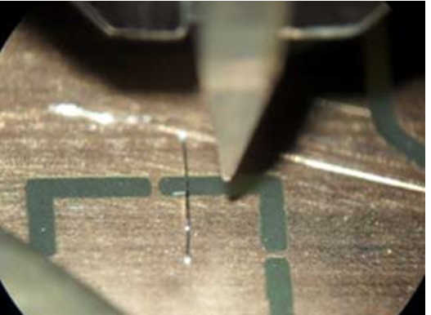
 | When you are finished please log into HSC and lock the tool.

Job Reference 1 – Threading the Wedge (1 of 1)
- Using Figure 1, carefully separate the clamp by rotating the clamp screw slowly. The clamp is spring loaded and rotates with a locking pin that rotates by turning the clamp screw. Ensure that the clamp tip is not dropped or damaged. It is has two sapphire pieces that are delicate and are used to feed the wire. Do not touch these pieces with your fingers. Set the clamp half in a safe location where it won’t get damaged.
Figure 1
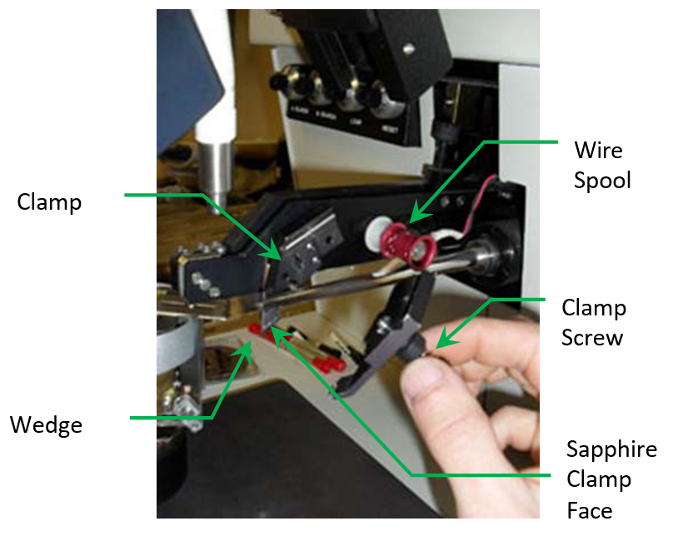
- Use a fine pair of tweezers to thread the wire through the hole along the length of the transducer. The wire will emerge from a lower point along the arm.

- Using Figure 2, thread the wire through the small loop in the clamp behind the sapphire clamp-face and continue through the wedge.
Figure 2
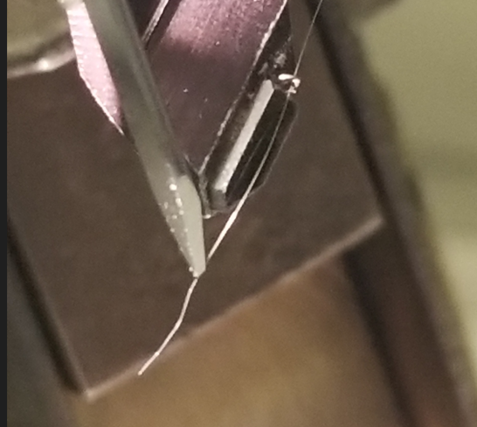

- Replace the wedge rotating the locking screw to ensure the wedge is secure.

- Trim the excess wire with the scissors.

Adjustable Machine Settings
Table 1 Adjustable Machine Settings

Wire | Bond Material | Time | Power | Bond Force | Clamp Position
25 um Al | Al bond pads | 3.0 | 7.0 | 2-8 | Normally down, may be adjusted when threading wire.
25 um Al | Cu traces | 5.0 | 7.8
50 um Al | Sandia MEMS Chips | 6.0 | 5.0
50 um Al | Cu Traces | 8.0 | 9.0

Non-Adjustable Settings
Table 2 Non-Adjustable Machine Settings

Search | Loop | Reset | Dual Weight | Speed | Tail
A - 2.9 | 7.1 | 1.55 | 12.5 | 7.2 | Do not adjust contact Staff.  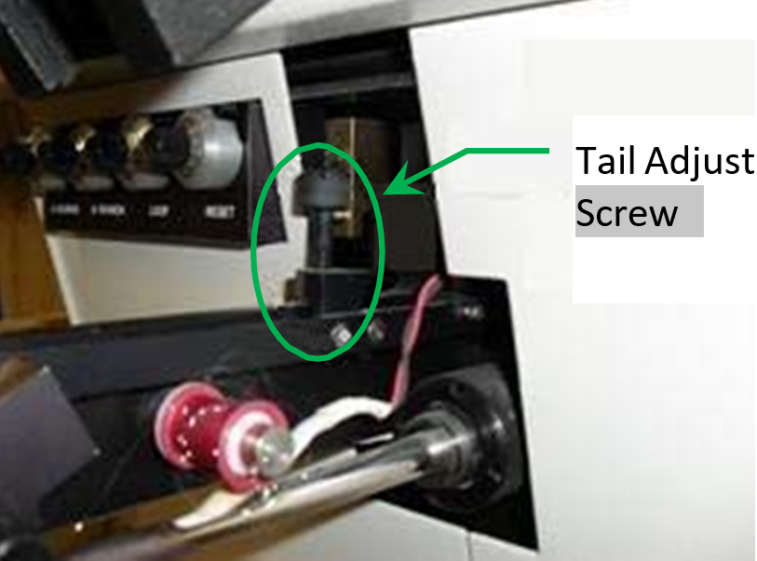
B - 9.7

NOTE: 25 um = .001 inch.

NOTE: Red spool = .001 inch Al wire.

Revision History
Rev | Author | Date | Description of Change
A | Sam Bell | 20 Apr 2010 | Initial Release
B | Jim Pierce | 01 Jan 2023 | Complete re-write.

